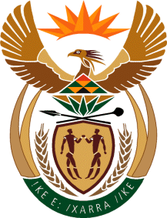

MINISTRY: COMMUNICATIONS
REPUBLIC OF SOUTH AFRICA
Private Bag X 745, Pretoria, 0001, Tel: +27 12 473 0164 Fax: +27 12 473 0585
Tshedimosetso House,1035 Francis Baard Street, Tshedimosetso House, Pretoria, 1000

NATIONAL ASSEMBLY
QUESTION FOR WRITTEN REPLY
QUESTION NUMBER: 1077
DATE OF PUBLICATION: APRIL 2016

Ms N W A Mazzone (DA) to ask the Minister of Communications:
Whether all the winners of the 15th Metro FM Awards held on 27 February 2016 have received their prize money; if not, (a) why not, (b) which of the winners have not received their prize money, (c) when will they receive their prize money and (d) in what format has/will the prize money be transferred? NW1180E

REPLY: MINISTER OF COMMUNICATIONS

No, not all winners have received their prize money yet.
- Various reasons, including:
  - Incorrect proof of banking supplied by artist and/or his Management Company.
  - Non submission of certified copies of identification from artist
  - No submission of supporting documents yet from artist and/or Management Company.
- The following artists have not received payment:
- Best Kwaito Album – DJBongs;
- Best Remix Single – AKA;
- Best Duo/Group - DBN Nyts;
- Best Hip Hop - Casper Nyovest ;
- Best Afro-Pop Album – Nathi;
- Song of the Year – Nathi.
- Three of the artists have submitted the required documentation and will be paid on 22 April 2016. The remaining two artists will be paid when their documentation is received.
- EFT.

MR NN MUNZHELELE
DIRECTOR GENERAL [ACTING]
DEPARTMENT OF COMMUNICATIONS
DATE:

MS AF MUTHAMBI (MP)
MINISTER OF COMMUNICATIONS
DATE:

