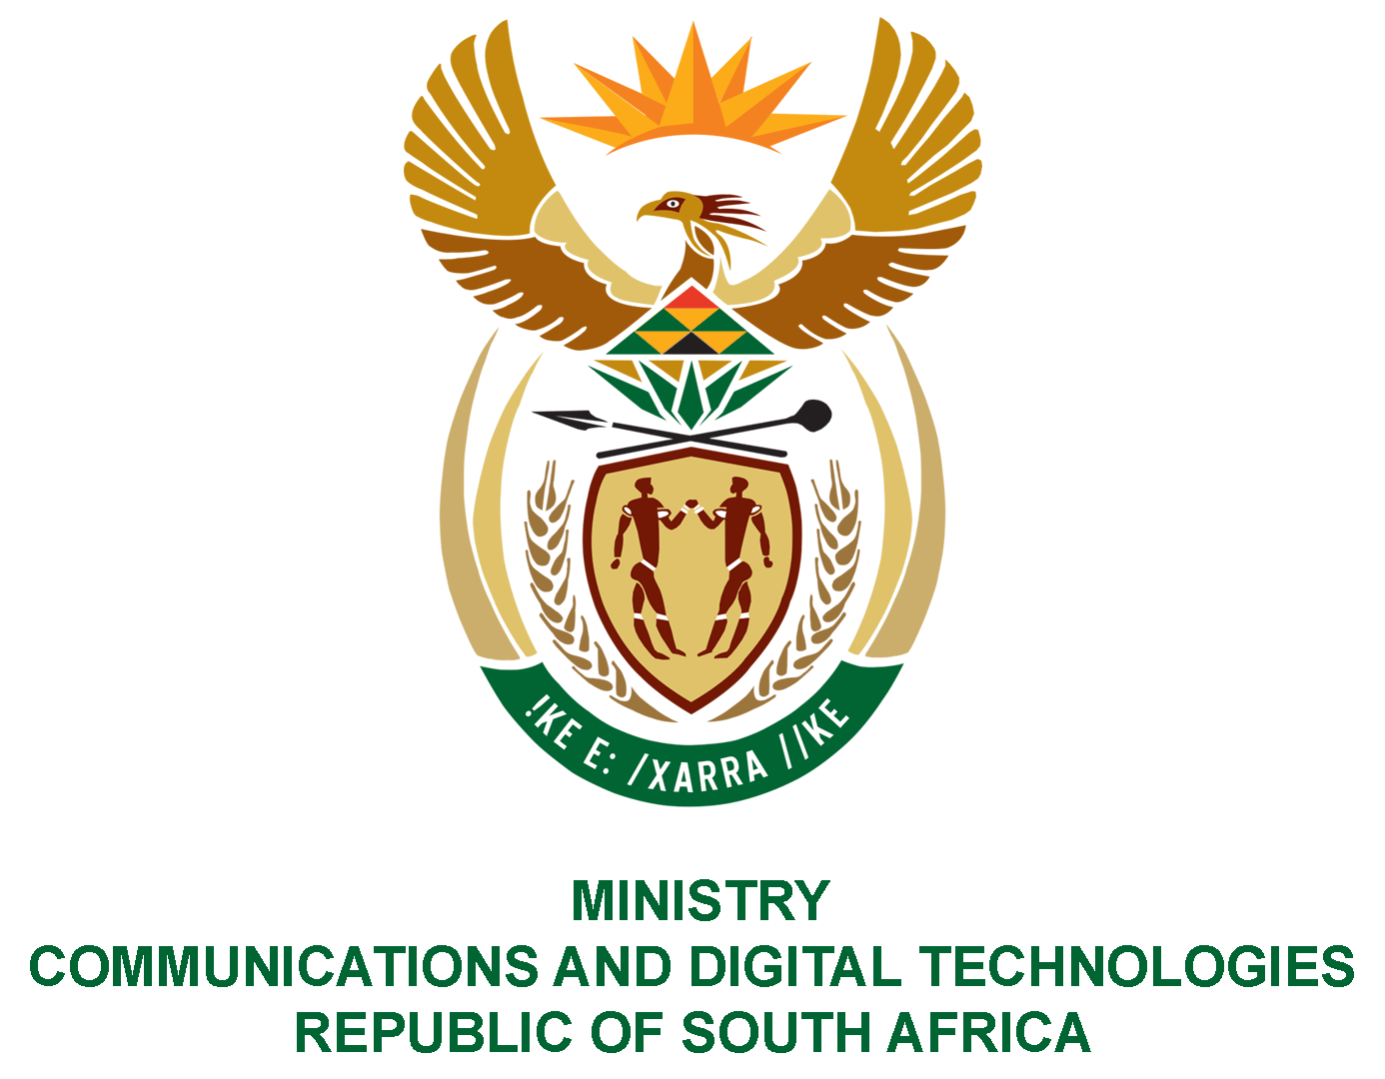

PARLIAMENT OF THE REPUBLIC OF SOUTH AFRICA

NATIONAL ASSEMBLY

WRITTEN REPLY

QUESTION: 1076

DATE OF PUBLICATION: 25 MARCH 2022
QUESTION PAPER NO: 12

Mr M S Malatsi (DA) to ask the Minister of Communications and Digital Technologies:

What amount does (a) State Information Technology Agency, (b) Broadband Infraco, (c) the Independent Communications Authority of South Africa and (d) Sentech, owe the (i) Tshwane Metropolitan Municipality, (ii) Johannesburg Metropolitan Municipality and (iii) Ekurhuleni Metropolitan Municipality for (aa) water, (bb) rates and (cc) electricity as at 7 March 2022?
NW1323E

REPLY:
I have been advised by the SOEs as follows:
- State Information Technology Agency (SITA):
- Tshwane Metropolitan Municipality account is up to date.
- Not applicable.
- Not applicable.

- Broadband Infraco (BBI):
(i-iii) The BBI does not owe any of the Municipalities in question.

- Independent Communications Authority of South Africa (ICASA)
(i-iii) ICASA does not owe any of the Municipalities in question.

- Sentech
- As at 7 March 2022, Sentech owed the Tshwane Municipality R1 221 722.00. This amount was subsequently paid off.
- Johannesburg Municipality was owed R724 934.89 and this amount was paid off on 18 March 2022.
- Not applicable.

Authorised for submission by

MS. NONKQUBELA JORDAN-DYANI
DIRECTOR-GENERAL (ACTING)
DATE:

Recommended/not recommended

__________________________
HON. PHILLY MAPULANE, MP
DEPUTY MINISTER OF COMMUNICATIONS AND DIGITAL TECHNOLOGIES
DATE:

Approved/ not approved

________________________________
HON. KHUMBUDZO NTSHAVHENI, MP
MINISTER OF COMMUNICATIONS AND DIGITAL TECHNOLOGIES
DATE:

