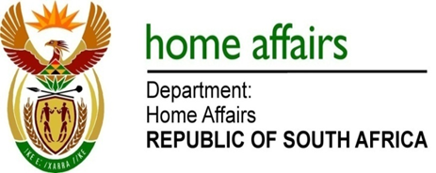

NATIONAL ASSEMBLY

QUESTION FOR WRITTEN REPLY

QUESTION NO. 1069

DATE OF PUBLICATION: FRIDAY, 20 APRIL 2018

INTERNAL QUESTION PAPER 12 OF 2018

1069. Mrs H O Mkhaliphi (EFF) to ask the Minister of Home Affairs:

(1) What are the details of the permits of employees of a certain company (name furnished) hired by SA Airways,

(2) do the specified permits allow the employees of the company to work in the country; if not, what legal action will his department take against the employees? NW1159E

REPLY:

The Visa Adjudication System (VAS) is not designed to keep statistics according to company names. The system keeps records of applicants’ details in a unique identification code, commonly known as a reference number. Only through these details would the Department be in a position to retrieve the original application and explain each decision.

