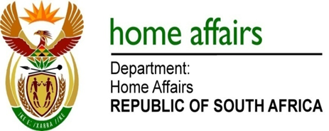

NATIONAL ASSEMBLY

QUESTION FOR WRITTEN REPLY

QUESTION NO. 1065

DATE OF PUBLICATION: FRIDAY, 20 APRIL 2018

INTERNAL QUESTION PAPER 12 OF 2018

1065. Mr M G P Lekota (Cope) to ask the Minister of Home Affairs:

(1) Whether he was aware or has been informed of negotiations and any agreement between certain parties (details furnished); if not, what is the position in this regard; if so,

(2) Whether these negotiations influenced the decision making processes of his department in this matter; if not, what is the position in this regard; if so, what are the relevant details? NW1154E

REPLY:

- No, the Minister of Home Affairs was not aware or informed of negotiations between the parties mentioned by the Honourable Member.

- Not applicable.

