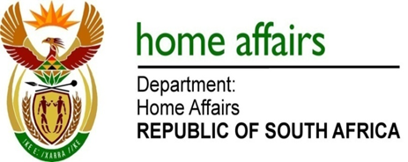

NATIONAL ASSEMBLY

QUESTION FOR WRITTEN REPLY

QUESTION NO. 106

DATE OF PUBLICATION: THURSDAY, 8 FEBRUARY 2018

INTERNAL QUESTION PAPER 1 OF 2018

106. Ms L V James (DA) to ask the Minister of Home Affairs:

With reference to the reply to question 3517 on 24 November 2017, (a) what number of asylum applications were approved out of a total of 35 377 applications and (b) what (i) was the nationality of each person whose application was approved and (ii) were the reasons given for applying for asylum in each case? NW112E
REPLY:

- Newcomers for 2016 was 35 377 and during the same reporting period 3157 applications were approved.

(b)(i) The following countries were approvals during the 2016 reporting period, Algeria, Angola, Bangladesh, Benin, Burundi, Cameroon, Congo, DRC, Eritrea, Estonia, Ethiopia, Ivory Coast, Kenya, Palestine, Rwanda, Somalia, Sudan, Syria, Turkey, Uganda, Zambia, Zimbabwe

(b)(ii) The vast majority of approved cases is for family joining, re-unification with some of the other reasons noted below:
- Persecution on political opinion
- Parent (s) and /or brother (s) and / or sister (s) killed
- Civil war and political instability
- Religion
- External aggression

