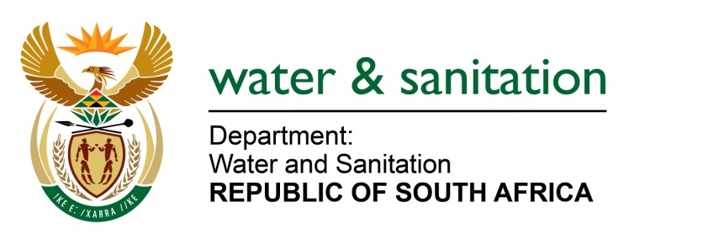

NATIONAL ASSEMBLY

FOR WRITTEN REPLY

QUESTION NO 1058

DATE OF PUBLICATION IN INTERNAL QUESTION PAPER: 5 MAY 2017
(INTERNAL QUESTION PAPER NO. 15)

1058. Mr T R Majola (DA) to ask the Minister of Water and Sanitation:
Whether the Public Protector conducted an investigation into Mhlathuze Water in the period 1 January 2008 to 31 December 2010; if so, (a) what was the purpose of the investigation and (b) on what date will the final report be available to the public? NW1190E

---00O00---
REPLY:
No, the Public Protector did not conduct an investigation on Mhlathuze Water Board during the period 01 January 2008 to 31 December 2010.
---00O00---

