MINISTRY: COMMUNICATIONS
REPUBLIC OF SOUTH AFRICA
Private Bag X 745, Pretoria, 0001, Tel: +27 12 473 0164 Fax: +27 12 473 0585
Tshedimosetso House,1035 Francis Baard Street, Tshedimosetso House, Pretoria, 1000

NATIONAL ASSEMBLY
QUESTION FOR WRITTEN REPLY
QUESTION NUMBER: 1058
DATE OF PUBLICATION: APRIL 2016

Ms V van Dyk (DA) to ask the Minister of Communications:
(1)(a) What are the details of the model that the Media Development and Diversity Agency (MDDA) uses to allocate funding for community (i) print media and (ii) projects, (b) how are the allocations done and (c) what are the criteria for each allocation made; (2) whether at least three separate quotations are asked from printers before allocations are considered by the MDDA for the printing of magazines and/or newspapers of community print media projects; if not, how are the allocated amounts determined; if so, what are the relevant details; (3) whether at least three separate quotations are requested for (a) office rentals and (b) furniture that needs to be bought for each community (i) print media and (ii) radio project before funding allocations are considered by the MDDA; if not how does the MDDA allocate the money in each case; (4) does the applicant provide projected costs and/or monthly expenditure analysis to the MDDA when applying for funding; if not, why not; if so, how is it compiled; (5) does the applicant need any business skills and/or background before being considered for funding by the MDDA; if not, do all applicants receive basic financial training? NW1191E

REPLY: MINISTER OF COMMUNICATIONS

(a)(i) and (ii)
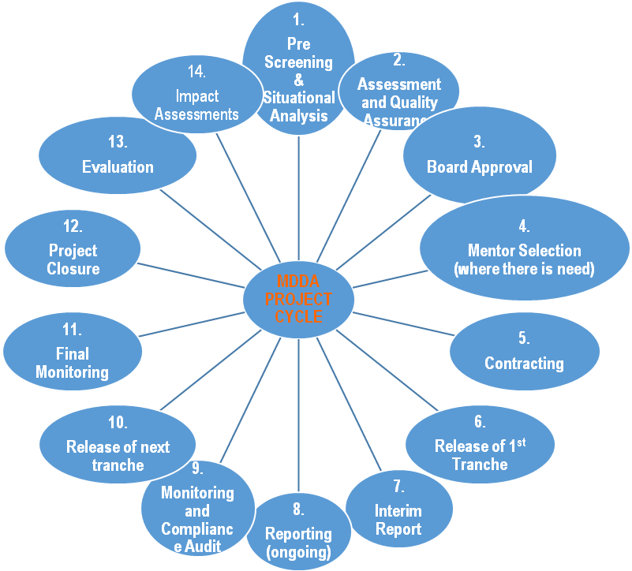

(b) The allocation is done based on the applications received and budget available in the specific financial year.
(c) The criteria for funding is listed on the application forms that are easily downloadable from the MDDA website. Screening of the applications received is guided by the funding guidelines and criteria, which are based on the mandate of the MDDA as stipulated in Section 3 of the MDDA Act of 2002. These guidelines and criteria are also posted on the MDDA website for easy reference by the applicants. Please refer:
ttp://www.mdda.org.za/Application%20Requirements%20for%20MDDA%20F unding.pdf

2. Every financial year the MDDA engages the major national printing houses and negotiates printing discounts for all of its supported publications. These printing houses include CAXTON, PAARLCOLDSET and RISING SUN. The discounted rates range between 10% and 20% of the normal printing price, depending on the print run of each publication. During assessment of applications and engaging projects on budgeting, publishers are alerted to these discounts and are able to select a printer of their choice. The nearest printer to the publication is always a preferred option to avoid transport costs and the amount will be the discounted rates as quoted by the printers.
3. (a)(i) The MDDA research unit has compiled a standardised cost structure on rental, which acts as a guide.. The applicant advises on the area in which the office will be located, and an assessment is done on the standard rates of rental costs in the area. An estimate is recommended for approval, to which the beneficiary will be obliged to adhere to during implementation.
(a)(ii) The MDDA research unit has compiled a standardised cost structure on rental, which acts as a guide. The applicant advises on the area in which the office will be located, and an assessment is done on the standard rates of rental costs in the area. An estimate is recommended for approval, to which the beneficiary will be obliged to adhere to during implementation
(b)(i) The MDDA research unit has compiled a standardised cost structure on furniture and equipment, which acts as a guide. During on-site assessment, which involves budgeting, projects are engaged on these standardised costs from major retailers and the publisher advises which retailer is nearest, e.g. Game, Incredible Connexion etc. On approval, the Grant in Aid Agreement includes a clause which obliges the grantee to source three different quotes before procuring any equipment or furniture and purchase from the lowest bidder.
(b)(ii) The MDDA research unit has compiled a standardised cost structure on furniture and equipment, which acts as a guide. During on-site assessment, which involves budgeting, projects are engaged on these standardised costs from major retailers and the publisher advises which retailer is nearest, e.g. Game, Incredible Connexion etc. On approval, the Grant in Aid Agreement includes a clause which obliges the grantee to source three different quotes before procuring any equipment or furniture and purchase from the lowest bidder.
4. The applicants submit an application form together with a business plan amongst the documents required as part of compliance. If the applicant meets the criteria but the business plan does not have three year financial projections, the applicant will be required to submit these projections before an assessment is conducted on the project. During assessment, the MDDA official will probe these financial projections and all matters relating to sustainability plans. These form part of the Project Justification Reports that are submitted to the MDDA Board during adjudication. The Grant in Aid Agreement includes Annexure A - the Schedule of Particulars, which provides a detailed guide on how the funds will be spent over four tranches. These tranches are allocated over a cycle of 12 months, and if, at any time during this cycle, the project has not complied, corrective measures are put in place as provided in the Grant in Aid Agreement.
5. Applicants are required to submit, amongst other documents, their profiles or CVs; this also includes the copies or samples of their publications. Consideration is given based on the strength of the motivation, which includes the area in which the project will be based, and the experience, skills or qualifications demonstrated by the applicant. Business skills/background of the applicant is always an added advantage but not a deterrent. Experience in the publishing sector or media related qualifications are an added advantage. In instances where it has been identified that there are weakness in the applicant, but the project has strong relevance to Section 3 of the MDDA Act, the officer assessing the project may recommend that a mentor be allocated to the project for a certain period or recommend training.

MR NN MUNZHELELE
DIRECTOR GENERAL [ACTING]
DEPARTMENT OF COMMUNICATIONS
DATE:

MS AF MUTHAMBI (MP)
MINISTER OF COMMUNICATIONS
DATE:

