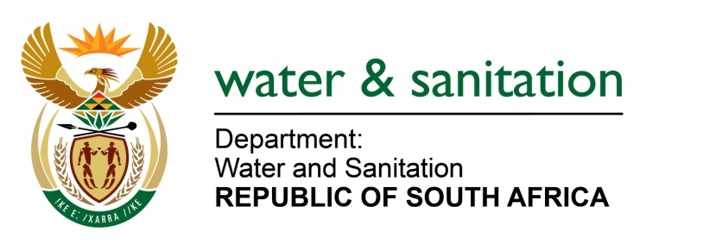

NATIONAL ASSEMBLY

FOR WRITTEN REPLY

QUESTION NO 1057

DATE OF PUBLICATION IN INTERNAL QUESTION PAPER: 5 MAY 2017
(INTERNAL QUESTION PAPER NO. 15)

1057. Mr T R Majola (DA) to ask the Minister of Water and Sanitation:
Whether a water use licence was issued to WPB Colliery for coal mining in Mpumalanga between 2010 and 2016; if not, why not; if so, was a full environmental impact assessment report made available to her department to consider the possible impact on the Elands River and Crocodile River? NW1187E
---00O00---
REPLY:
Yes, a water use license was issued to WPB Colliery on the 04 October 2015. Yes, an Environmental Impact Assessment and Environmental Management Report compiled by M2 Environmental Connections dated June 2012, was considered during the assessment of this application.
---00O00---

