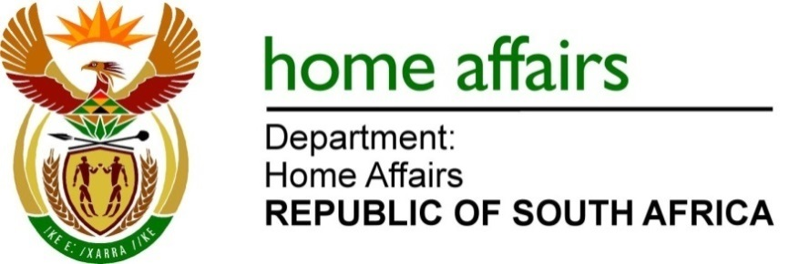
NATIONAL ASSEMBLY

QUESTION FOR WRITTEN REPLY

QUESTION NO.1056

DATE OF PUBLICATION: FRIDAY, 24 MARCH 2023

INTERNAL QUESTION PAPER 11 – 2023

1056. Adv G Breytenbach (DA) to ask the Minister of Home Affairs:

(1) Whether the SA Revenue Service laid a criminal complaint with the SA Police Service in terms of section 15 of the Customs and Excise Act, Act 91 of 1964, read with section 34(2) of the Prevention and Combating of Corrupt Activities Act, Act 12 of 2004, against the traveller, Mr Hazim Mustafa, for failing to declare his possession of currency which is an offence in terms of section 81 of the specified Customs and Excise Act; if not, why not; if so, what are the relevant details;

(2) whether the passport of the specified person will be or has been flagged at all ports of entry to the Republic; if not, why not; if so, what are the relevant details? NW1166E

REPLY:
- The Honourable member is requested to direct this question to the relevant authority, namely the South African Revenue Services.

- The relevant law enforcement authorities did not request the Department to flag Mr Hazim Mustafa’s passport, consequently, the Department is not in a legal position to flag his passport.

END

