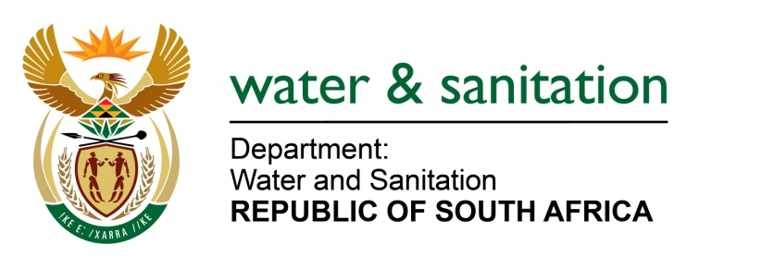

NATIONAL ASSEMBLY

FOR WRITTEN REPLY

QUESTION NO 1056

DATE OF PUBLICATION IN INTERNAL QUESTION PAPER: 5 MAY 2017
(INTERNAL QUESTION PAPER NO. 15)

1056. Mr T R Majola (DA) to ask the Minister of Water and Sanitation:

(1) Whether water use licences were issued to certain companies (names furnished) for the mining operation (a) in the Wakkerstroom area and/ (b) in any other area in the GertSibande District in Mpumalanga; if so, on what date was the water use licence issued in each case;

(2) whether a full environmental impact assessment was conducted prior to the issuing of each water use licence; if so, what are the full relevant details of the report? NW1186E
---00O00---
REPLY:
(1)(a) Yes, a licence was issued for Atha-Africa Ventures on the 07 July 2016. The property where the activity will take place is in a mining area located 58 km South West of Piet Retief within the Pixley Ka Seme Local Municipality which falls within Gert Sibande District Municipality in Mpumalanga in the W51A quaternary Catchment.
(1)(b) There are no records of any authorisation issued to Bashubile Trust.
(2) Yes, an Environment and Social Impact Assessment Report and Environmental and Social management Programme: Yzermyn Underground Coal Mine, EcoPartners, January 2015 was submitted with the application.
---00O00---

