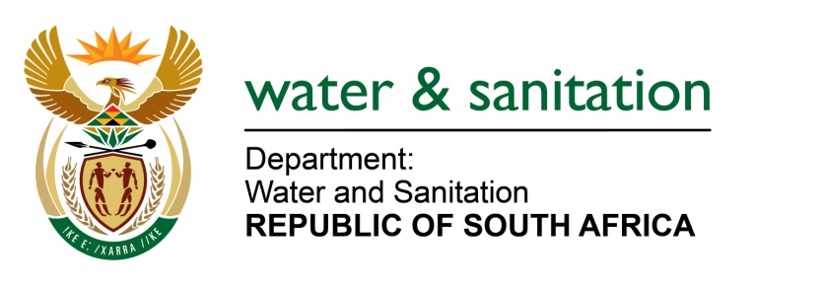

NATIONAL ASSEMBLY

FOR WRITTEN REPLY

QUESTION NO 1055

DATE OF PUBLICATION IN INTERNAL QUESTION PAPER: 5 MAY 2017
(INTERNAL QUESTION PAPER NO. 15)

(1) Whether water use licences were issued to certain companies (names furnished) for the mining operation (a) in the Wakkerstroom area and/ (b) in any other area in the GertSibande District in Mpumalanga; if so, in each case, (i) on what date was the licence issued and (ii) for which area was the licence granted;

(2) whether the specified areas are protected in accordance with the National Environmental Management: Protected Areas Act, Act 57 of 2003;

(3) whether there is any risk of water contamination of the water sources in the specified area as a result of such mining activity? NW1185E
---00O00---
REPLY:
(1) A licence was issued for Atha-Africa Ventures on the 07 July 2016. The property where the activity will take place is in a mining area located 58 km South West of Pietretief within the Pixley Ka Seme Local Municipality which falls within Gert Sibande District Municipality in Mpumalanga in the W51A quaternary Catchment. There are no records of any authorisation issued to Bashubile Trust.
(2) This property where Atha-Africa Ventures which is Ptn 1 of the farm Yzermine 96 HT has been excluded from the Mabola Protected Environment and the Surface disturbance associated with the activity will be located on the farm.
(3) New technologies, as well as best practice guidelines will be used to ensure that water use is minimal and where possible water is reused or recycled. A plan and engineering designs will be developed to ensure that cut-off Trenches/ open drains and beams separate the 1:100 clean water runoff, from the 1:50 dirty water, to divert clean runoff around the identified operational areas that may pollute water resources. The PCDs will be sized to collect the average Dirty runoff from the mining area as well as the 1:100 24 hour storm event.
---00O00---

