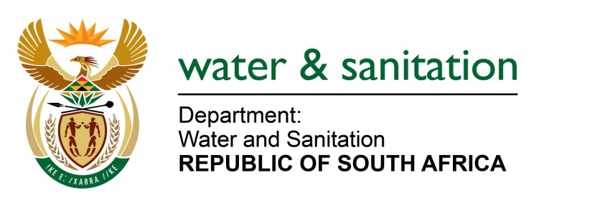

NATIONAL ASSEMBLY

FOR WRITTEN REPLY

QUESTION NO 1054

DATE OF PUBLICATION IN INTERNAL QUESTION PAPER: 5 MAY 2017
(INTERNAL QUESTION PAPER NO. 15)

1054. Ms T E Baker (DA) to ask the Minister of Water and Sanitation:

(1) Whether her department has suspended any water use licences since 1 January 2008; if so, what is the (a) name of the company and/or (b) nature of its business in each case;

(2) whether any suspensions have been appealed; if so, what is the status of the appeal in each case? NW1184E
---00O00---
REPLY:
- Yes, my Department has suspended one Water Use License during the period, April 2010 for Aganang Beef Trust, which was for agricultural water use: Irrigation.
(2) No appeal has been received by my Department thus far.
---00O00---

