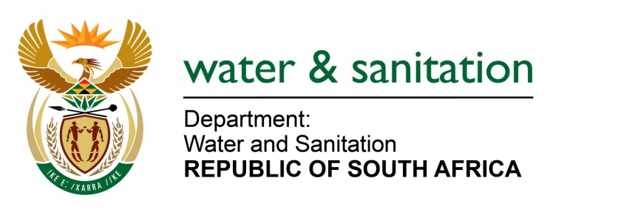

NATIONAL ASSEMBLY

FOR WRITTEN REPLY

QUESTION NO 1053

DATE OF PUBLICATION IN INTERNAL QUESTION PAPER: 5 MAY 2017
(INTERNAL QUESTION PAPER NO. 15)

1053. Ms T E Baker (DA) to ask the Minister of Water and Sanitation:
Whether the water tribunal has concluded the appeal against the granting of water use licence to a certain company WPB Colliery (Pty) Ltd in Mpumalanga; if not, by what date will the appeal be concluded; if so, will he provide a copy of the resolution to Ms T E Baker? NW1183E
---00O00---
REPLY:

No, the Appellant requested to be furnished with the reasons and documents in compliance with Item 5 (3) of Schedule 6 of the National Water Act, 1998 (Act No. 36 of 1998). That information has since been supplied to the Appellant to afford them the opportunity to supplement, vary or amplify its Appeal if they so wish. The respondent will also be given opportunity to file its Replying Statement. At the end of the exchange of papers the appeal record of proceedings will be submitted to the Chairperson of the Water Tribunal, who may give directives and also provide a date for setting the matter down. The date of finalisation of this matter is dependent on all the parties involved and not my Department alone.
---00O00---

