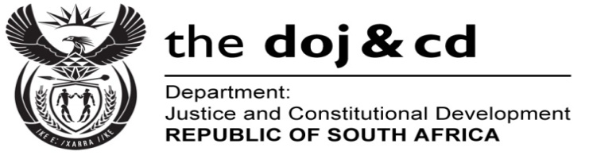
Private Bag X276, Pretoria, 0001, Tel (012) 406 4669, Fax (012) 406 4680
Private Bag X256, Cape Town, 8000, Tel (021) 467 1700 Fax (021) 467 1730
Memorandum from the Parliamentary Office
NATIONAL ASSEMBLY
FOR WRITTEN REPLY
QUESTION 1051
DATE OF PUBLICATION OF INTERNAL QUESTION PAPER: 11/04/2016

(INTERNAL QUESTION PAPER 10 OF 2016)

DATE OF SUBMISSION: 25 APRIL 2016
Mr M S Malatsi (DA) to ask the Minister of Justice and Correctional Services:

- Whether he has been requested to commission legal advice with regard to certain persons (names furnished) about possible legal consequences of travelling to Zurich, Switzerland for Fédération Internationale de Football Association (FIFA) related business; if not, has he volunteered legal advice to the specified persons in this regard; if so, (a) who requested him to commission such advice, (b) what was the detailed request in respect of each specified person, (c) on what date(s) were such requests submitted to his department, (d) what was the department’s advice and (e) what were the reasons for providing such advice in each case;
- whether his department has been in contact with FIFA regarding questions that they sent to the specified persons in relation to the US$10 million paid for the Diaspora Legacy Programme; if not, why not; if so, (a) when did his department contact FIFA, (b) what requests and submissions did his department make to FIFA and (c) what was FIFA’s response in each case;
- whether his department has contacted (a) the office of the United States Attorney-General (USAG), (b) the Federal Bureau of Investigation and/or (c) any other US-based law enforcement authority about the identity of the two South African nationals identified as co-conspirators in the USAG’s indictment on corruption and vote-buying in FIFA World Cup bids; if not, why not; if so, what was the (i) nature and (ii) content of the interactions he had with any of the US-based law enforcement authorities?
NW1184E
REPLY:

- No. I was neither approached by the Minister of Sports and Recreation nor volunteered to commission legal advice about possible legal consequences of travelling to Zurich, Switzerland for Fédération Internationale de Football Association (FIFA) related business.
- To date, the Department only received a copy of an indictment against fourteen (14) accused persons. No South African is listed as an accused person. Twenty five (25) persons are referred to, in the indictment, as co-conspirators. The co-conspirators are referred to as #1 to #25. Their names are not revealed in the indictment. It is stated that their names are known to the Grand Jury. The following details of the alleged South African co-conspirators are provided in the indictment:
- #15 was a high-ranking official of the 2006 and 2010 South African World Cup Bid Committee and member of the local South African Organizing Committee; and
- #16 was also a high-ranking official of the 2006 and 2010 South African World Cup Bid Committee and member of the local South African Organizing Committee.

To date, the Department did not receive any further communication regarding the matter from the authorities of the United States of America.

The Department is not aware of any questions sent to any persons.

- The Department did not contact the authorities of the United State of America. The indictment was forwarded to the Ministers of Sports and Recreation, International Relations and Cooperation, and Planning, Monitoring and Evaluation, as well as Directorate for Priority Crime Investigation for their information and consideration for the way forward.

