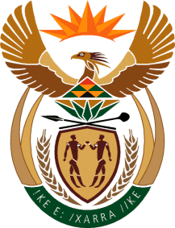

MINISTRY OF TOURISM
REPUBLIC OF SOUTH AFRICA

Private Bag X424, Pretoria, 0001, South Africa. Tel. (+27 12) 444 6780, Fax (+27 12) 444 7027
Private Bag X9154, Cape Town, 8000, South Africa. Tel. (+27 21) 469 5800, Fax: (+27 21) 465 3216

NATIONAL ASSEMBLY:

QUESTION FOR WRITTEN REPLY:
Question Number: 1050
Date of Publication: 24 March 2023
NA IQP Number: 11
Date of reply:

Ms H Ismail (DA) to ask the Minister of Tourism:
(a) What total number of invoices were not paid within 30 days and (b)(i) what consequence management tools are being used by her department to ensure that invoices are paid within 30 days and (ii) how effective has she found the specified consequence management tools to be? NW1160E

REPLY:

(a)
I have been informed by the Department that the information is still to be audited for the 2022/23 financial year.

(b) (i) The Office of the CFO issued non-compliance letters for invoices that exceeded 30 days. Supervisors discussed the non-compliance with affected employees. In cases where an employee was at fault, a verbal warning was issued and in some cases further travel by affected employee was suspended until the matter was resolved. In cases of repeat offenders, written warnings were issued.

(ii) The approach to consequence management will be strengthened through introducing disciplinary measures in cases of repeat offenders.

