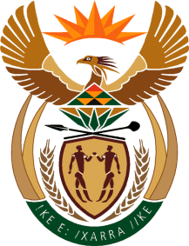

MINISTRY OF TOURISM
REPUBLIC OF SOUTH AFRICA

Private Bag X424, Pretoria, 0001, South Africa. Tel. (+27 12) 444 6780, Fax (+27 12) 444 7027
Private Bag X9154, Cape Town, 8000, South Africa. Tel. (+27 21) 469 5800, Fax: (+27 21) 465 3216

NATIONAL ASSEMBLY:

QUESTION FOR WRITTEN REPLY:
Question Number: 105
Date of Publication: 28 June 2019
NA IQP Number: 2
Date of reply: 12 July 2019

Mr K P Sithole (IFP) to ask the Minister of Tourism:

Whether, with reference to tourism being one of the drivers of the economy, her department has a system in place to encourage transformation in the tourism sector, particularly with regard to providing job opportunities; if not, what is the position in this regard; if so, what are the full relevant details? NW1062E

Reply:

In line with National Tourism Sector Strategy (NTSS), the efforts to grow tourism have in the main two interrelated priorities, which are inclusive growth and sector transformation. Inclusive growth will bring about employment creation, investment and GDP contribution. In this regard, in partnership with the industry and other stakeholders we will increase the number of tourists to our country and their expenditure on related goods and services during their trips. Government overall has also highly placed tourism on the priority list and a whole-of-government approach to tourism development and promotion will be applied to maximise on our growth potential. On transformation, there are a number of initiatives aimed at increased participation of black people in sector. These are access to finance, development of capabilities of South Africans in particular youth and women across the tourism value chain, enterprise and supplier development, and implementation of the B-BBEE tourism sector codes of good practice. The department will continue to take advantage of the expanded Public Works Programme to empower youth through development of skills while they also earn a stipend wage through job opportunities.

