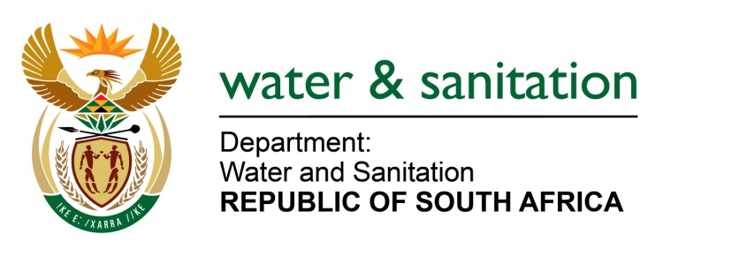

NATIONAL ASSEMBLY

FOR WRITTEN REPLY

QUESTION NO 1049

DATE OF PUBLICATION IN INTERNAL QUESTION PAPER: 18 MARCH 2022
(INTERNAL QUESTION PAPER NO. 11)

1049. Ms R N Komane (EFF) to ask the Minister of Water and Sanitation:
Whether his department has any programme and/or plans to eradicate pit toilets in the Free State; if not, why not; if so, what are the details of the programme?
NW1296E
---00O00---
MINISTER OF WATER AND SANITATION

The Department does not have a specific program to eradicate pit toilets. The role of the department is to provide financial support to municipalities to enable progressive eradication of pit toilets.

Local water supply and sanitation services are a function over which municipalities have executive authority in terms of section 156 of the Constitution read together with Schedule 4 Part B. However, although municipalities have executive authority, other sections of the Constitution and legislation requires government (national and provincial) to support municipalities and intervene where there is failure of water and sanitation services:

The Water Services Authorities should, on the basis of its Water Services Development Plans (WSDP’s) and Integrated Development Plan (IDP) prioritise the provision of water and sanitation and eradicate sanitation backlogs within communities.

Water Services Authorities have access to the Municipal Infrastructure Grant (MIG) from the Department of Cooperative Governance and Traditional Affairs and or Water Services Infrastructure Grants (WSIG) from the Department of Water and Sanitation to fund such projects. The WSIG and MIG allocations for the Free State Province for the financial year 2022/23 are R393 237 million and R844 877 million respectively.

---00O00---

