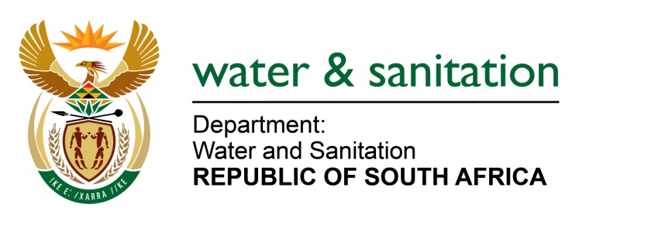

NATIONAL ASSEMBLY

FOR WRITTEN REPLY

QUESTION NO 1046

DATE OF PUBLICATION IN INTERNAL QUESTION PAPER: 18 MARCH 2022
(INTERNAL QUESTION PAPER NO. 11)

1046. Ms N Tafeni (EFF) to ask the Minister of Water and Sanitation:
In light of the fact that the (a) Buffalo City and (b) Nelson Mandela Metropolitan Municipalities in the Eastern Cape have been facing water challenges over the past two months, with the water declared unsuitable for human consumption at some stage, what steps has he taken to resolve these problems?
NW1293E
---00O00---

MINISTER OF WATER AND SANITATION

The Buffalo City Metropolitan Municipality (BCMM) is both the Water Services Authority (WSA) and the Water Services Provider (WSP) in the Buffalo City area. Amatola Water manages bulk infrastructure and provides bulk water into some areas of Buffalo City.
Following the repeated complaints of water outages and water discoloration in East London and surrounding areas; the Department of Water and Sanitation (DWS) engaged the Metro and undertook site visits to the uMzonyana Water Treatment Works and affected areas.
The following has been done to remedy the situation:

- The Executive Mayor of the BCMM, has convened a Technical Task Team (TTT) under the leadership of the City Manager, comprising officials of BCMM, the Department of Water and Sanitation (DWS), Amatola Water and co-opted specialists.
- The technical task team has prepared an action plan to address the concerns against which progress can be monitored.
- The DWS has further provided five (5) road water tankers for a period of one month to assist with emergency water delivery where reservoirs were empty.
- The DWS has temporarily lifted water restriction notice for one month to both the Metro and Amatola Water Board to ensure that the system stabilises. However, there is vigorous monitoring of the water use against restricted allocations to avoid system failure.
The primary objective of these interventions is to facilitate co-operation and to ensure that operational glitches are minimised. It is also to ensure that water distribution and reservoir levels can be stabilised and restore confidence in the capacity of the Buffalo City to deliver water services to communities. Both the BCMM and Amatola Water participate in the DWS’ monthly Drought Monitoring Committee for the Amathole Water Supply System.
With regard to the Nelson Mandela Bay Metropolitan Municipality (NMBM), the Municipal Health Department, along with municipal Scientific Services found drinking water failures had occurred and issued a boil water notice to their water users. The Department of Water and Sanitation (DWS) performed its own tests and monitoring to confirm the status of water complaints in Gqeberha, even though these failures were drought related emanating from elevated turbidity caused by low reservoir levels preventing periodic scouring as required. The resultant turbid water failed to comply with the national standard for drinking water quality (SANS 241) necessitating the issuing of a preventative boil water alert. The laboratory analyses indicated the presence of associated higher total coliforms in the areas of contaminated reservoirs but no prevalence of E-coli (which is the general indicator of bacterial and faecal contamination). In addition, there was no indication of the presence of Salmonella typhi which underlines the finding that there was no Typhoid present in the Nelson Mandela drinking water.
The DWS has supported the NMBMM to isolate the Grassridge Temporary Water Treatment Plant from use and to remove the sludge build-up manually. However, the Temporary Water Treatment Works (WTW) needs to be put back into service soon, as the Metro continues to over abstract from the Algoa WSS Dams on the Western Side. The Metro has also increased chlorine dosing at all WTW and all bulk and distribution reservoirs.

The prolonged and severe drought has placed a lot of pressure on the water supply system in the NMBM. In addition, water reservoir levels remain low, and the risk of distribution interruptions is still high. The DWS has facilitated the return to site of the contractor and Implementing Agent, so that Phase 3 of Nooitgedagt-Coega Low Level Scheme can be completed and commissioned without any further delay. This will see an additional 70ML/d of clean water to the existing NMBM system.

---00O00---

