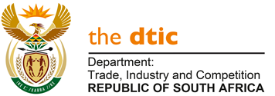

THE NATIONAL ASSEMBLY

QUESTION FOR WRITTEN REPLY

QUESTION NO. 1045
Mr D W Macpherson (DA) to ask the Minister of Trade, Industry and Competition: Whether he has convened any Ministers and Members of Executive Councils meetings since the start of the national lockdown to curb the spread of Covid-19; if not, why not; if so, (a) on what date was each meeting held and (b) what was on the agenda of each meeting? NW1335E

REPLY
Since the start of the national lockdown, engagements with members of the Provincial Executive Councils included the following:
- Meetings convened by the Presidency and attended with Premiers, on discussions related to the Covid-19 pandemic were held as follows:
- 4 April,
- 18 April,
- 16 May, and
- 17 June.

- Discussions were held between Deputy Ministers and Provincial MECs in May/June 2020, to discuss the regulation of liquor sales under Lockdown Level 3.

- A meeting of the Ministry with the MECs in the Economic Development Portfolio was held on 17 June 2020, covering a briefing on Covid-19 recovery plans at provincial level and views on the sale of alcohol.

-END-

