NATIONAL ASSEMBLY
FOR WRITTEN REPLY QUESTION 1043
DATE OF PUBLICATION IN INTERNAL QUESTION PAPER: 7 MAY 20 (INTERNAL QUESTION PAPER NO 12-2021)

1043. Dr P J Groenewald (FF Plus) to ask the Minister of Police:

1. Whether any screening of SA Police Service members is taking place for placement in the anti-gang unit; if not, why not; if so, what are the criteria for such placement;
2. whether members of the relevant unit are subjected to Integrity tests on a regular basis, to determine if they were bribed by gangs; il not, why not; if so, what are the relevant details of the tests;
3. whether he will make a statement on the matter? NW1226E

REPLY

(1) and (2) Yes, screening is taking place and includes profiling, disciplinary screening, criminal record screening and an lnkwazi search. The following minimum requirements/criteria are applicable for the placement of members, in the Anti-Gang Units:
Visible Policing:
Must be in possession of a valid driver's licence.
Must undergo psychometric testing.
Competence In system-related courses (Investigation Case Docket Management System (ICDMS)/Case Administration System (CAS), Circulations/Criminal Record Information Management (CRIM) System/firearm competence, etc.).
A minimum of one year investigation experience.
Placement is subject to six month’s probation, where screening of the member wlll be compulsory;
Must be subjected to a Net Worth Analysis and Financial Disclosure is compulsory.
May be subjected to a Lifestyle Audit at any time.
Vetting at the level of secret to be done.
Must not be a member of a gang or have any gang-related tattoos.
Detective Service:
Same as above for visible Policing, with the Inclusion of the following requirements:
Must be a Detective with Detective Service Training (Detective Course, Dete4ive Learning Programme (DLP), Resolving of Crime (ROC), etc.
Commanders should have undergone a Detective Commanders Course.
Commanders should have a minimum of three years management experience within the Detective Service;

(3) Various media statements have been made, pertaining to the establishment of the Anti-Gang Units and I the need arises, further statements to this effect, will be released.

Reply to question 1043 recommended

GENERAL NATIONAL COMMISSIONER: SOUTH AFRICAN POLICE SERVICE
KJ SITOLE (SOEG)
Date: 2021-05-24
Reply to question 1043 approved/not approved

GENERAL BH CELE, MP
MINISTER OF POLICE
Date: 30/05/2021

:

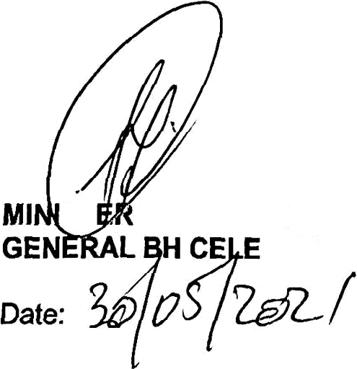
ST
OF POLICE

e8c8

Ti
GENERAL
UTH AFRICAN POLICE SERVICE
OLE, SOEG

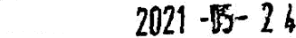
Date:

Reply to question 1043 approved,

