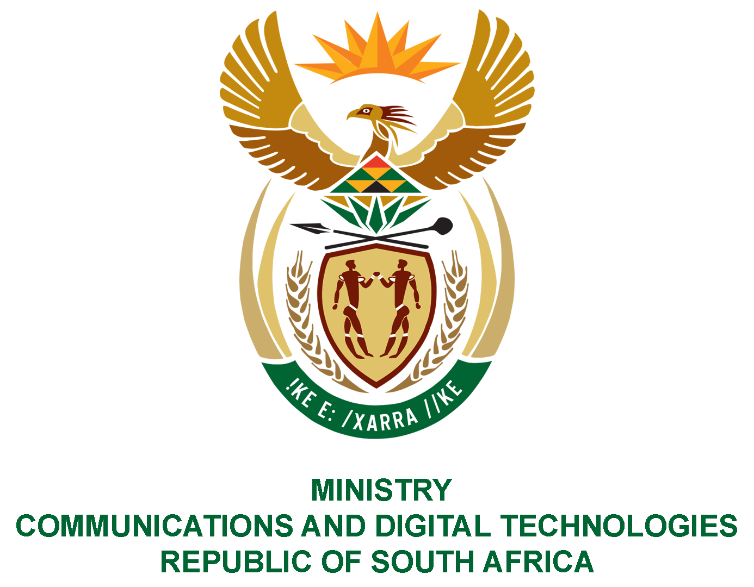
PARLIAMENT OF THE REPUBLIC OF SOUTH AFRICA
NATIONAL ASSEMBLY
WRITTEN REPLY

QUESTION NO: 1034
DATE OF PUBLICATION: 17 MARCH 2023
QUESTION PAPER NO: 11
Ms D Kohler (DA) to ask the Minister of Communications and Digital Technologies:

(1) Whether his department has taken any action against those who were implicated in irregular expenditure from 1 January 2019 until 31 December 2022; if not, why not; if so, what total number of employees have been (a) found to have incurred irregular expenditure and (b)(i) dismissed and (ii) criminally charged;

(2) what are the consequences for any individual who takes part in corrupt activities and/or misconduct within his department? NW1144E
REPLY:

- Yes
- Three (3) and the fourth one is underway.
- (i) Nil (0)
- (ii) Nil (0)

- Individuals are subjected to a disciplinary hearing.

Thank You.

