National Assembly

Question Number: 1034

Mr M H Redelinghuys (DA) to ask the Minister of Transport:
Whether there are any plans to extend the network of A Re Yeng, the Tshwane Bus Rapid Transit system, to (a) Atteridgeville, (b) Ga-Rankuwa, (c) Mamelodi, (d) Soshanguve, (e) Mabopane, (f) Winterveldt and/or (g) Temba; if not, why not in each case; if so, in each case, what are the (i) relevant details, (ii) current timeframes and (iii) anticipated date for (aa) infrastructure development and (bb) roll out of services to each of the specified areas?

BACKGROUND

In 2011, the City of Tshwane (CoT) Mayoral Committee approved the Phase 1 report for the implementation of the BRT system. The Phase 1 network design comprises two trunk line services and numerous feeder services supplemented by a comprehensive NMT network. The trunk line service is divided into two (2) sections namely:

- Line 1 – Pretoria CBD to Kopanong and
- Line 2 – Pretoria CBD to Mahube Valley.

The trunk network is comprised of approximately 69 km (refer to Figure 1) of median dedicated trunk infrastructure and low floor median trunk stations. The BRT network integrates with the rail network at five key railway stations, these being Kopanong, Wonderboom, Pretoria Station, Hatfield as well as Denneboom. This provides for multimodal service integration to the North as well as the East of Pretoria CBD.

Furthermore, in February 2016 the CoT Mayoral Committee approved Line 3 evaluation report study which contains the BRT alignment between Pretoria CBD and Atteridgeville. The route alignment is 14.6km in length and integrates with the rail network at Saulsville rail station. Figure 1 shows A Re Yeng alignments.

The details below are based on Division of Revenue Act’s Public Transport Network Grant allocation.
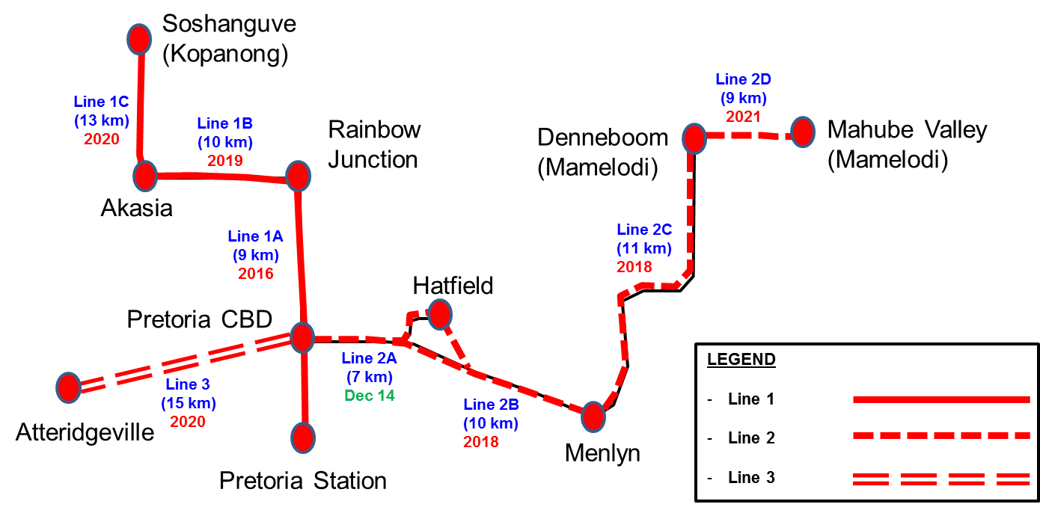

Figure 1: A Re Yeng Alignment

Intermodal Facilities

Six public transport intermodal facilities are planned along the BRT network. This will allow for the affected operators (i.e. minibus taxi associations and bus operators) to transfer passenger to A Re Yeng services. The CoT is on the process of entering into agreement with affected operators to provide the feeder service between the suburbs/township and intermodal facilities.

The public transport intermodal facilities are earmarked at the following nodes:

- Kopanong,
- Wonderboom,
- Akasia,
- Saulsville,
- Pretoria Station,
- Menlyn, and
- Denneboom.

Current A Re Yeng Operations

A Re Yeng inception phase (Line 2A) which operates between Pretoria CBD and Hatfield became operational in December 2014. The construction of A Re Yeng trunk route between Pretoria CBD and Wonderboom / Rainbow Junction (Line 1A) is underway and it is anticipated to become operational in 2016. The Rainbow Junction interim minibus taxi facility is also under construction. The purpose of these facilities is to enable seamless transfer of passengers between minibus taxi operators and A Re Yeng.

Three affected minibus taxi associations were selected to transfer passengers at (Wonderboom Station) Rainbow Junction. The affected minibus taxi associations are:

- Hammanskraal Taxi Organisation (HATO);
- Ga-Mokone, Hammanskraal, Stinkwater Taxi Association (GHSTA); and
- Stinkwater Eersterust Taxi Association (SETA).

Permanent Rainbow Junction intermodal facility is planned to become operational in 2018 and additional affected operators will be required to transfer passengers at this facility.

RESPONSE

- (i),(ii) Atteridgeville

A Re Yeng services to Atteridgeville are planned to become operational in 2020. Affected operators will transfer passengers at Saulsville intermodal facility and A Re Yeng stations along the route.

(iii) (aa) (bb) Refer to Figure 1 for more details.

- (i),(ii) Ga-Rankuwa

Affected operators will provide the feeder services between Ga-Rankuwa and Akasia intermodal
facility. A Re Yeng services to Akasia are planned to become operational in 2019.

(iii) (aa) (bb) Refer to Figure 1 for more details.

- (i),(ii) Mamelodi

A Re Yeng services to Mamelodi (Denneboom Intermodal Facility) are planned to become operational in 2020. Affected operators will provide feeder services between Mamelodi township and Denneboom Intermodal Facility.

(iii) (aa) (bb) Refer to Figure 1 for more details.

- (i),(ii) Soshanguve

A Re Yeng services to Soshanguve (Kopanong Intermodal Facility) are planned to become operational in 2020. Affected operators will transfer passengers at A Re Yeng stations and at the following three intermodal facilities:

- Kopanong,
- Akasia, and
- Rainbow Junction.

(iii) (aa) (bb) Refer to Figure 1 for more details.

- (i),(ii) Mabopane

A Re Yeng services to Soshanguve (Kopanong Intermodal Facility) are planned to become operational in 2020. Affected operators from Mabopane will transfer passengers at A Re Yeng stations and three intermodal facilities at:

- Kopanong,
- Akasia, and
- Rainbow Junction.

(iii) (aa) (bb) Refer to Figure 1 for more details.

- (i),(ii) Winterveldt

A Re Yeng services to Soshanguve (Kopanong Intermodal Facility) are planned become operational in 2020. Affected operators from Winterveldt will transfer passengers at A Re Yeng stations and at the following three intermodal facilities:

- Kopanong,
- Akasia, and
- Rainbow Junction.

(iii) (aa) (bb) Refer to Figure 1 for more details.

- (i),(ii) Temba/Hammanskraal

A Re Yeng services to Rainbow Junction/ Wonderboom (Line 1A) are planned to become operational in 2016. Affected operators from Hammanskraal (i.e. HATO) will transfer passengers at Rainbow Junction interim minibus taxi transfer facility.

(iii) (aa) (bb) Refer to Figure 1 for more details.

NW1166E

