NATIONAL ASSEMBLY
36/1/4/1(201900243)

FOR WRITTEN REPLY QUESTION 1026
DATE OF PUBLICATION IN INTERNAL QUESTION PAPER: 20 SEPTEMBER 2019 (INTERNAL QUESTION PAPER NO 17-2019)

1026. Mrs M O Clarke (DA) to ask the Minister of Police:

- Whether the patrol vehicles of the Elsburg Police Station have been branded and fitted with blue lights; if not, (a) why not and (b) by what date will this be done;

- (a) what was the total cost of the recent reno\lation of the specified police station and (b) how long did the renovation project take?
NW2180E
REPLY:

(1) Yes, all the patrol vehicles of the Elsburg Police Station have been branded and fitted with blue lights.

(1)(a)(b) Not applicable.

(2)(a)(b) The old police station building was vacated, on 18 March 2019, due to a Prohibition Notice, by the Department of Labour and a new location for premises was identified, in Wadeville. There are currently no renovations at the new premises, which is situated at 100 to 102 Nagington Road, Wadeville.

Reply to question 1026 recommended/

GENERAL UTH AFRICAN POLICE SERVICE
KJ
CO
LE (SOEG)

Date: ›fI19 l6- IN 1

2

Reply to question 1026 approved/
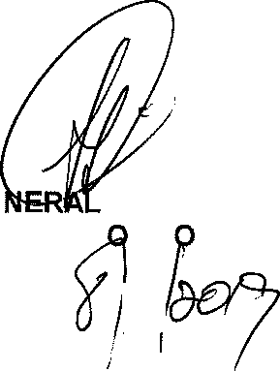
GE
BH CELE (MP)
MINISTER F P LICE

