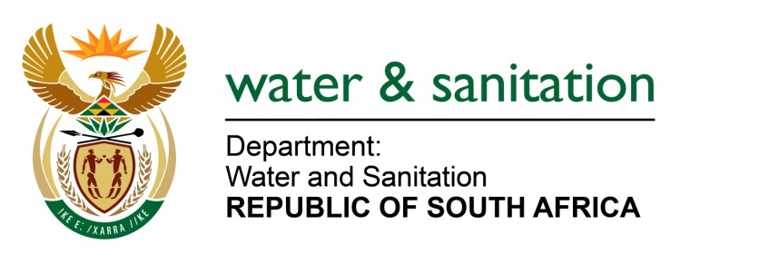

NATIONAL ASSEMBLY

FOR WRITTEN REPLY

QUESTION NO 1024

DATE OF PUBLICATION IN INTERNAL QUESTION PAPER: 11 APRIL 2016
(INTERNAL QUESTION PAPER NO. 10)

1024. Mr L J Basson (DA) to ask the Minister of Water and Sanitation:

(1) Whether her department’s investigation into alleged corruption regarding the training of youth in the Rubbytad CC project has been concluded; if not, why not; if so, (a) what were the outcomes of the specified investigation, (b) how many of her department’s officials were involved in alleged corrupt activities, (c) how many of the specified officials have been (i) suspended and/or (ii)criminally charged, (d) what amount is involved in the alleged corruption and (e) what measures have been put in place to prevent a repetition in the future;

(2) (a) what is the total amount owed to a certain company (name furnished), if any, (b) when will the outstanding amount be settled, (c) what amount has been spent on the specified project up to the latest specified date for which information is available and (d) what is the total number of youth that (i) were trained and (ii) are currently working on the project? NW1156E
---00O00---
REPLY:
(1)(a) Yes, my Department investigated the mismanagement of the project at Dr. Moroka Municipality into which Rubbytad CC was appointed as the service provider. The investigation found that there was no project governance. Investigation also revealed that one official received a sum of money from Rubbytad CC.

(1)(b) Falls away.

(1)(c) One official was suspended in the alleged corrupt activities.

(1)(d) The amount involved in the alleged corruption was Ten Thousand Rands (R 10 000.00).

(1)(e) My Department has developed a project management Framework to prevent repetition in the future.

(2)(a) Rubbytad is contracted to National Youth Skills Development Programme. Therefore, any outstanding amounts have to be established by this entity.

(2)(b) Falls away.

(2)(c) This information cannot be determined since the project was halted due to lack and unavailability of funds.

(2)(d)(i)A total of 500 Youth were enrolled (in excess of the 300 originally agreed on). Additional information cannot be disclosed as the matter is currently sub-judice.

(2)(d)(ii) Falls away.

---00O00---

