cbalie@parliament.gov.za National of Assembly

Question No: 1023

1023. Mr C H HHunsinger (DA) to ask the Minister of Transport:
Whether, with the Covid-19 demanding that we do things differently such as being more hygienic, his department has a plan to move towards cashless transactions for public transport; if not, why not; if so, (a) what are the plans and timelines for the implementation of the plan and (b) how will the plan be funded? NW1312E

REPLY

The Department has commenced with the exploratory work towards a Public Transport Mobility Account that will operated with an Integrated Ticketing System based on cashless system. SANRAL is being engaged to be a lead agency to work on the modalities of this. Initial conceptualization is illustrated in the two tables below;

Diagram No.1

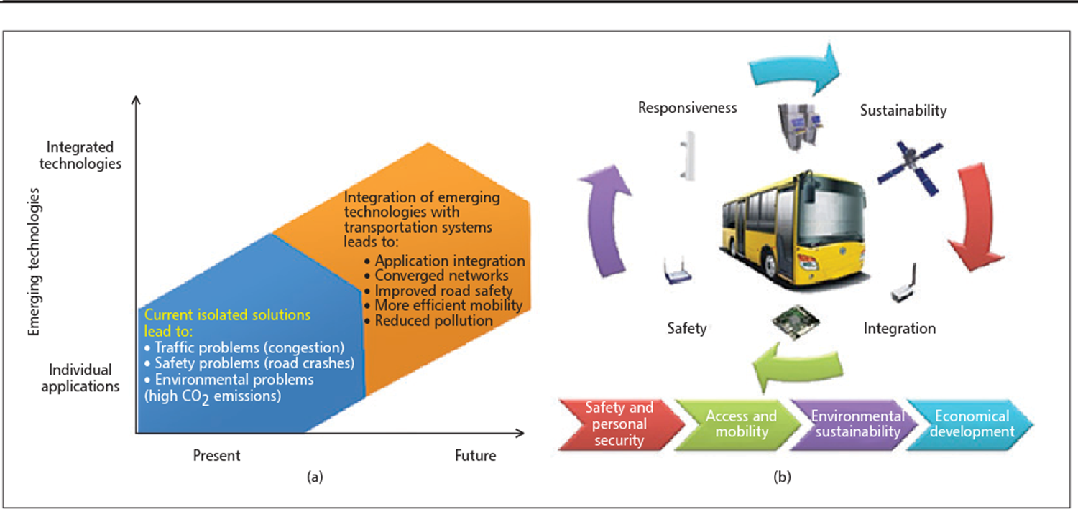
Diagram No.2
