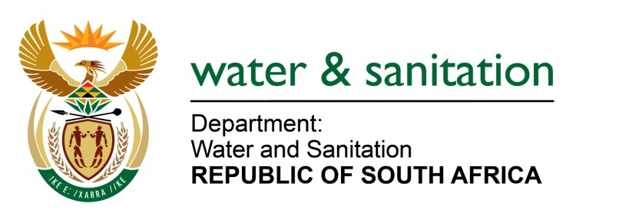

NATIONAL ASSEMBLY

FOR WRITTEN REPLY

QUESTION NO 1023

DATE OF PUBLICATION IN INTERNAL QUESTION PAPER: 11 APRIL 2016
(INTERNAL QUESTION PAPER NO. 10)

1023. Mr L J Basson (DA) to ask the Minister of Water and Sanitation:

(1) With reference to her statements made during the debate on the State of the Nation Address on 16 February 2016 in Parliament (details furnished) that plans were under way to drill new and refurbish existing boreholes, (a) how many boreholes will be drilled in each province during the next three financial years, (b) where will the specified boreholes be drilled, (c) which communities will benefit in each case and (d) what will the cost be (i) per meter for drilling and (ii) per borehole drilled;

(2) Whether her department has issued any tenders for the drilling of the specified boreholes; if not, why not; if so, (a) who has been appointed to date to (i) drill and (ii) equip the specified boreholes and (b) what is the estimated costs for each province in this regard;

(3) (a)How many existing boreholes will be refurbished, (b) at what cost and (c) where are the existing boreholes situated in each case? NW1155E
---00O00---
REPLY:

(1) Refer to the table 1 below which indicates the number of boreholes planned to be drilled in each province during the next three financial years including communities that will benefit.

It should be noted that the drilling costs are mostly dictated by the geological and drilling conditions, diameter required, required depth, and the length and type of casing installed.
Table 1: Planned Boreholes to be drilled for the financial year 2016/17-2018/19

(1)(a) Number of Boreholes to be drilled | (1)(b) Province | District Municipality | Local Municipality | (1)(c) Number of villages or communities | (1)(d) Total Estimated costs
300 | Limpopo | Capricon  Waterberg  Vhembe | Aganang  Blueberg  Molemole  Polokwane  Mokgalakwena | 191 | R287.6 million
250 | Eastern Cape | OR Tambo  Chris Hani  Alfred Nzo  Joe Gqabi  Amathole | Maletswai  Mnquma  Nyandeni  Sakhisizwe | 377 | R196.3 million
90 | Mpumalanga | Gert Sibande  Nkangala  Ehlanzeni | Lekwa  Msukalinga  Thembisile Hani  Dr JS Moroka | 62 | R44 million
200 | Northern Cape | Namakwa  ZF Mgcawu  Pixley ka Seme  JTG | Hantam  Karoo Hoogland  Richtersveld  Kammiesberg  Nama Khoi  Mier  Kareeberg  Joe Morolong | 47 | R100 million
23 | North West | Dr.Ruth Sekgomotsi Mompati  Bojanala | Moses Kotane  Moretele  Rustenburg  Kgetlengrivier  Ramotshere-Moiloa  Mahikeng  Ditsobotla  Ratlou | 185 | R 11.5 million
164 | Free State | Thabo- Mofutsanyane  Mangaung-Metro | Maluti A Phofung  Mangaung Metro  Naledi  Ngwathe  Setsoto  Nketoana  Xhariep | 120 | R82 million
16 | Western Cape | Cape Winelands  Central Karoo | Bergrivier  Witzenberg  Prince Albert | 3 | R1.6 million
190 | Kwazulu Natal | Uthukela  Zululand  Umkhanyakude  Ilembe  Harry Gwala | Jozini  Mtubatuba  hlabisa  Umhlabayingana | 272 | R42 million
(2) Tenders for drilling of the specified boreholes have not yet been issued. No service providers have been appointed to date. However my Department has advertised National Bids for Drilling, Testing, and Hydrogeological Consulting Services. The estimated costs per province are as indicated in table 1 above.

(3) Table 2 below indicates existing boreholes to be refurbished per province.

Table 2: Existing Boreholes to be refurbished per Province

(3)(a) Number of Boreholes to be refurbished | Province | District Municipality | (3)(b) Local Municipality | Number of villages or communities | (3)(c) Total Estimated costs
800 | Limpopo | Mopani  Sekhukhune | Elias Motswaledi  Makhuduthamaga  Tubatse  Greater Tzaneen | 935 | R200 million
25 | Eastern Cape | Amathole  Joe Gqabi  Chris Hani  Alfred Nzo  OR Tambo | Ingquza Hill  Matatiele  Ntabankulu  Emalahleni  Elundini  Mbhashe | 19 | R11.1 million
96 | Mpumalanga | Gert Sibande  Nkangala  Ehlanzeni | Chief Albert Luthuli  Thembisile | 67 | R34.2 million
50 | Northern Cape | Namakwa  JTG | Kammiersberg  Joe Morolong | 13 | R25 million
30 | North West | Dr Ruth Sekgomotsi Mompati  Bojanala | Moses Kotane  Moretele | 180 | R15 million
123 | Free State | Thabo- Mofutsanyane  Xhariep | Maluti A Phofung  Naledi  Ngwathe  Setsoto  Nketoana  Xhariep | 18 | R61.5 million
17 | Western Cape | Cape Winelands  Eden | Witzenberg  Oudtshoorn | 2 | R3.4 million
106 | Kwazulu Natal | Uthukela  Umkhanyakude | Jozini  Mtubatuba  Hlabisa  Umhlabayingana | 150 | R53 million

---00O00---

