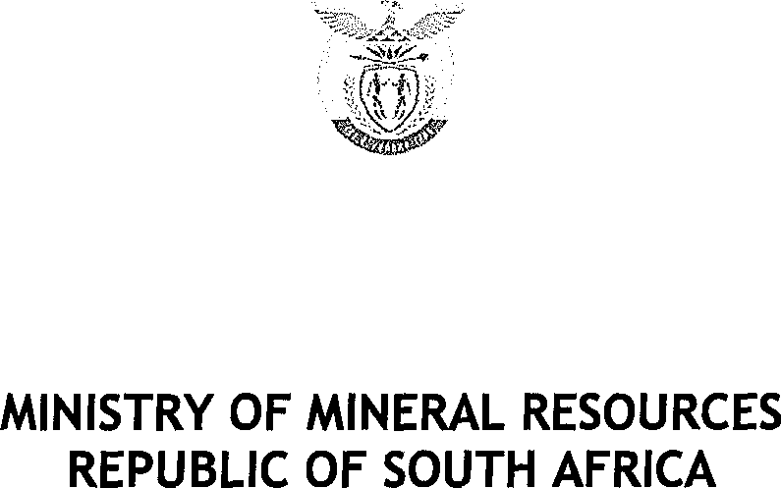

PRIVATE BAG x 59, PRETORIA, 0001, Tel (012) 444 3979, Fax (012) 444 3145
PRIVATE BAG x 9111, CAPE TOWN, 8000 (021) 462 2310, Fax (021) 461 0859
Enquiries: Carmichael Ngalo Z Carmichael.ngaloG›dmr.gov.za

Memorandum: Parliamentary Liaison Office

NATIONAL ASSEMBLY QUESTION FOR WRITTEN REPLY

QUESTION NUMBER: 1019 ADVANCE NOTICE No: NW2173E

DATE OF PUBLICATION IN INTERNAL QUESTION PAPER: 20 Sept 2019 INTERNAL QUESTION PAPER NUMBER: 17
1019. Mr K J Mileham (DA) to ask the Minister of Mineral Resources and
Energy:

- What number of mining entities, including prospecting and exploration entities, are currently in or facing business rescue;

- whether a business rescue plan has been approved in each case; if not, why not; if so, what (a) are the details in each case and (b) is the current status of each business rescue plan? Nw2173E

Reply

Regions | (1) | (2)
Mpumalanga | 05 | Business rescue plan were not submitted
Limpopo | 01 | No, It’s not our competency therefore the office cannot give a response since it’s the responsibility/competency of the Business  Practitioners.

”.%._«

MINISTRY OF MINERAL RESOURCES REPUBLIC OF SOUTH AFRICA

North West | 04 | - Programme for Community Development 10000MR, Business Rescue Plan approved and a contarctor is currently mining  - Hernic Ferrochrome 91, 308 & 396 MR> Business Rescue Plan adopted on 29/03/2019, the mining right has been ceded to Samancor Chrome Limited with the only outstanding precedent condition being the conclusion of an electricity supply agreement with Eskom.  - Shiva Uranium (228, 400 & 401MR)> Business Rescue Plan not approved,  - Horizon Chrome Mine (247 MR) > Business Rescue Plan is approved, the mine is operational
Northern Cape | 01 | Details of the business rescue plans are not share with the office by  the practitioners
KwaZulu Natal | 00
Gauten | 00
Free State | 02 | In both cases the process is still ongoing and not concluded.
Western Cape | 00
Easter Cape | 03 | The office does not have business rescue plans at this point, entities were engaged to submit copies thereof and have failed thus far.
TOTAL | 16

(1) The number of entities facing business rescue are 16

(2)

