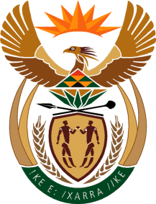

MINISTRY OF TOURISM

REPUBLIC OF SOUTH AFRICA

Private Bag X424, Pretoria, 0001, South Africa. Tel. (+27 12) 444 6780, Fax (+27 12) 444 7027

Private Bag X9154, Cape Town, 8000, South Africa. Tel. (+27 21) 469 5800, Fax: (+27 21) 465 3216

Ref: 2/1/1/10

MINISTER OF TOURISM
NATIONAL ASSEMBLY QUESTION: 1016 (NW1148E) OF 2016 BY MR J VOS (DA)
FOR WRITTEN REPLY:
REGARDING THE: SAT COUNTRY OFFICES

NATIONAL ASSEMBLY:

QUESTION FOR WRITTEN REPLY:
Question Number: 1016
Date of Publication: 11 April 2016
NA IQP Number: 10
Date of reply: 19 April 2016

Mr J Vos (DA) to ask the Minister of Tourism:
Does his department intend to cut down on the number of its SA Tourism offices located abroad with a view to preventing duplication of services; if not, what is the position in this regard; if so, (a) which offices and (b) by what date? NW1148E
Reply

No, the department does not intend to cut down the number of SA Tourism offices.
- SA Tourism continuously looks at adopting the most effective operating model in each market that allows for maximum spend in-market, on both the traveller and trade. This approach includes setting up physical country offices in core markets, the hub approach, operating virtual offices, and General Marketing Agencies (GMAs). Any office closures are considered on this principle.

- South African Tourism’s physical office in Milan will be closed in the 2016/17 financial year to maximise marketing investments across the entire South Europe territory. The Italian market will be serviced through a virtual office reporting into South Europe Hub Office based in France.

