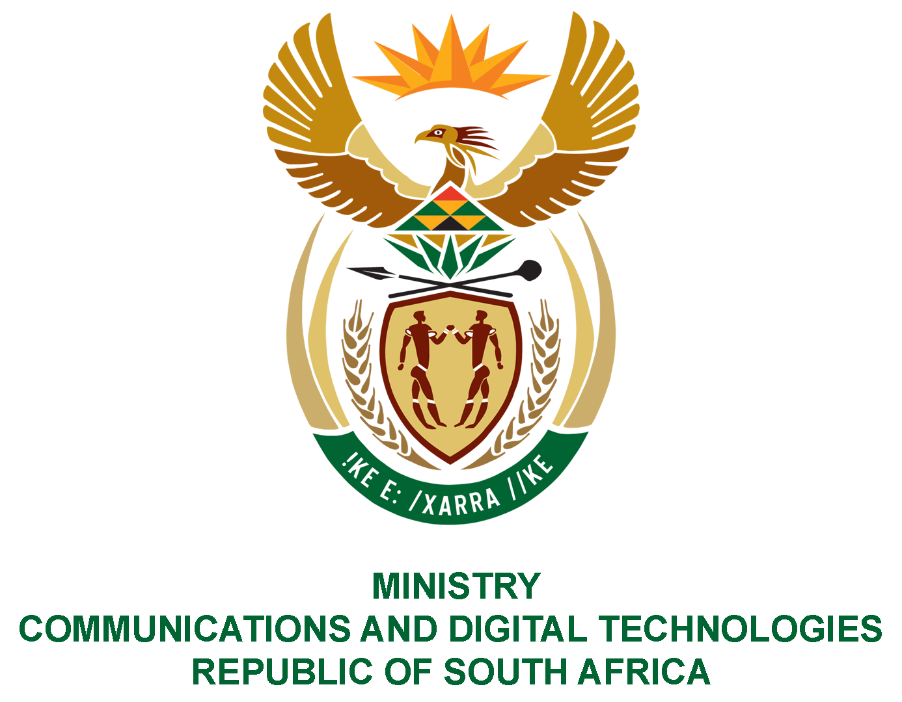
PARLIAMENT OF THE REPUBLIC OF SOUTH AFRICA
NATIONAL ASSEMBLY
WRITTEN REPLY
QUESTION NO: 1015
DATE OF PUBLICATION: 7 May 2021
QUESTION PAPER NO: 12
Mr S N August (Good) to ask the Minister of Communications:
- Whether, in light of the recent announcement by the SA Broadcasting Corporation (SABC) of its intention to publicly auction the Rocklands Villas residential property in Sea Point, Western Cape, she has considered leasing the specified building to any other government department, particularly to provide social and affordable housing within the Cape Town Central Business District; if not, why not; if so, what are the relevant details

- Whether she intends on having discussions with other government departments regarding making the best use of the property in order to address spatial justice within the society; if not, why not; if so, which government departments? NW1198E

REPLY:

- On 21 September 2020, the SABC was granted concurrent approval by the Ministers of Communications and Digital Technologies (DCDT) and Finance to dispose of 25 non-core properties including Rockland Villas through an open market auction in terms of section 54(2)(d) of the Public Finance Management Act, 1999. The concurrent approval was also granted in keeping with National Treasury’s prefunding conditions which were attached to the financial bailout allocation and turnaround plan implementation to dispose of all residential properties as the leasing of properties does not form part of SABCs core mandate.

- The Department of Human Settlements, Water and Sanitation has since submitted a request and proposal to the DCDT on 05 May 2021 for possible acquisition of the Rocklands Villas residential property based in Cape Town, Sea Point by the Housing Development Agency for human settlement development purposes. DCDT is currently facilitating engagements between the SABC, Department of Human Settlements, Water and Sanitation as well as the Housing Development Agency (HDA) seeking to find an amicable solution between the parties (SABC and the HDA).

MS. STELLA NDABENI-ABRAHAMS, MP
MINISTER OF COMMUNICATIONS AND DIGITAL TECHNOLOGIES

