NATIONAL ASSEMBLY
36/1/4/1(201900239)

FOR WRITTEN REPLY

QUESTION 1011

DATE OF PUBLICATION IN INTERNAL QUESTION PAPER: 20 SEPTEMBER 2019 (INTERNAL QUESTION PAPER NO 17-2019)

1011. Mr H Ismail (DA) to ask the Minister of Police:

- Whether there are any police reservists stationed at the Kempton Park Police Station; if so, what (a) number of police reservists are stationed at the police station and (b) is the (i) rank, (ii) number of years of service and (iii) number of hours that each reservist work in each month;

- whether any police officer stationed at the specified police station has been (a) investigated and/or (b) dismissed or prosecuted for any corrupt activities (i) in each of the past three financial years and/or (ii) since 1 April 2019; if so, what are the rele\/ant details in each case;

- whether the police officers stationed at the police station are rotated regularly to preVent them from geting too relaxed in a specific posting; if not, what is the position in this regard; if so, what are the relevant details?
NW2164E
REPLY:

(1)(a) There are 10 actiVe police reservists at the Kempton Park Police Station.

(1)(b)(i)(ii)(iii)

Rank | Number of years’ service | Monthly hours worked
R/Lt Colonel | 28 years | 16 hours
R/Lt Colonel | 32 years | 16 hours
R/Captain | 25 years | 16 hours
R/Captain | 26 years | 16 hours
R/Warrant Officer | 22 years | 16 hours
R/Warrant Officer | 25 years | 16 hours
R/Constable | 13 years | 16 hours
R/Constable | 11 years | 16 hours
R/Constable | 11 years | 16 hours
R/Constable | 11 years | 16 hours

(2)(a)(b)(i)(ii)
No police officer, stationed at the Kempton Park Police Station has been investigated, dismissed or prosecuted for any corrupt activities, in each of the past three financial years and since, 1 April 2019.

(3) Yes, the police officers stationed at the Kempton Park Police Station are rotated on a regular basis. In terms of the South African Police Service (SAPS), National Instruction, 8 of 2019, Employee Rotation in the SAPS, personnel are rotated at the discretion of the Commander, based on an assessment of operational requirements.

Reply to question 1011 recommended/id

L C OLE (S
Date: 2§]lJ -lJ- 1

ER:
GENERAL AFRCANPOLlCESERVCE

Reply to question 1011 approved e

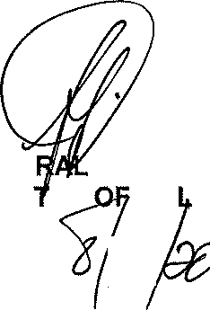
GENE
BH CELE (MP)
MINIS ER PO ICE

