FOR WRITTEN REPLY QUESTION 101

NATIONAL ASSEMBLY
36/1/4/1(201900001)

DATE OF PUBLICATION IN INTERNAL QUESTION PAPER: 7 FEBRUARY 2019 (INTERNAL QUESTION PAPER NO 1-2019)

101. Mr M S Shackleton (DA) to ask the Minister of Police:

What number of (a) cases of (i) murder, (ii) rape, (iii) housebreaking, (iv) carjacking,
(v) theft of motor vehicles, (vi) house robbery and (vii) drug-related crimes were reported at the Temba Police Station, (b) such cases were sent to court and (c) convictions were obtained for the specified cases in the past three financial years?
NW106E
REPLY:

(a)

Number of Cases Re orted at the Temba Police Station
 | 2016 | 2017 | 2018
Murder | 62 | 55 | 73
Ra e | 203 | 182 | 156
Housebreakin | 1 048 | 880 | 776
iv Car”ackin | 134 | 98 | 107
Theft of motor vehlcle | 193 | 124 | 130
House robbery | 122 | 134 | 4 33
Dru -related crimes | 1 636 | 1 968 | 2 428

(b)

Number of Cases to Court
 | 2016 | 2017 | 2018
Murder | 30 | 32 | 29
Rape | 101 | 100 | 109
Housebreaking | 159 | 110 | 106
Carjacking | 10 | 5 | 5
Theft of motor vehicle | 16 | 5 | 9
House robbery | 15 | 10 | 17
Drug-related crimes | 1 645 | 1 968 | 2 430
(c)

Number of Cases wlth Convlctlone
 | 2016 | 2017 | 2018
(i) Murder | 15 | 23 | 11
(ii) Rape | 17 | 23 | 18
(lii) Housebreaking | 22 | 29 | 11
(iv) Carjacking | 0 | 1 | 2
(v) Theft of motor vehicle | 1 | 1 | 1
cvi) House robbery | 1 | 5 | 4
(vii) Drug-related crimes | 664 | 226 | 266

2

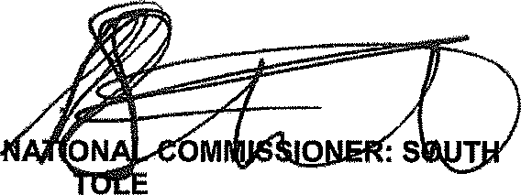
Reply to question 101 recommended/ d•

KJ SI (SOEG)

Date: t i› »- i ›
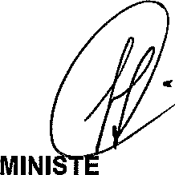
Reply to question 101 approved/

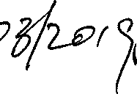R OF POLICE BH CELE, MP

Date:
GENERAL AFRICAN POLICE SERVICE

