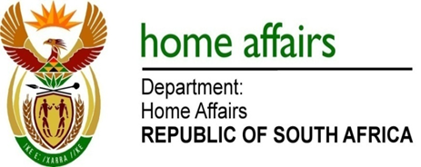

NATIONAL ASSEMBLY

QUESTION FOR WRITTEN REPLY

QUESTION NO. 1009

DATE OF PUBLICATION: Monday, 11 April 2016

INTERNAL QUESTION PAPER 10 OF 2016

1009. Mr M H Hoosen (DA) to ask the Minister of Home Affairs:

How many nationals from the African continent have been granted (a) permanent residence, (b) work and (c) business visas and (d) South African citizenship (i) in (aa) 2012, (bb) 2013, (cc) 2014 and (dd) 2015 and (ii) since 1 January 2016? NW1141E
REPLY:

Nationals from the African continent that have been granted:

(a) Permanent residence:
(i)(aa) 2012 = 209
(i)(bb) 2013 = 5984
(i)(cc) 2014 = 13594
(i)(dd) 2015 = 3565

(ii) Since 1 January 2016 = 398

(b) Work Visas:
(i)(aa) 2012 = 684
(i)(bb) 2013 = 616
(i)(cc) 2014 = 419
(i)(dd) 2015 = 1707

(ii) Since 1 January 2016 = 393

(c) Business Visas:
(i)(aa) 2012 = 474
(i)(bb) 2013 = 839
(i)((cc) 2014 = 1203
(i)(dd) 2015 = 51

(ii) Since 1 January 2016 = 2

(d) South African citizenship
(i)(aa) 2012 = 397
(i)(bb) 2013 = 846
(i)(cc) 2014 = 526
(i)(dd) 2015 = 570

(ii) Since 1 January 2016 = 129

