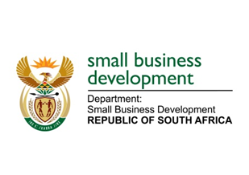
NATIONAL ASSEMBLY
QUESTION FOR WRITTEN REPLY
DUE DATE: TUESDAY, 6 APRIL 2021

“1007. Mr H C C Krüger (DA) to ask the Minister of Small Business Development:

(1) With regard to the letter from the Banking Association of South Africa dated 10 October 2020 (details furnished), what (a) total number of small-, medium-, and micro-enterprises have been successfully assisted (i) with payment breaks on credit agreements and (ii) under the loan guarantee scheme since 27 September 2020 and (b) are the relevant details of the total assistance provided;
(2) what (a) total number of requests by small-, medium-, and micro-enterprises for payment breaks on credit agreements have been denied since 27 September 2020 and (b) are the relevant details of the total assistance denied;
(3) what (a) total number of requests by small-, medium-, and micro-enterprises for assistance under the loan guarantee scheme have been denied since 27 September 2020 and (b) are the relevant details of the total assistance denied;
(4) what measures has her department put in place to ensure that more small-, medium-, and micro enterprises receive appropriate and sufficient financial assistance? NW1175E

REPLY:
(1)– (4): The Department of Small Business Development does not have the information requested as the scheme is jointly managed by National Treasury and the South African Reserve Bank. We will therefore request that this question be redirected to National Treasury.

_______________________________________________________________________________
RESPONSE RECOMMENDED BY:

_______________________
MR LINDOKUHLE MKHUMANE
ACTING DIRECTOR GENERAL: DEPARTMENT OF SMALL BUSINESS DEVELOPMENT
DATE:

______________________________________________________________________________
RESPONSE RECOMMENDED BY:

________________________
MS ROSEMARY CAPA, MP
DEPUTY MINISTER OF SMALL BUSINESS DEVELOPMENT
DATE:

_______________________________________________________________________________
RESPONSE APPROVED BY:

_________________________
MS KHUMBUDZO NTSHAVHENI, MP
MINISTER OF SMALL BUSINESS DEVELOPMENT
DATE:

