MINISTER FOR HUMAN SETTLEMENTS: N C MFEKETO, MP
DIRECTORGENERAL:MSTSHANGANA

NATIONAL ASSEMBLY QUESTION FOR WRITTEN REPLY QUESTION NUMBER: 1004
DATE OF PUBLICATION: 29 MARCH 2018

REPLY RECOMMENDED BY:
N CHAINEE
DEPUTY DIRECTOR-GENERAL: STRATEGY AND PLANNING

NATIONAL ASSEMBLY QUESTION FOR WRITTEN REPLY QUESTION NUMBER: 1004
DATE OF PUBLICATION: 29 MARCH 20J8

Ms N K F Hlonyana (EFF) to ask the Minister of Human Settlements:

What is the total amount that her department has spent on purchasing land for human settlement in each pFOVince from 1 January 1994 to the latest date for which information is available?

PROVINCE | 1997/S8 |  |  | 2000/01
EASTERN CAPE
GAUTENG
KWAZULtJ NATAt | R | R 19 293.OJ | R 298 340.OJ | R 5 650.OJ | R 3 918 505.86 | R S 766 509.6J
uwm*o
MPUMAtANGA
GRAND TOTAL | R 880100.00 | R 19 253.00 | R Z98 340.00 | R 5650.tXl | R 3918 505.86 | R 5 766 503.61

PROVINCE | 2003/04 |  | 2005/06 |  |  | 2tXf8/09
EASTERN CAPE
FREESTATE |  |  |  |  | R 870400.OJ | R 33589652.38
GAUTENG | R 24022802.OJ | R S4711610.00 | R 8449803.13 | R 24152.14 | R 9677DJ0.£0 | R 5413878.70
KWAZULUNATAL | R 793726.65 | R 1231437.25 | R 1569282.57 | R 212580.£10 | R 80763.57 | R 132490QJ0.OJ
UMPOPO |  |  |  | R 45000£XXJ.00
MPUMALANGA |  |  |  |  | R 75068 356.43
NORTH WEST
NORTHERN CAPE |  |  |  |  | R 1647 QJ0.£XJ
WESTERN CAPE |  |  |  |  |  | R 143 419 404.46
GRAND TOTAL | R 24816528.65 | R 55 943 047.25 | R 10 019 085.70 | R 45 Z36732,14 | R 87343 520.00 | R 314 912 935.54

PROVINCE | 2QJ9/10 | 2010/11 | 2O1Z/12 | Z012/13 | 20t3/14 | 2014/15 | 2OIS/16
EASTERN CAPE |  | R 8287 716.67 | R 70011 257.65 | R 105 144 644.12 | R 208635.42 | R 7 724566.42 | R 2 179 760.74
FREESTATE | R 23 958533.16 | R 38 104 776.80 | R 8 355 600.00 | R 300 0£O.OJ | R 832 £XXJ.€0 | R 200QJ 000.00 | R 15 000 0QJ.00
GAUTENG | R 1 170 100.00 | R 107804 335.00 | R 56780000.00 | R 2397620£O.00
KWAZULU NATAL | R 77 274526.BS | R 88 877990.00 | R 368830301.27 | R 7 969 117.S1 | R 94081493.06 | R 44 638 377.00 | R 44 664916.84
MMPOPO
MPUMALANGA |  | R 108711 104.19 | R 57 0£O000.00 | R 940600£O.00 | R SS 730000.00
NORTHWEST | R 13 064 QJ0.£XJ |  |  |  | R 33 783304.41 |  | R 85 QJ0000.00
NORTHERN CAPE
WKTERN CAPE | R 31729 348.37 | R 112 19B 275.00 |  | R 7 042 00.00

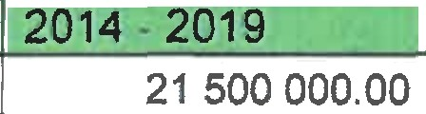

 |  |  |  |  | 25 000 000.00 | 26.857
 |  |  | 3 500 000.00 | 21500 000.00
Eastern Cape
Free State |  |  | 60257 000.00 | 145 900223.00 | 206 157 223.00 | 1095.5502
Gauteng |  |  | 18 750 000.00 | 915 660 000.00 | 934 410 000.00 | 1091.4073
KwaZulu Natal |  |  | 0.00 | 136 028750.00 | 136 028 750.00 | 928.5064
Limpopo |  |  | 65 400 000.00 | 158 810 000.00 | 224 210 000.00 | 179.8132
Mpumalanga |  |  | 0.00 | 53 320 000.00 | 53 320 000.00 | 685.6764
North West |  |  | 118 732 000.00 | 106 400 000.00 | 225 132 000.00 | 1087.1333
Northern Cape |  |  | 0.00 | 148 900 000.00 | 148 900 000.00 | 404.4045
Western Cape |  |  | 7 230 000.00 | 0.00 | 7 230 000.00 | 703.0483
TOTAL |  |  | 273 869 000.00 | 1 686 518 973.00 | 1 960 387 973.00 | 6202.3966

NATIONAL ASSEMBLY QUESTION FOR WRITTEN REPLY QUESTION NUMBER: PQ1004
DATE OF PUBLICATION: 29 MARCH 2018

X CHAINEE
DEPUTY DIRECTOR-GENERAL: STRATEGY AND PLANNING

Recommended/not recommended

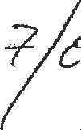
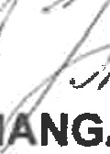
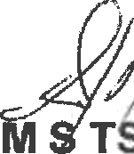
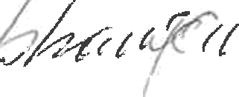

DIRECTOR-GENERAL: DATE: C C°
Approved/Not approved

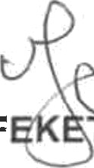
N C MF
O, MP
MINISTER FOR HUMAN SETTLEMENTS
DATE:

