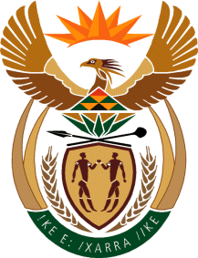

MINISTRY OF TOURISM
REPUBLIC OF SOUTH AFRICA

Private Bag X424, Pretoria, 0001, South Africa. Tel. (+27 12) 444 6780, Fax (+27 12) 444 7027
Private Bag X9154, Cape Town, 8000, South Africa. Tel. (+27 21) 469 5800, Fax: (+27 21) 465 3216

Ref: TM 2/1/1/10

NATIONAL ASSEMBLY:
QUESTION FOR WRITTEN REPLY:
Question Number: 1000
Date of Publication: 29 March 2018
NA IQP Number: 10
Date of reply: 26 April 2018
Mr J Vos (DA) to ask the Minister of Tourism:

How much land does (a) his department and (b) the entities reporting to him (i) own, (ii) have exclusive rights to and/or (iii) lease from the State to (aa) use and/or (bb) occupy? NW1093E

Reply:
- Department
- How much land does the department own?

None
- How much land does the department have exclusive rights to?

Not applicable
- How much land does the department lease from the state?

(aa) to use: None

(bb) occupy: None
- SA Tourism
- How much land does South Africa Tourism own?

5345 sq. meters
- How much land does South Africa Tourism have exclusive rights to:

South African Tourism owns the South African business premises used for marketing operations in line with the Tourism Act no 3, 2014.
- How much land does South Africa Tourism lease from the state?

(aa) to use: South African Tourism does not lease land from the state.

(bb) occupy: South African Tourism does not lease land from the state.

