NATIONAL A9SEMBLY

FqR we›pE)\i REPLY
QUE9TI N j00

fINTER c euesnou eAPER NO z-zc‹ei
100. Dr P J Groenewald (FF Plua) to ask the Minister of Police:
- Whather any atatlon commander from Voeloorus, East Rand, was found gultty at the Boksburg Ma8lstratas' COurt in the pa9t 10 yBare and eentenced to 12 yeae' imprieonment o/ a fine of R12 000 and Is back at workwtth the SA Police S MC0 (SAP,

- whether there are any members of tha SAPS who were (a) sentenced to jail, but antlnuad to racalva their salaries whtle ln]alt and(b) ratnstatad in the SAPS after serving thelr eentence In the paet 10 years; P so, (I) what Is the total number of auch empbyees in each caao, (ii) on which salary level/rank is each of the epectfied SAPS members employed and (III) at which Olice statiDns‘2
NW1057E
REPLY:
(1) The Station Commander of SAPS Vosloorus waa found guilty and sentencad to twalve (12) months Imprisonment or R10 000 fine and 19 currently back at work. The dlsclpllnary matter was finalised on 24 November 2017, by means of the expedltioU9 §fOcees end the offfcar was given a final wrixen wamlng.

(2)
None

None
None
No

Q0

The Information provided Is for 2017/2018 and 201a-2o‹e znancial years, from 1 Ap‹tl 2017 to September 2018.

DATE OF PUBLICATION IN INTERN/\L QUESTION PAPER: 2g JUNE 2§1g flNTERNAL QUESTION PAPER NO 2-2010)

Reply to question 100 recommend

VI NAL C NTSHIEA
LIEUTENANT GENERAL

NN!S9!ONER:PER9ONWELNANAOENENT

Raply to question 100 racommendad/

LIEUTENANT GENERAL DEPUTY NATI SSIONER: ASSET AND LEGAL MANAGEMENT FN VUMA
Date:

Reply to quastlon 100 recommended/bee

S9I LE (SOEG)

GENERAL OUTH AFRICAN POLICE SERVICE

DATE OF PUBMCATION IN INTERNAL C\UESTION PAPER: 28 JUNE 2019 (INTERNAL QUESTION PAPER NO 2-2010)

Reply to question 100 approvad/
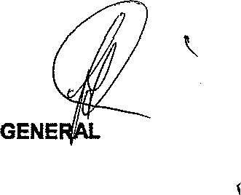

BH CELE (MP) MINIS R F P L4CE

