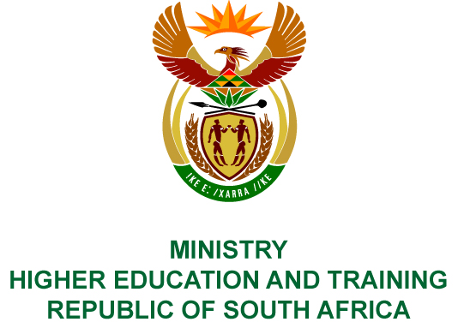
Private Bag X893, Pretoria, 0001, Tel (012) 312 5555, Fax (012) 323 5618
Private Bag X9192, Cape Town, 8000, Tel (021) 469 5150, Fax: (021) 465 7956
Memorandum from the Parliamentary Office: National Assembly
FOR WRITTEN REPLY
QUESTION 10
DATE OF PUBLICATION OF INTERNAL QUESTION PAPER: 08/02/2018

(INTERNAL QUESTION PAPER NO 1 OF 2018)
Mr W M Madisha (Cope) to ask the Minister of Higher Education and Training:
(a) When was free higher education for poor and working class students as announced by President J G Zuma on 16 December 2017 considered in and agreed to by the Cabinet, (b) when was she consulted by the President on the matter and (c) when (i) was the decision put in writing and (ii) did she countersign the policy as Minister responsible for the function?
NW13E

REPLY:
The President of the Republic of South Africa established the Commission of Inquiry into Higher Education and Training, and matters pertaining thereto were dealt with by the Presidency.

