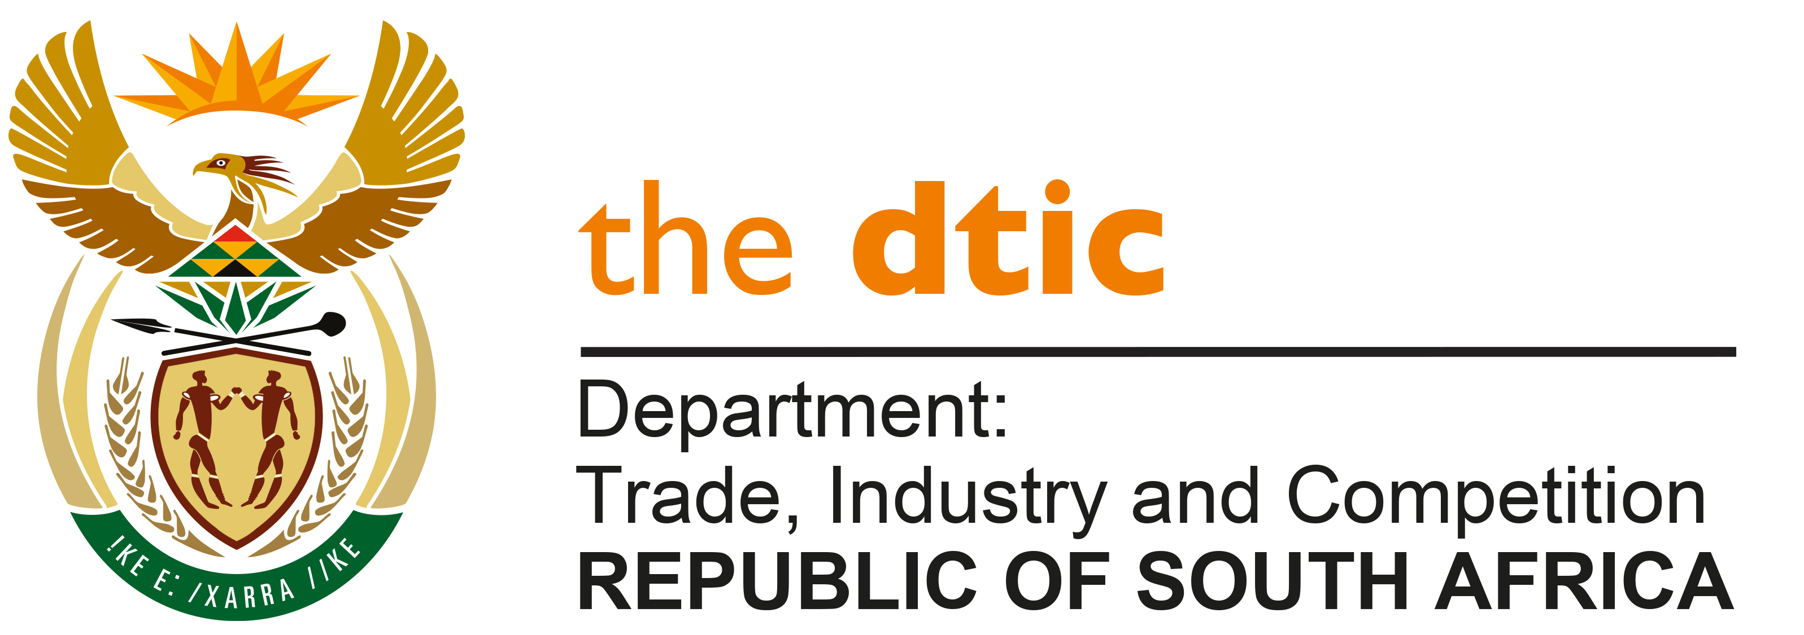

THE NATIONAL ASSEMBLY

QUESTION FOR WRITTEN REPLY

Question No. 01

DATE PUBLISHED: 10 FEBRUARY 2022

Mr M G E Hendricks (Al Jamah-ah) to ask the Minister of Trade, Industry and Competition:

(1) Whether, in view of the International Tribunal Judgment finding that China is guilty of human rights violations, genocide and oppression of the country’s Uyghur, Kazakh and Turkic Muslim populations and in light of the United States of America signing a new law banning all products manufactured in the Xinjiang region under forced labour, to mark its disapproval of China’s human rights violations, his department will use trade relations to send a message against the inhumane practices and genocide of Muslims; if not, why not; if so, what are the relevant details;

(2) whether his department will (a) pursue measures to stop trade with China and other countries who are collaborating with the Chinese government’s oppressive internal policies against Muslims, (b) further denounce the Chinese Communist Party and countries like Vietnam’s involvement in a deceptive trade practice such as relabelling merchandise to defeat the ban on products made with forced labour in the Xinjiang region and (c) support calls for the implementation of a mechanism and/or oversight to report practices of forced labour; if not, why not, in each case; if so, what are the relevant details in each case;

(3) whether the Republic is currently importing products that were manufactured in the Xinjiang region; if not, what is the position in this regard; if so, what are the relevant details? [NW2E]

REPLY

- Trade decisions on imports are made in compliance with the rules of the World Trade Organisation (WTO). It requires granting non-discriminatory market access for imports from all WTO Members, subject to applicable tariffs and health, safety and environmental standards, such as sanitary and phyto-sanitary requirements. Any restrictions beyond these need to comply with specified rules. This provides the legal framework within which any administration is required to operate.

- International trade data is not disaggregated to sub-national levels. Available data specifies the country of origin only.

- Any illegal relabeling practices which misrepresent the national origin will be in contravention of South African customs, legislation requiring that imports enter the South African market only if accompanied with a declaration of the true country of origin and of export (Article 40.1(c) of Customs and Excise Act). Should the Honourable Member have evidence of any illegal labeling practices, it should be reported to the Office of the Head of Customs at the South African Revenue Services (SARS).

-END-

