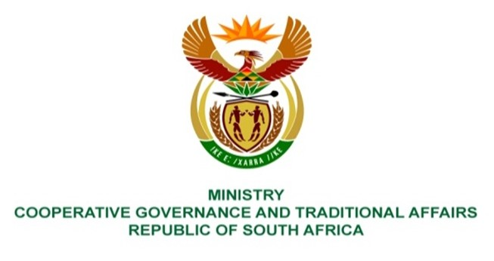

484.Ms HO Mkhaliphi (EFF) to ask the Minister of Cooperative Governance and Traditional Affairs:

Whether she has been informed of the report of the Forensic Investigation into Irregularities and Irregular Payments at uMuziwabantu Local Municipality in KwaZulu-Natal, which among other things recommends disciplinary action and criminal charges against the current municipal manager and other officials for their alleged role in defrauding the specified municipality; if not, what is the position in this regard; if so, what actions has she and/or her department taken to assist that municipality to hold the officials accountable and to recover the monies lost? NO3512E

REPLY:

I received communication which had information on a forensic investigation conducted at the Umuziwabantu Local Municipality and I responded by referring the matter to the Kwa-Zulu Natal Province. I have not received the final forensic report and its findings. I have since requested that the uMuziwabantu Local Municipality shares a copy of the report with the Department, which report I will submit to Parliament once I have received same.

