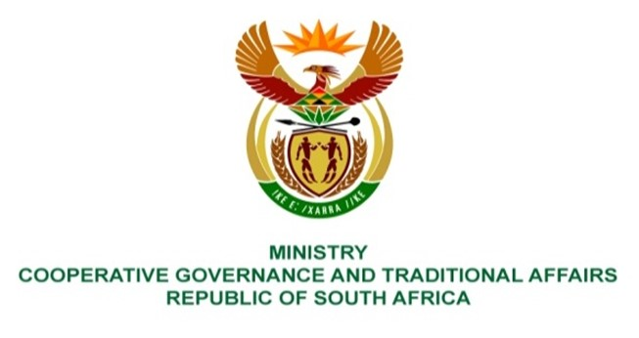

473. Ms SA Buthelezi (IFP) to ask the Minister of Cooperative Governance and Traditional Affairs:

(1) Whether she has seen an improvement in the performance of the municipalities that have been placed under administration such as the Amahlathi, Walter Sisulu, Enoch Mgijima, Raymond Mhlaba and Dr Beyers Naudé Local Municipalities; if not, what is the position in this regard; if so, what are the relevant details;

(2) whether her department plans to place any more municipalities under administration in this financial year; if not, why not; if so, what are the relevant details? NO3500E

REPLY:

- Yes, there are improvements in the performance of some municipalities mentioned that are placed under administration, particularly the Amahlathi and Walter Sisulu Local Municipalities as follows:

Amahlathi Local Municipality

In Amahlathi, a functional Audit Committee was established, the financial delegations were instituted, negotiations with creditors were undertaken, a financial turnaround-plan was adopted by the Municipal Council, improved legislative compliance was registered in that the annual report and financial statements were prepared and submitted, and meetings were held according to the schedule of ordinary Municipal Council meetings. As a result, there have been improvements in the Audit Outcomes from qualified audit opinion in 2018/19 to unqualified audit opinion in 2019/20 and 2020/21financial years.

Walter Sisulu Local Municipality

In Walter Sisulu, the improvements noted included the filling of critical vacancies such as the Municipal Manager, the Chief Financial Officer, and General Manager: Corporate Services. There have been improvements in the functionality of the human resource component, the supply chain management policy was developed and implemented for the running of the procurement management processes. Regrettably these improvements did not translate into an improved audit outcome, albeit work continues to improve the audit opinion obtained.

Enoch Mgijima Local Municipality

The Eastern Cape Provincial Executive in August 2018 placed Enoch Mgijima Local Municipality under administration in terms of Section 139 (1)(b) and (5) of the Constitution. The intervention did not yield any positive results, particularly as it related to the implementation of the Financial Recovery Plan.
Cabinet invoked section 139(7) of the Constitution, read with section 150 of the Municipal Finance Management Act, 2003, wherein Cabinet imposed a Financial Recovery Plan (FRP) and assumed the responsibility for the implementation thereof.

A National Cabinet Representative was appointed to lead the intervention with a team of specialists in April 2022. To compliment efforts by the National Treasury, the Minister of COGTA appointed a Task Team to support the efforts of the NCR. It is still early to tell if there are any improvements yet as work is ongoing and may take time to address all issues of concern.

Raymond Mhlaba and Dr Beyers Naude Local Municipalities

Contrary to the view of the Honorable Member, the Raymond Mhlaba and Dr Beyers Naude Local Municipalities were never placed under administration.

- No, the department has no intention of putting more municipalities under administration. The responsibility to intervene in a Municipality is vested with the Provincial Government in terms of section 139 (1) – (5). It is only when the provincial government fails to intervene in such a dysfunctional Municipality or when such intervention yields no tangible results, that the national government would consider putting such a municipality under national intervention in terms of Section 139(7) of the Constitution.

