DATE OF PUBLICATION OF INTERNAL QUESTION PAPER: 27/02/2020
INTERNAL QUESTION PAPER: 04/2020

59.. Ms H S Boshoff (Mpumalanga: DA) to ask the Minister of Basic Education:
Building of boarding school
Why was the building of the Thaba Chweu Boarding School (a) halted and (b) moved from the original identified land near Coromandel to Beetgekraal?
Response
The Question has been sent to the Province for a proper response, which immediately after receipt from Mpumalanga, will be rendered accordingly.
COMPILED BY:

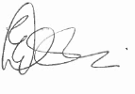
MR E RAMASEDI MAFOKO
DIRECTOR: PHYSICAL PLANNING & RURAL SCHOOLING
DATE: 03/03/2020

OFFICIALS INVOLVED

QUESTION NO: 59. IS APPROVED
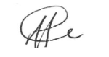
MR HM MWELI
DIRECTOR-GENERAL
DATE: 06/03/2020

QUESTION NO: 59. IS APPROVED
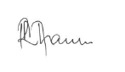
DR MR MHAULE, MP
DEPUTY MINISTER
DATE: 08/03/2020

QUESTION NO: 59. IS APPROVED
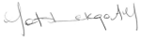
MRS AM MOTSHEKGA, MP
MINISTER
DATE: 12/03/2020

