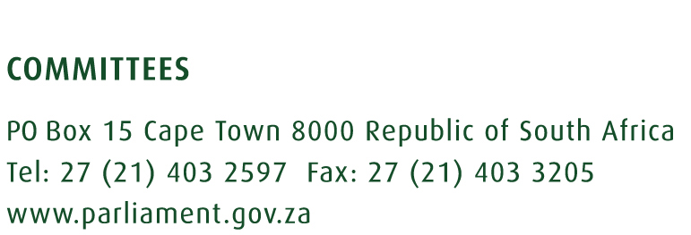

Portfolio Committee on Communications

Interviews for SABC Board

Venue: Virtual Platform

Friday, 16 September 2022

 | Name of Institution | Time
1. | Ms Thandeka Gqubule-Mbeki | 09:00 – 09:45
2. | Ms Nwabisa Matyumza (candidate withdrew) | 09:45 – 10:30
3. | Ms Phathiswa Magopeni | 10:30 – 11:15
4. | Mr Lance Rothschild | 11:15 – 12:00
 | BREAK | 12:00 – 12:30
5. | Mr Kingdom Moshounyane | 12:30 – 13:15
6. | Mr Paris Mashile | 13:15 – 14:00
7. | Dr Oscar Van Heerden | 14:00 – 14:45
8. | Ms Fundiswa Skweyiya-Gushu | 14:45 – 15:30
9. | Ms Z Matthews | 15:30 – 16:15
 | BREAK | 16:15 – 16:45
10. | Ms Magdalene Moonsamy | 16:45 – 17:30
11. | Ms Yvonne Yolelwa Sikhunyana | 17:30 – 18:15
12. | Ms Lindiwe Jacqueline Maepa | 18:15 – 19:00
13. | Ms Mandisa Titi | 19:00 – 19:45

Enquiries:

Name: Ms Portia Ntabeni Name: Ms Hajiera Salie
Email: pntabeni@parliament.gov.za Email: hsalie@parliament.gov.za

