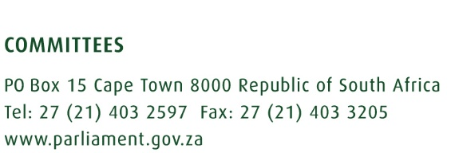

Portfolio Committee on Communications

Interviews for SABC Board

Venue: Virtual Platform

Wednesday, 14 September 2022

 | Name of Institution | Time
1. | Adv Tseliso Thipanyane | 12:00 – 12:45
2. | Mr Quentin Green | 12:45 – 13:30
3. | Mr Mpho Tsedu | 13:30 – 14:15
4. | Mr Shadrack Bokaba | 14:15 – 15:00
 | BREAK | 15:00 – 15:30
5. | Prof Franz Krüger | 15:30 – 16:15
6. | Mr Zolile Zamisa | 16:15 – 17:00
7. | Mr Langa Zita | 17:00 – 17:45
8. | Ms Nomazulu Mda | 17:45 – 18:30
 | BREAK | 18:30 – 19:00
9. | Mr Lumko Mtimde | 19:00 – 19:45
10. | Mr Khathutshelo Ramukumba | 19:45 – 20:30
11. | Mr Thembisa Fakude | 20:30 – 21:15

Enquiries:

Name: Ms Portia Ntabeni Name: Ms Hajiera Salie
Cell: 072 1874514 Cell: 061 472 9191
Email: pntabeni@parliament.gov.za Email: hsalie@parliament.gov.za

