PUBLIC PARTICIPATION IN PARLIAMENT -
A SURVEY OF PARTICIPANTS

Compiled by the Parliamentary Monitoring Group (PMG)
Written by Monique Doyle (PMG researcher)
2017
Cape Town
www.pmg.org.za
INTRODUCTION
An effective avenue for the provision of public participation is one of the hallmarks of a democratic government. Political scientist, Blondel, states that “one of the most important questions of political life – perhaps the most important of all is that of the nature, extent and strength of relationship between people and government, between rulers and ruled”.
With Parliament occupying the space of ultimate representative of the people, the work of Parliament is grounded in public engagement and ensuring that decisions taken, policies and legislation adopted and general discourse is intrinsically tied to the public. Public participation makes up one third of the salient functions of Parliament, the other two being oversight and passing legislation. However we cannot completely separate the three functions as they are all rooted in the needs of South African citizens – Parliament carries out oversight to ensure the Executive is meeting the service delivery needs of South Africans and to hold it accountable for its spending of public funds. Parliament also has to ensure that legislation it passes is in line with the needs of the people and legislation has to have adequate public participation. Put simply, public participation is at the heart of the work of Parliament.
Proponents of public participation state that the practice allows for good governance because it opens up government and parliamentary processes to public involvement – a practice not seen in non-democratic states. Further, opening up processes in this manner allows for public accountability, transparency and meets a constitutional requirement. South Africa occupies a unique position in that public participation is constitutionally entrenched.
Civil society is a key conduit for public participation. Steven Friedman states that “participation by civil society remains an important check on government which helps ensure it accounts to citizens”. There are various forms of public participation in Parliament such as public hearings, petitions, lobbying, submissions, “Taking Parliament to the People” and sectoral engagements.
In 2016, the Dullah Omar Institute published a report, Not in the House, which looked at the performance of parliamentary committees between 2009 and 2015 in terms of, openness and public access, independence and holding the Executive to account, responsiveness to public input and general effectiveness. This study is an important analysis of the current public participation framework.
This survey report will focus on public hearings in Parliament over the period 2015/2016 specifically looking at who the key participants are, why and how they get involved, their observations about Parliament’s role in the process and what can be done to improve the process. We express our gratitude to those who took the time to complete the survey and shared their experience and insights.
METHODOLOGY
The survey covered the period June 2015 to July 2016 and included all individuals/organisations that made oral submissions and directly engaged with one or more of the 50 parliamentary committees in public hearings. The submissions were made on legislation (72%), policy (13%) or topical matters (15%) such as firearms, climate change and department budget analysis.
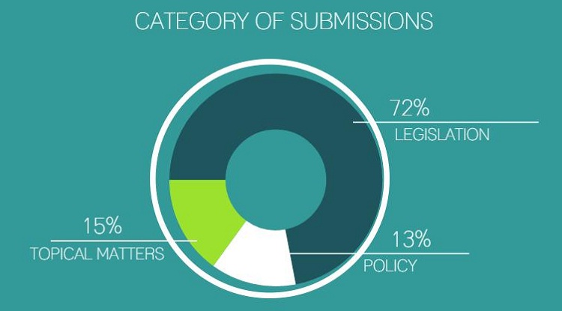
Sifting through all 1 134 meetings of parliamentary committees for this period, we found 39 meetings (3%) where the committees had heard submissions from the public. From these, 235 individuals / organisations were identified as being involved in these public participation events. There were instances of individuals/organisations participating in more than one public hearing during this time period as well as contact details (telephone number/email address) for some participants not being traceable. This resulted in 180 individuals/organisations being contacted to participate in this survey. Below is a sample of the organisations/individuals who were involved in public participation, by way of making a submission to a parliamentary committee, over the stipulated time period:

ORGANISATION | SECTOR | COMMITTEE | TOPIC UNDER DISCUSSION
Wits School of Law | Academic | Constitutional Review Committee | Constitutional Amendment Submissions
Molo Songololo | NGO | Portfolio Committee Social Development | Children’s Amendment & Second Amendment Bill
FEDUSA | Trade Union | Portfolio Committee Labour | Unemployment Insurance Amendment Bill Public Hearings
Mr David Bruce (independent researcher) | Individual acting in personal capacity | Portfolio Committee Police | Seminar on Risk Factors for Policing
KPMG | Business | Standing Committee Finance | Financial Intelligence Centre Amendment Bill Public Hearings
Veterinary Council of South Africa | Public Institution | Constitutional Review Committee | Constitutional Amendment Submissions
Commission for Gender Equality | Constitutional Body | Portfolio Committee Justice | Legal Aid Bill Public Hearings

The survey was emailed to 180 participants in July 2016 – ultimately we were able to obtain 77 responses of which:
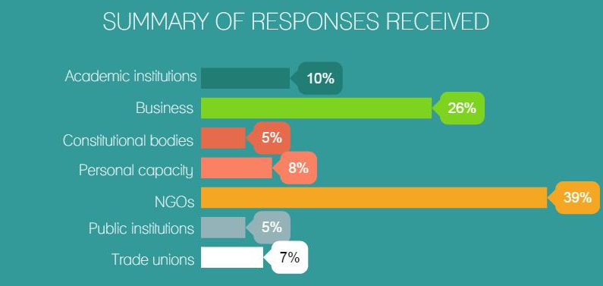
The survey was aimed at gaining more insight from participants in the following thematic areas:
- Who participates in parliamentary public hearings and their motivation for getting involved
- Views and assessment of how Parliament performs in carrying out its function of public participation
- Views on how formal public participation with Parliament could be improved
To encourage a greater response rate, individuals/organisations were given the choice to submit their responses anonymously.

FRAMING THE PUBLIC PARTICIPATION DISCUSSION
This report aligns itself, firstly, with the definition of “public” as ordinary South Africans at large in a general context. Public participation then is defined as the public sharing in, taking part of, providing input and involved in government, or in the case of this report, legislation, policy and government accountability.
This is closely linked to the theory of deliberative democracy which is theorised as the public gathering to consider, talk about and exchange views on policy proposals, national issues and laws. Such practices open spaces for the public to better grasp and comprehend policies and legislation affecting their lives. This in turn makes for better informed and aware citizens who are able to engage their representatives. Deliberative democracy, in this sense, then “represents a more direct and continuous means of allowing citizen input into policy and political decision-making”. Deliberative democracy allows for citizens to be integral to the decision making process instead of simply engaging in democratic action only when depositing a vote in a ballot box once every four years.
Turning our focus to the national legislature, the Constitution outlines, in section 42 (3), that the National Assembly is elected to represent the people and to ensure government by the people under the Constitution. The Assembly does this by, most importantly for this report, providing a national forum for public consideration of issues. Section 42 (4) outlines the role of the National Council of Provinces (NCOP), in the discussion of public participation, as providing a national forum for public consideration of issues affecting the provinces. Section 59 speaks specifically to public participation in that the National Assembly must (1) (a) facilitate public involvement in the legislative and other processes of the Assembly and its committees, and (1) (b) conduct its business in an open manner, and those of its committees, in public. Similarly in section 72 (1), the NCOP must (a) facilitate public involvement in the legislative and other processes of the Council and its committees; and (b) conduct its business in an open manner, and hold its sittings, and those of its committees, in public. In a civil society conference paper on South Africa’s legislatures, former Constitutional Court Justice, Albie Sachs, noted “That phrase in the Constitution about the public being involved was not simply [so that] the public can watch, [or] make representations to...committees. It meant an ongoing act of connection and association”.
Mijiga outlines that public participation, at its core, provides opportunities for the public to get involved in decision making and understand firsthand the decisions that influence their lives and livelihoods. It lessens perception that the public are excluded from government and instead contributes to a feeling of having some power. On the side of government/legislatures, public participation allows for an avenue through which decisions, actions and policies can be legitimised and supported by the public. Moreover, participation by the people allows for the legislature to tap into expertise possessed by the public and for citizens to contribute towards legislative oversight and scrutiny - this is particularly in the case of those committees that invite comments on annual reports and budgets of departments and entities.
To reiterate, this study is looking at public participation through the focused prism of the public directly participating in parliamentary activity whether commenting on legislation, providing input on annual reports or budgets of a government department/public entity, making an oral/written submission before a committee in response to such a call and getting involved in a committee workshop, seminar or colloquium. “Public” includes citizens in their personal capacity, civil society organisations, interest groups, private sector/business companies, trade unions and academic institutions – in summary, all encompassing of those outside of the government sector. Additionally, “public participation refers to the direct involvement of citizens in seeking information about and making decisions related to certain specified public issues”.
PUBLIC PARTICIPATION PROCEDURE IN THE COMMITTEES
Mijiga outlines that parliamentary committees are the ideal platform for participation by the public primarily because the smaller size of the committee facilitates narrower focus and its multiparty composition assists with broader discussion. Looking at the normative procedure related to the function of facilitation of public participation as carried out by parliamentary committees, following the process of the development of Green Papers and White Papers (policy documents preceding the introduction of a Bill where the public is able to comment), when a Bill is introduced to the National Assembly, it is sent to the relevant portfolio committee. The committee would then advertise and invite written submissions from the public. The committee then also invites the public to make oral submissions on a Bill – public hearings. Together the written and oral submissions form part of the constitutionally-obligatory process of public consultations between the legislature and interested parties. The committee is meant to consider all public comments, whether written or oral, when processing the Bill. In this context, consultation is seen as “using an audience as a sounding board and eliciting opinions, suggestions, advice and recommendations about an issue before and after a decision is taken”. Interesting, the authors of this definition point out that public consultation is weak and futile if decision makers are not committed to accepting the views of the audience. Committees have also come to use workshops, colloquiums and round tables as another means to invite public comment and create dialogue between the public and their representatives on key topical issues.
Following the public hearings, a summary of the submissions is presented to the committee by its researcher and, where it involves policy or legislation, the relevant department provides its response to each suggestion made by the public. In its deliberations, the committee will assess the public comments and department responses and, ideally, independently make the best decision for each point of contention in the policy or legislation.
RESPONDENTS ASSESSMENT OF PARTICIPATION PROCESS
Motivation for participation
Our survey asked participants what their primary motivations are for getting involved in parliamentary processes. When it comes to the legislative process, the respondents cite several reasons: they have vested interests in a particular law, want to bring potential shortcoming in a law to the fore, and thus improve its constitutionality, and make recommendations for amendment or change. Another key motivator is to make their interests and constituencies known – opportunities to interact with committees are thus a tool used by individuals, organisations and interested parties to make their interests known to members, ensuring those interests are promoted and to make contact with their legislative representatives. Interests highlighted in the survey included gender mainstreaming, investment interests, advocating for interests in the small business sector, safety and security, environmental issues, labour interests and student issues.
Sufficient time to prepare comments
According to our records, between 2012 and 2016, the average comment period provided by Parliament for bills was 17 calendar days – slightly more than two weeks for the public to prepare submissions on a bill.
Our survey asked participants whether they were satisfied with the amount of time allocated to prepare submissions in response to a parliamentary invitation to do so. The majority of respondents (46.1 per cent) were satisfied with the amount of time allocated while 31.6 per cent were sometimes satisfied with the time period and the remaining 22.4 per cent were not pleased with the time allotted to submit their input to Parliament. However when probed about the ideal amount of time in which to prepare a submission, 44 per cent of respondents expressed that one month (more or less four weeks) was a sufficient amount of time to prepare a submission. 35 per cent of survey respondents felt that more than one month was required (more or less six to eight weeks).
Responses interestingly indicated that there is no one standard for the amount of time allocated for the preparation of a submission – for example some bills are less “controversial” or “heavy” and so would not require too much time in the preparation of a submission. A good example would be when a Bill is requiring amendment that does not substantially change the principles of the legislation. The case would be different, for example, if a Bill is seeking to break new ground (such as the expected Hate Crimes Bill) or seeks to disrupt the status quo or potential questions of constitutionality arise. Such a piece of legislation would require a number of months in which submissions can be prepared – it requires those wanting to comment to conduct research, consult and formulate arguments.
Taking public input seriously
Our survey results reveal mixed responses to the question “were you satisfied that your submission was adequately taken into account or considered?” Thirty per cent of participants felt their submissions were adequately considered by the respective committee. They pointed out that while their submissions might not have directly translated into significantly changed policy or legislation, they felt that their submission/input was valued. One respondent outlined that in participating in the amendment of the Sexual Offences Bill, “MPs went out of their way to hear what the public had to say”. One cannot expect a committee to directly apply each and every submission to what is before it, however, engaging and considering submissions and input goes a long way in explaining how participants, and the time taken to prepare and present submissions, could feel valued and heard. One of the respondents raised this in the survey by noting that he/she felt his/her submission was taken seriously as MPs engaged with it and raised pertinent questions on the submission.
Some respondents noted that specific parts of their submissions were seen in amendments to legislation such as in the Protection and Promotion of Investment Bill, legislation relating to the Independent Police Investigative Directorate and Children Amendment Bills. Other participants noted that input they provided on departmental performance was taken on board by committee members and used as a resource when questioning the department and formed part of the committee’s recommendations. Again participants who indicated that they were satisfied that their submissions were adequately taken into account based this opinion on the fact that after giving the oral submission, there was engagement between the participant and the committee where committee members asked questions for clarity and expressed agreement or disagreement. This exercise greatly affirms the public participation process. One of the survey respondents appreciated the fact that the committee “engaged with certain aspects of the submission and requested further explanation and details on matters”. Another respondent noted the submission was adequately taken into account because the “questions and [discussion] which ensued thereafter were an indication”. This was similarly expressed by a respondent who noted the Portfolio Committee on Public Works took their submission on the Expropriation Bill seriously even allowing the participants extra time to provide input and asking “good questions” thereafter.
Thirty seven per cent of the public participation survey participants however said Parliament does not take public input seriously, in their experience. Comments were raised about the limited amount of time for committee members to engage with each submission (with one participant pointing out he/she could not even make the oral submission to the committee as time ran out), that not enough MPs show up for public hearings and that a general impression was given that the input was not valued. Interestingly, some respondents felt that a decision had already been taken that the view of the dominant political party would be adhered to – they pointed out this was just a “window dressing exercise”, that MPs “simply seemed to be going through the motions” and that “it looked as if the result was predetermined”. This ties in with comments such as “the bias has been clear over many years” and that there is “a penchant for embracing the views of those already powerful and berates those without the experience”. Further, “Parliament can do much more to ensure that the views of the public and interest groups...are taken more seriously”. Sentiments expressed by those who felt their submissions were not taken seriously also stem from not seeing input being directly applied to legislation or policy and not receiving feedback on how the committee had considered the input.
Providing feedback to participants on how the committee considered submissions, or would generally move forward with the process, would perhaps assist in ensuring the public felt their submission was considered and that they were not merely part of an obligatory showpiece. Dissatisfied participants stated that substantive reasons were not given for why their submission was not accepted. One participant felt strongly about this and stated that the organisation no longer prioritises engagement with Parliament. Looking at responses in detail, it is revealed that many felt MPs did not have regard for the fact that it takes much time and effort to present a submission. One such response reveals “I was interrupted by the chairperson who did not understand the burning issues of the lived experience...they never considered that we had to get up early on behalf of communities who suffer...we should all be respected no matter the subject as we [leave] our homes to bring the voices of those who cannot be present”. There is acknowledgement that not every input or submission could be translated to changed policy or legislation but there is an expectation from the pubic participating that the committee provide feedback on how inputs are considered. This is further substantiated by the fact that 79.5 per cent of our survey respondents indicated that the feedback process on submissions, after the oral hearing was held by the committee, was inadequate.
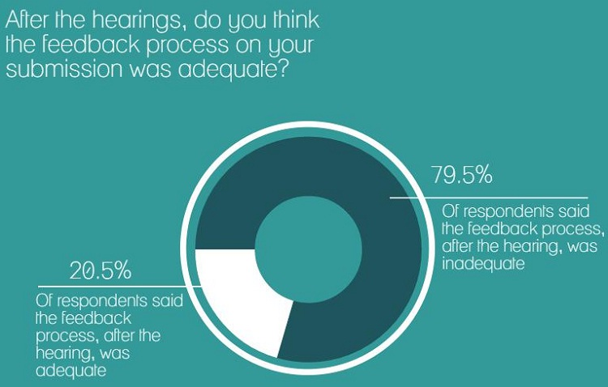
As pointed out by one of the respondents – “there is never any feedback from portfolio committees; they should do those who contribute to their deliberations the courtesy of responding with reports and an indication of the conclusions drawn by committee on the basis of inputs provided. Otherwise this is a one-way process”. Providing feedback builds trust between the public and Parliament, as highlighted by Mafunisa and Maphunye. Unpacking the extent of feedback is discussed later in this report, under opportunities and suggestions.
Mijiga states that it is unrealistic to expect elected representatives to consult and please all people all the time and that, essentially, not all views can be reflected in every final decision. However there is strong opinion that providing feedback to those providing submissions is non-negotiable. This sends out a clear message that Parliament takes input seriously, appreciates the public taking time to provide submissions and encourages future participation. Further, it fosters relationships between committees and civil society because civil society is a resource tool that committees can draw on and civil society can often reach wider networks and a broad base that would otherwise be inaccessible. Committees are obligated to table reports on the processing of legislation once approved but these are often mere one-liners. If a committee does not have the capacity to provide a hearings report, the department response document to submissions could be provided to the participants to ensure they receive feedback on the process and how their input fits into the picture. Additionally, the simple act of engaging in discussion with participants during the hearings has a significant effect in participants believing their submissions are taken seriously.
Lobbying MPs/ Political Parties
Our survey questioned whether, apart from making submissions, individuals/organisations also lobbied MPs and political parties to push for their views and interests. This report defines lobbying as the exercise of attempting to influence members of parliament to advance a certain view or interest in the legislature. The majority of respondents (58 per cent) indicated that they did not while 42 per cent did engage in lobbying.
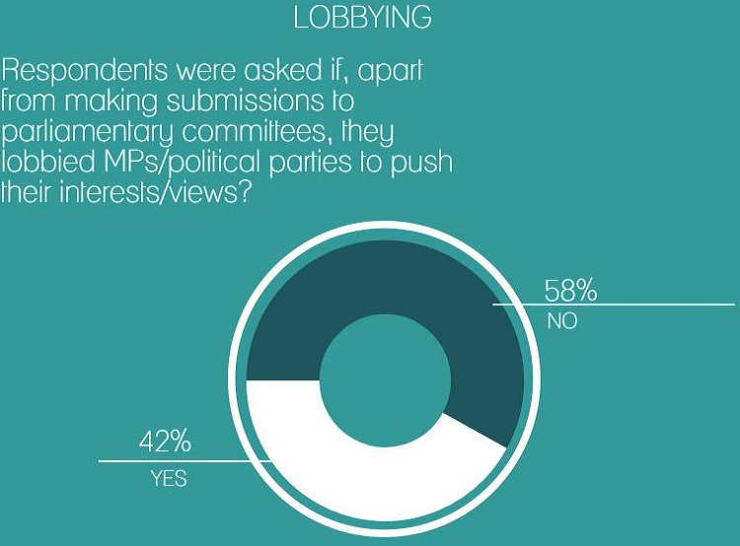
Respondents were further probed on the benefits of lobbying and if it had yielded any results. Those who had indicated there were positive results to the exercise noted that it makes for better informed MPs prior to public hearings and that it resulted in changed laws and assisted in building relationships with MPs which served to strengthen understanding of varying views and perspectives within committees. One respondent indicated that the practice of lobbying allowed for more strategic engagement, empowered MPs by increasing their knowledge base, offered solutions and assisted in creating a climate of more critical and engaged debate. Other positive responses showed that lobbying allowed for opportunities to share relevant experience, information and expertise, particularly on technical and industry-specific matters, and provided committee members with additional information and resources for consideration. Others indicated that the lobbying was so successful that “MPs that have championed our cause have assisted us to gain access to parliamentary processes and helped in broadening/raising awareness”. Further, it was highlighted that lobbying assists in getting agreements and ensuring a submission “find its way into the Act”. Another interesting response was that lobbying is beneficial because it provided insight that one does not encounter during public hearings. Another such benefit to the exercise of lobbying, as noted by a survey respondent, was that it enabled organisations to get pertinent questions to be asked by MPs during committee meetings thus ensuring issues and interests were placed on the agenda.
There were, on the other hand, survey respondents who indicated that lobbying exercises did not yield any results. Some views were strong such as that lobbying was “absolutely pointless - [the] chairperson [was] completely dismissive of alternate points of view”. Others pointed out that engaging in lobbying was not of any value because “ruling party MPs do not take positions outside the caucus”.
Impediments to Public Engagement with Parliament
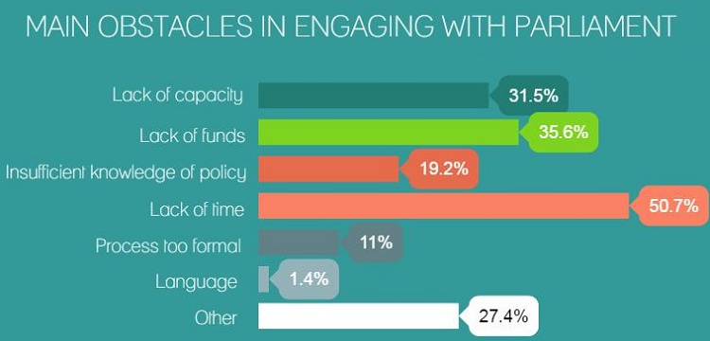
Our survey brought to light many of the impediments relating to public participation in Parliament. One of the key impediments was a lack of time – when asked to select the main obstacles in engaging with Parliament, 50 per cent of respondents found the lack of time to be the main obstacle. It was highlighted in the survey that putting a submission together for Parliament takes a substantial amount of time and effort to prepare. It often entails doing research, formulating arguments and refinement. Such an exercise is more taxing on a small organisation (much less an individual) with access to limited resources and time because of other demands. Often, it was noted, smaller and more grassroots- based organisations rely on goodwill and voluntary commitment. Also, as noted earlier in the report, some policy and legislative issues are more complex than others and require an even greater amount of work in formulating the submission.
Inadequate time also extended to that of the hearing of the oral submission itself – lack of time for the oral public hearing was repeatedly mentioned in the survey and so is considered a significant impediment to effective public participation. A respondent noted that he felt dejected when he was stopped halfway through his presentation because time had run out. Another respondent was of the opinion that committee members are too overburdened with other issues and so do not have enough time to consider public input. Another response puts the impediment clearly in context when he states that the committee “never considered that we had to get up early, take time off work from our busy schedule to prepare and deliver a presentation on behalf of communities”. The hurdle of lack of time was also raised sharply by survey respondents when asked how best to encourage public participation.
The second largest impediment for the public engaging with Parliament was lack of funds and capacity – 35 per cent of respondents indicated that lack of funds was the largest obstacle while 31 per cent indicated lack of capacity. The two will be discussed jointly as funds, resources and capacity work inclusively of each other for individuals and organisations preparing submissions to present to parliamentary committees. Throughout the survey responses, remarks were that participating in legislative hearings and preparing inputs are time-consuming and costly in terms of preparation. The need for more participatory events closer to local communities and districts is a large indicator of the obstacle of funds, in this case, when it comes to travelling. It could be argued that there are many individuals and organisations who wish to participate in parliamentary committee proceedings but are unable to do so because of travelling costs. This point is further substantiated by one of the respondents who said that Parliament should consider teleconferencing to accommodate those unable, or without the funds, to travel. Interestingly, 66 per cent of survey respondents were of the opinion that Parliament should pay for travel costs for participants not based in Cape Town.
The core problem with lack of funds, resources and capacity is that the public participation space in Parliament becomes exclusive to the well-resourced, funded and capacitated. This was highlighted by a respondent who pointedly observed that “it is the well resourced who generally participate and this is done to protect the interests of the elite in South African society. The full and legitimate participation of all South Africans does not take place because submissions are seen as technical, complex, far removed from the reaches of ordinary people and people feel helpless or overwhelmed in most instances by travel costs and the status of Parliament”. Another respondent simply stated “funding is needed for effective public participation”. Academic and political analyst, Steven Friedman, highlighted that the common case in SA is dialogue between the elite in society about the lives of everybody else in society – the issue is that this dialogue always excludes the most important citizens of SA – the people who live in poverty and deprivation. This is further evidential in the academic observation that the public participation process in committees usually consists of the same actors which results in a lack of diversity and plurality of views.
Interestingly this point is further touched on in some of the literature reviewed for this report – Kelso et al find that there were very few submissions made by grassroots community-based organisations mentioned in parliamentary committee reports (reporting on decisions made and results of a public hearing process) whereas submissions made by larger organisations were cited more heavily. Further, the Kelso et al piece finds that private sector organisations tend to be the most commanding in public participation processes. The authors find that this dominance translates into a large impediment to participation experienced by smaller organisations and individuals where they often struggle to find their voice and agency in the participatory space. This is substantiated by Aparajita et al who state that it is more often that the business sector and organised civil society have immediate access to information and resources to know what legislation/policies are on the parliamentary programme, understand the complex legal jargon, research and formulate a formal submission within a narrow period of time. This results in the privileged, powerful, organised and better-resourced disproportionately influencing the public participation space. This is compounded by the fact that hearings at Parliament are held in the city centre far from poor communities and are advertised by mediums not always accessible to the marginalised and grassroots-based organisations - plainly, it is always the same actors and not many new faces.
This point is corroborated by the Dullah Omar Institute who find, in their comprehensive study of the extent of and responsiveness to public input in South Africa’s Legislatures, that looking at the profile of who engages with Parliament across the board, it is predictably the better resourced organisations, businesses and structures that access committees.
Friedman also outlined that public participation has come to be prejudiced towards the poor and so cements inequality because the process is geared towards being highly organised and based on the terms of the powerful. Constitutional law expert, Pierre de Vos, adds that “[W]ho gets to speak, who gets to be listened to, has a lot to do with who has access to resources. Whether you’re in civil society or whether you’re in business, if you don’t have access to resources to mobilise people, and if you don’t have access to the money, you’re not going to be listened to”.
Emerging from the survey were a number of other factors which could be discussed as impediments to engaging with Parliament. Key amongst these was the stark observations that committee members do not seem to take the public participation process seriously. There were a number of comments that members do not seem to listen during hearings, “belittle” points of view that are generally not agreed with and that some chairpersons were too “heavy handed” and thus intimidating for participants. Furthermore, it was noted that MPs often seem uninterested, ask irrelevant questions, at times do not attend the public hearing or that meetings are at times cancelled with no prior notice. It is useful to note that such comments are not unique to the South African legislature and were raised in a paper set in the US context – the author observed that during public participation processes, decision makers in Congress often do not pay attention, talk amongst themselves, read other materials and even leave the room.
It can be argued that this perception is a serious impediment in engaging with Parliament because it could easily dissuade or discourage future participation. This ties into perceptions brought to the fore in the survey that decisions seemed to be predetermined prior to the public participation processes and that the process then served as a means to “legitimise” decisions already taken.
It would be important to contextualise the above discussion in terms of South Africa’s electoral system – the country makes use of a Proportional Representation (PR) system. The electorate vote for political parties and the proportion of seats won represent the division of seats in the national legislature. Parties in turn make use of closed lists to allocate seats to members in the legislature. The core of the process comes down to MPs owing their seat allocation to the party and not directly to the people (as would have been the case if there were constituency-based elections). This dynamic was highlighted in the survey when respondents felt strongly that “MPs need to be more accountable to constituents, not simply to their party bosses, so they take their legislative role more seriously”. Various other sentiments were expressed that members are bound to allegiance to the party and that members are bound to take decisions on caucus lines and about members needing to be less focused on supporting the party and more focused on ensuring public interest is well served. As observed by the Dullah Omar Institute, the extent of public participation in parliamentary committees is unquestionably affected by the general political context in which the committee operates.
Opportunities and Suggestions for Effective and Meaningful Public Participation
Respondents were asked to provide suggestions on how to improve public participation to best encourage comment from a wide cross-section of society. In analysing the responses, it is clear that the existing strategies to promote public participation are insufficient and that the national legislature needs to do more to get a plurality and multiplicity of views.
What is glaringly required from Parliament when discussing the obligation of public participation is standardisation of process amongst parliamentary committees. Respondents noted that there is great variation between how participation is carried out from one committee to the next. Standardising the process allows for expectations to be set and “rules of engagement” established for both participants and the committee itself. It also allows for standards to be set for how the committee would carry out the process and the timeframes involved. Lack of time was raised sharply as a primary impediment for the public in engaging with Parliament. While being mindful of the fact that portfolio committees are extremely busy and often deal with multiple agenda items on any given day, MPs should look at how best to maximise time to hear and engage with the public. This is especially so when a given topic is particularly detailed or very important to the public at large. It might also be prudent for committees to make it known to participants before the hearing that they would only have X amount of time to make a submission or have their say – this would aid in ensuring the public is fully aware of time constraints before arriving and ensure their submission meets the time limit set.
The key rationale for standardisation is that it provides consistency in the execution of public participation. This could lead to public engagement being a standing item on the agendas of committees, quarterly, and so ensure the solicitation of public views and inputs becomes institutionalised and engrained in the work of parliamentary committees and not simply sought when dealing with legislation. This is particularly so for topical matters being discussed between committees and the public as only 15 per cent of engagements were on “issues of national importance” relevant to that portfolio committee compared to 72 per cent dealing with legislation during the year this survey covered.
The lack of feedback on the participation process needs to be considered by Parliament – this is seen in the survey results where 79.5 per cent of respondents felt the feedback process was inadequate. It is suggested that committees produce specific reports on all processes involving public participation with feedback provided on how the committee considered submissions and input, how concerns raised would be dealt with and how the process moves forward from that point. Such a report should be made available to participants and made available on various public platforms – many organisations, groups and people are not even aware of Parliament’s Announcements, Tablings and Committee Reports (ATC). As already highlighted, feedback assists in fostering relationships and trust between committees and the public by ensuring there is transparency in the decision making process and that input provided by the public is taken seriously by Parliament.
Our survey brought to the fore a number of interesting suggestions on how Parliament could further solicit input and interaction beyond the run-of-the-mill “call for comment”. One such suggestion is to leave comment boxes in local municipalities, especially in rural areas, to ensure a wider reach of participation. Another was that constituency offices should be centres where people can get access to information about what is going on and how they can participate. It is unclear if they are actually fulfilling this role. Additionally, Parliament could make use of opinion gauging exercises and online surveys. Another proposal was that Parliament make better use of technology not only for communicating with the public but also teleconferencing – this would assist when members of the public are unable to travel to Parliament physically or lack the funds to do so. Central points could be arranged at a town hall or community centre, for example, for teleconferencing with the committee.
IN CONCLUSION
Public participation is commonly seen as a bilateral dialogue between two opposing sides but Innes and Booher argue that it best that this discourse be altered for the democratically-rooted process to be seen as a “multi-way interaction” where there is both formal and informal communication between Parliament and the public.
Moving forward, Parliament needs to dig deeper to encourage an even wider reach in soliciting input whether on legislation, policy or issues of national importance, that will include all corners of society thus ensuring the process is not dominated by those with access to resources, funds and technical know-how. This is particularly so when the legislature is engaging the public on key topical issues – as the holding of this type of hearing by parliamentary committees is troublingly low for the period under review.
Increasing the scope for innovation and “opening spaces” cannot lie squarely at the door of Parliament but also requires the involvement of the public itself to ensure there is collaborative effort. Effective and meaningful public participation is the backbone of legitimate democratic governance – while the constitutional and institutional design for the function is present, greater action is needed to better use this design.
At the time of writing this report, Parliament still had not adopted its Public Participation Model. The Fourth Parliament initiated its development while the Fifth Parliament has undertaken to conclude the process. The foreword of the current draft promises to address many of the issues identified by the survey respondents – it states:
“Parliament thus seeks to increase access and improve the quality of participation through enhanced programmes to ensure participatory democracy by implementing the Public Participation Model…..strengthening the work of Members in constituencies, improving public education and participation programmes, and establishing feedback and engagement mechanisms. Furthermore, Parliament aims to provide better and more regular information to people, ensure more meaningful engagement with communities, provide regular public participation processes on issues of national importance, and increase public access and participation in its processes”.
Parliament intends to implement the Public Participation Model by 2019. According to the document, the legislature must develop “monitoring and evaluation mechanisms for public participation within Parliament” and “there should be an annual assessment report on implementation of the Model”. South Africans should be vigilant and follow the process as it unfolds.

Mafunisa, Dr M John & Maphunye, Dr Kealeboga, J. 2005. Public Participation in Decision-Making in the Gauteng Provincial Legislature. Accessed: 22 November 2016. Available at: http://repository.hsrc.ac.za/bitstream/handle/20.500.11910/7255/2943_Mafunisa_Publicparticipation.pdf?sequence=1&isAllowed=y
Nyalunga, Dumisani. 2006. “An Enabling Environment for Public Participation in Local Government”. International NGO Journal. 1:1. Accessed: 22 November 2016.Available at: http://ddp.org.za/information-material/articles/An%20enabling%20environment%20for%20public%20participation%20in%20local%20government.pdf
Waterhouse, Samantha & Mentor-Lalu. Vivienne. 2016. Not in the House – The extent of and responsiveness to public input in South Africa’s Legislatures 2009 – 2015. Dullah Omar Institute. Accessed: 20 January 2017, From: http://www.osf.org.za/wp-content/uploads/2016/10/Not-in-the-house-final-no-cover.pdf
Girma, Aida. 2012. “Effective Public Involvement in the Oversight Processes of Parliaments and Provincial or Regional Legislatures”. South African Legislative Sector Consultative Seminar: Strengthening Democracy through Global Collaboration of Legislatures on Oversight. Accessed: 10 June 2016 From: https://www.unicef.org/southafrica/SAF_resources_publicinvolvement.pdf
What is Deliberative Democracy? Accessed: 21 April 2017, From: http://democracyrenewal.edu.au/what-deliberative-democracy
Constitution of the Republic of South Africa. 1996. Cape Town: Government Printers
People’s Power, People’s Parliament: A Civil Society Conference on South Africa’s Legislatures. 2012: 18
Mijiga, Foster. 2001. Public Participation in the Legislation Process: A Summary of Results from a Nation-Wide Regional Survey and a National Conference Conducted by the National Council and the National Democratic Institute between April and October 2000. Accessed: 10 June 2016, From: https://www.ndi.org/sites/default/files/1408_na_publicpart_093101_5.pdf
Kelso, Alexander, Boswell, John & Ryan, Matthew. 2016. “Public Participating in Parliamentary Policy Scrutiny: An Interpretative Analysis of Select Committee Inquiries. Paper delivered to the PSA Annual Conference 21 -23 March 2016. Accessed: 10 June 2016 From: https://www.psa.ac.uk/sites/default/files/conference/papers/2016/PSA%20Paper%202016%20Select%20Committees%20and%20public%20participation%20KelsoBoswellRyan.pdf
Booysen, Susan. 2006. “Public policy-making in South Africa”. In: Venter, Albert and Landsberg, Chris (ed). Government and Politics in the new South Africa. Cape Town: Van Schaik Publishers
Mijiga, 2001: 11
Cloete, Fanie and Meyer, Ivan. H. 2006. “Policy agenda setting” In, Cloete, F, Wissink, H and de Coning, C. Improving Public Policy from theory to practice. Cape Town: Van Schaik Publishers
Mafunisa and Maphunye, 2005: 24
Mijiga, 2001: 10 - 11
People’s Power People’s Parliament: A Civil Society Conference on South Africa’s Legislatures. 2012: 20
Kelso et al, 2016: 18
Aparajita, Aditi, McConnachie, Chris, Mehta, Dhvani, Carelli, Franceso and Dhru, Kelly. 2011. A Comparative Survey of Procedures for Public Participation in the Lawmaking Process – Report for the National Campaign for People’s Right to Information (NCPRI). Accessed:22 November 2016, From: http://ohrh.law.ox.ac.uk/public-participation-in-the-lawmaking-process/
Waterhouse & Mentor-Lalu, 2016: 9
People’s Power People’s Parliament: A Civil Society Conference on South Africa’s Legislatures. 2012: 21
People’s Power People’s Parliament: A Civil Society Conference on South Africa’s Legislatures. 2012: 21
Innes, Judith E and Booher, David E. 2005. Reframing Public Participation: Strategies for the 21st Century. Accessed: 10 June 2016, From: http://escholarship.org/uc/item/4gr9b2v5
Waterhouse and Mentor-Lalu, 2016: 24
Innes and Booher, 2005: 428 – 429

