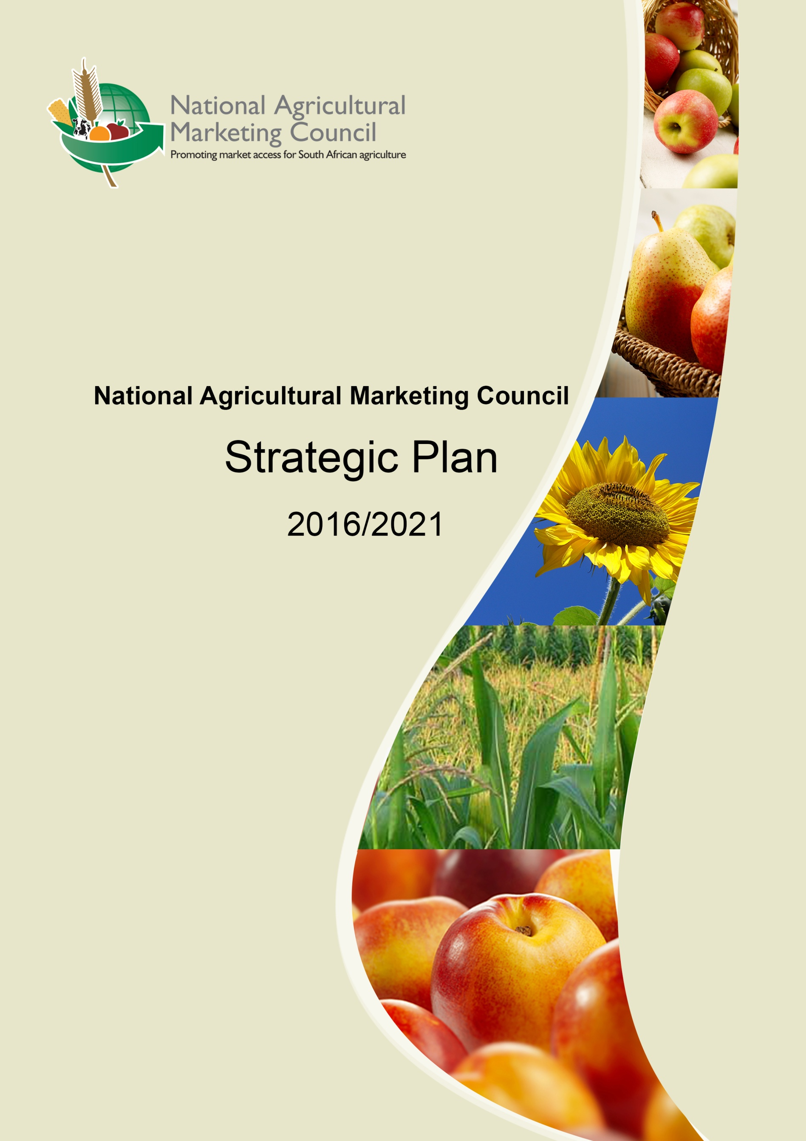

FOREWORD

Honorable Minister, the National Agricultural Marketing Council has offered vital policy support to the agricultural sector for the past 16 years. A challenging external environment coerced us to deal with the realities we operate in. As a result of this, budget cuts where unavoidable and caused us to reprioritise some of our programmes.

Chapter 6 of the National Development Plan (NDP) highlights an inclusive rural economy as a long term goal. This rallies for those within the agricultural and rural sectors to begin developing synergies to work towards food security, agricultural production and job creation. Therefore, our strategy is mainly informed by these goals. The Presidential Infrastructure Coordinating Commission (PICC) for one, tasked the NAMC to develop an infrastructure plan for agriculture, labeled Strategic Integrated Projects (SIP) 11.

To promote job creation, we have taken a firm step to guide commodity organisations on the spending of transformation funds. A Transformation Review Committee was established to monitor the allocation of levies under the ambit of the Statutory Measures and Industry Trusts Divisions.

In the same vein, Cabinet adopted the National Policy on Food and Nutrition Security (2013). This policy provides a broad framework for the fulfillment of the Constitutional imperative for every citizen to have “the right to have access to sufficient food and water”. The Agro-food chains studies and the Supply and Demand Estimates Reports will contribute towards a better understanding of the food market dynamics.

Honorable Minister, we trust that collaboration between the NAMC and the Ministry of Agriculture, Forestry and Fisheries will contribute to the realisation of key national policy imperatives.



____________________________

**AD Young**

**Acting Chairperson: NAMC Council**

**Date: 24 November 2015**

# **OFFICIAL SIGN-OFF**

It is hereby certified that this revised Strategic Plan:

* Was developed by the management of the National Agricultural Marketing Council, under the guidance of the Chief Executive Officer TR Ramabulana.
* Takes into account all the relevant policies, legislation and other mandates for which the National Agricultural Marketing Council is responsible.
* Accurately reflects the strategic goals and objectives which the National Agricultural Marketing Council will endeavour to achieve over the period 2016 to 2021.

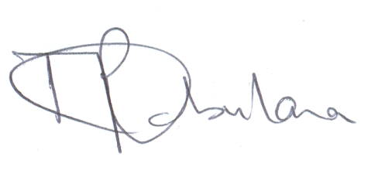

**___________________**

**TR Ramabulana**

**Chief Executive Officer**

**Date: 24 November 2015**



**_____________________**

**AD Young**

**Acting Chairperson: NAMC Council**

**Date: 24 November 2015**

**TABLE OF CONTENTS**

|  |  |  |
| --- | --- | --- |
| **NO** | **ITEM** | **PAGE** |
|  | **PART A** |  |
| 1. | **STRATEGIC OVERVIEW** | 6 |
| 1.1 | Vision | 6 |
| 1.2 | Mission | 6 |
| 1.3 | Core Business Values | 6 |
| 1.4 | Legislative And Other Mandates | 7 |
|  | **PART B** | 9 |
| 2. | **SITUATIONAL ANALYSIS** | 9 |
| 2.1 | Performance Environment | 9 |
| 2.2 | Organisational Environment | 10 |
| 2.3 | Strategic Planning Process | 11 |
|  | **PART C** | 12 |
| 3. | **STRATEGIC OBJECTIVES** | 12 |
| 3.1 | Strategic Outcome Oriented Goals | 12 |
| 3.2 | Programme 1: Administration | 12 |
| 3.3 | Programme 2: Markets Economic & Research Centre | 16 |
| 3.4 | Programme 3: Statutory Measures | 19 |
| 3.5 | Programme 4: Agricultural Trusts | 21 |
| 3.6 | Programme 5: Agri-Business Development | 23 |
|  | **APPENDIXES** |  |

**ABBREVIATIONS**

|  |  |
| --- | --- |
| AEASA | Agricultural Economics Association of South Africa |
| BBBEE | Broad-Based Black Economic Empowerment |
| CEC | Crop Estimates Committee |
| CEO | Chief Executive Officer |
| CELC | Crop Estimates Liaison Committee |
| CFP | Custom Feeding Programme |
| DAFF | Department of Agriculture, Forestry & Fisheries |
| DAGs | Directly Affected Groups |
| DTI | Department of Trade & Industry |
| FANRPAN | Food, Agriculture and Natural Resources Policy Analysis Network |
| GDP | Gross Domestic Product |
| IT | Information Technology |
| MAP ACT | Marketing of Agricultural Products Act |
| MERC | Markets and Economic Research Centre |
| MTSF | Medium Term Strategic Framework |
| NAMC | National Agricultural Marketing Council |
| NRMDP | National Red Meat Development Programme |
| PPECB | Perishable Products Export Control Board |
| TRALAC | Trade Law Centre of Southern Africa |
| SIP11 | [Strategic Integrated Projects'](http://www.economic.gov.za/picc/sips-chairpersons) |

**PART A**

1. **STRATEGIC OVERVIEW**

**1.1 Vision**

Strategic positioning of agriculture in a dynamic global market.

**1.2 Mission**

To provide agricultural marketing advisory services to key stakeholders in support of a vibrant agricultural marketing system in South Africa.

**1.3 Core Business Values**

The following values are adopted as our commitment to entrench and deepen the “NAMC” way, both in our behaviour and service offering.

* **Integrity** (honesty / ethical / trustworthy / transparent)
* **Assertive** (accountable / responsible / reliable / taking ownership / confident)
* **Collaborative** (consultative / teamwork / participative / co-operative)
* **Service excellence** (performance driven / target oriented / service oriented / motivated / committed / diligent)
* **Fairness** (equal treatment / respectful / tolerance / consistency)
* **Objective** (analytical / rational / attention to detail / conceptual)
* **Innovative** (creative / pro-active / adaptive / flexible / initiative)

**1.4 Legislative and other Mandates**

The NAMC was established in terms of Sections 3 and 4 of the MAP Act No. 47 of 1996, as amended by Act No. 59 of 1997 and Act No. 52 of 2001. The mandate as spelled out in the Act reads as follows:

The NAMC:

a) *“shall, when requested by the Minister or of its own accord, investigate the establishment, continuation, amendment or revocation of statutory measures and other regulatory measures affecting the marketing of agricultural products, evaluating the desirability, necessity or efficiency of the measures and, if necessary, proposing alternatives to the establishment, continuation, amendment or repeal of a statutory measure or other regulatory measure and report to and advise the Minister accordingly;*

*b) “shall prepare and submit to the Minister, for consideration, statutory measures and changes to statutory measures which the Minister directs it to prepare”;*

*c) “shall, whenever requested by the Minister and at least once annually, report on the activities of the Council”;*

*d) “may direct any institution or body of persons designated for the purpose of the implementation or administration of a statutory measure in terms of Section 14 of the Act, to furnish the Council with such information pertaining to a statutory measure as the Council, the Minister or the Parliamentary Committees may require”;*

*e) “may undertake investigations and advise the Minister regarding –*

*• the agricultural marketing policy and the application thereof;*

*• the coordination of agricultural marketing policy in relation to national economic, social and development policies and international trends and developments; and*

*• the possibilities for promoting the objectives of the Act as mentioned in section 2(2) of the Act.”*

**Other key national policy mandates**

* National Development Plan
* Agricultural Policy Action Plan
* Infrastructure Development Act
* Integrated Growth and Development Plan
* Medium Term Strategic Framework

**PART B**

### 2. SITUATIONAL ANALYSIS

### 2.1 Performance Environment

The NAMC derived opportunities and threats in the external performance environment through a focused group discussion process.

|  |  |
| --- | --- |
| **Opportunities** | **Threats** |
| * Strengthening relationships with all stakeholders through engagement platforms. * Centre of Excellence for creating market access for small holder farmers. * Expanding development projects in all provinces. * Expand the number of research partners. * Leverage funding opportunities. * Play an active role in the defining of the NAMC mandate. * Assignments from DAFF within the core business of the NAMC. * Participation in land reform initiatives. * Capitalise on levies and trusts to enhance transformation efforts. * Large need for farming training initiatives. * Agricultural sector branding support. * Increased visibility in topical agricultural issues * Improve communication in terms of the agricultural Trust Policy document. | * Misplaced views and perceptions of stakeholders on the NAMC role. * Key stakeholders not understanding the value proposition of NAMC. * Competition for critical skills. * Lack of collaborations between NAMC and the different spheres of government. * Financial constraints. * Lack of alignment between DAFF and NAMC. * Assignments from DAFF outside of the core business / mandate of the NAMC. |

### 2.2 Organisational Environment

### Strengths and weaknesses in the organisational environment of NAMC were derived through a gap analysis process of the strategic goals and objectives of NAMC

|  |  |
| --- | --- |
| **STRENGHTS** | **WEAKNESSES** |
| **Administration**   * Business process support * Human resource management support   **Markets and Economic research centre**   * Smallholder market access research * Agro food chain research * Strategic integrated projects coordination   **Statutory measures**   * Statutory measures implementation * Statutory measures compliance monitoring * Committee secretarial support * Register of directly affected groups administration   **Agri-business development facilitation**   * Agri-business development planning support * Agri-business development implementation support | **Administration**   * Financial management support * IT support   **Markets and Economic research centre**   * Trade research |

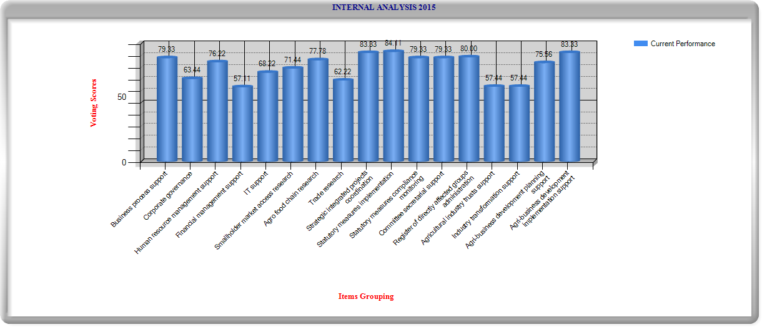

**2.3 Strategic Planning Process**

The National Treasury MTEF cycle for strategic planning processes is followed by the NAMC. The Chief Executive Officer and senior management had a session on key strategic issues on 08 and 09 October 2015. The strategic plan was reviewed.

**PART C**

1. **STRATEGIC OBJECTIVES**

### Strategic Outcome Oriented Goals

|  |  |
| --- | --- |
| **Strategic Outcome Oriented Goal** | 1. Increasing market access to all market participants 2. More efficient marketing of agricultural products 3. Increased export earnings from agricultural products 4. Enhanced viability of agricultural sector |
| **Goal statement** | To provide agricultural marketing advisory services to key stakeholders in support of a vibrant agricultural marketing system in South Africa. |

Five business strategic goals were identified as pillars underpinning the NAMC’s mission. These goals were aligned with five organisational programmes of which the first goal is a support goal and the other four goals, line of business goals.

**3.2** **PROGRAMME 1: ADMINISTRATION**

|  |  |
| --- | --- |
| **Strategic Goal 1** | To ensure internal business excellence within the NAMC |
| **Goal statement** | To ensure internal excellence in practices supporting the NAMC in effectively delivering on its mandate |
| **Justification** | This aims to ensure that the NAMC functions optimally through effective business processes, corporate governance and resource support services |
| **Links** | Government outcome 5 and 12  2009 Government Priority 7 |

The programme is currently structured in accordance with the following sub-programmes:

* Office of the CEO (business process support)
* Financial & Administration support (including ICT support)
* Human Resources Management Support

**Key strategies relating to business process services are as follows:**

|  |  |  |
| --- | --- | --- |
| **STRATEGIC GOAL** | **KEY STRATEGIES** | **RESOURCE CONSIDERATIONS** |
| **Business Process Support**  *(Planning, Communication,*  *Organisational performance*  *management, Stakeholder relations management,*  *Organisational development, Corporate governance support, Risk management, Legal services, Internal audit)* | * Enterprise risk management and compliance strategy reviewed * Risk register reviewed * Organisational structure reviewed * Corporate communication strategy reviewed * Stakeholder relations management framework developed and implemented * Code of conduct reviewed * Internal audit three year rolling plan developed | * Additional HR capacity required * Additional budget required * HR Systems required * IT Systems required |
| **Financial Management Support** *(Management accounting, Financial accounting, Asset / inventory management, Supply chain management)* | * Financial delegations of authority reviewed * Internal financial management operating procedures reviewed * A strategy to source alternative funds in the event of financial constraints on projects, developed. * Opportunities to raise management fees on projects, investigated | * Additional project funds required |
| **Human Resource Management Support** | * Human resource strategy and plan reviewed * Remuneration strategy reviewed * Scarce and critical skills identified for NAMC * Human resource support service standards implemented * Employee satisfaction survey conducted | * Additional budget required |
| **IT Support** | * IT strategy and master system plan implemented * IT policies and standard operating procedures (SOP’s) reviewed | * Additional personnel and budget required |

| **OFFICE OF THE CHIEF EXECUTIVE TARGET PERSPECTIVE** | | | | | | |
| --- | --- | --- | --- | --- | --- | --- |
| **STRATEGIC**  **OBJECTIVES / KPA** | **PERFORMANCE INDICATOR** | **TARGET**  **2016/17** | **TARGET**  **2017/18** | **TARGET**  **2018/19** | **TARGET**  **2019/20** | **TARGET**  **2020/21** |
| **Corporate Governance support** | Compliance reports produced (n) | 4 | 4 | 4 | 4 | 4 |
| Risk reports produced (n) | 4 | 4 | 4 | 4 | 4 |
| Council Committee Secretarial Support reports produced (n) | 4 | 4 | 4 | 4 | 4 |
| Council committees performance evaluation report produced (n) | 1 | 1 | 1 | 1 | 1 |

| **FINANCE AND ADMINISTRATION** **TARGET PERSPECTIVE** | | | | | | |
| --- | --- | --- | --- | --- | --- | --- |
| **STRATEGIC**  **OBJECTIVES / KPA** | **PERFORMANCE INDICATOR** | **TARGET**  **2016/17** | **TARGET**  **2017/18** | **TARGET**  **2018/19** | **TARGET**  **2019/20** | **TARGET**  **2020/21** |
| **Financial Management Support** | Budget submitted for approval (n) | 1 | 1 | 1 | 1 | 1 |
| Annual statutory financial report produced within prescribed time (n) | 1 | 1 | 1 | 1 | 1 |
| Quarterly statutory financial reports produced within prescribed time (n) | 4 | 4 | 4 | 4 | 4 |
| Monthly statutory financial reports produced within prescribed time (n) | 12 | 12 | 12 | 12 | 12 |
| BBBEE procurement reports produced (n) | 4 | 4 | 4 | 4 | 4 |
| **IT Support** | IT performance reports produced (n) | 4 | 4 | 4 | 4 | 4 |

|  |  |  |  |  |  |  |
| --- | --- | --- | --- | --- | --- | --- |
| **HUMAN RESOURCES MANAGEMENT SUPPORT TARGET PERSPECTIVE** | | | | | | |
| **STRATEGIC**  **OBJECTIVES / KPA** | **PERFORMANCE INDICATOR** | **TARGET**  **2016/17** | **TARGET**  **2017/18** | **TARGET**  **2018/19** | **TARGET**  **2019/20** | **TARGET**  **2020/21** |
| **Business Process Support** | Strategic Plan produced (n) | 1 | 1 | 1 | 1 | 1 |
| Annual Performance Plan produced (n) | 1 | 1 | 1 | 1 | 1 |
| Performance Information reports produced (n) | 4 | 4 | 4 | 4 | 4 |
| Annual report produced (n) | 1 | 1 | 1 | 1 | 1 |
| Corporate communication service reports produced (n) | 4 | 4 | 4 | 4 | 4 |
| **Human Resource** | Human resource reports produced (n) | 4 | 4 | 4 | 4 | 4 |

**3.3 PROGRAMME 2: MARKETS AND ECONOMIC RESEARCH CENTRE**

|  |  |
| --- | --- |
| **Strategic Goal 2** | To provide quality research outputs to key stakeholders in support of agricultural marketing decision making. |
| **Goal statement** | Effectual agricultural marketing decisions will enhance competition, resulting in more effective market structures and increased market access. |
| **Justification** | This aims to inform key stakeholders to contribute to policy debate and create a more efficient and inclusive marketing system |
| **Links** | National development plan  Integrated growth and development plan  Agricultural Policy Action Plan  Government outcome 4 and 7  2009 Government Priority 4  NAMC outcomes 1,2,3 and 4  State of the nation address on national priorities |

MERC programme has the following sub-programmes:

* Smallholder market access research
* Agro food chain research
* Trade research
* Strategic integrated projects coordination

**Key strategies relating to market and economic research are** **as follows:**

|  |  |  |
| --- | --- | --- |
| **STRATEGIC GOAL** | **KEY STRATEGIES** | **RESOURCE CONSIDERATIONS** |
| **To provide quality research outputs to key stakeholders in support of agricultural marketing decision making** | * Economic research strategy implemented. * SIP11 project monitoring conducted. * Facilitation of the development of the agricultural information management system. * Role clarification session between DAFF and NAMC finalised. * Stakeholder engagement platforms created at NAMC * NAMC to provide branding support to the agricultural sector | * Additional funds required for SIP11 and APFP * Additional staff required (e.g. specialised research staff) * Additional technology required (e.g. analytical software) |

| **PROGRAMME 2: MARKETS AND ECONOMIC RESEARCH CENTRE TARGETPERSPECTIVE** | | | | | | |
| --- | --- | --- | --- | --- | --- | --- |
| **STRATEGIC**  **OBJECTIVES / KPA** | **PERFORMANCE INDICATOR** | **TARGET**  **2016/17** | **TARGET**  **2017/18** | **TARGET**  **2018/19** | **TARGET**  **2019/20** | **TARGET**  **2020/21** |
| **Smallholder Market Access Research**  (see MERC strategic objectives no 1) | Smallholder market access research reports produced (n) | 4 | 4 | 4 | 4 | 4 |
| Smallholder market access academic journal articles produced (n) | 2 | 2 | 2 | 2 | 2 |
| Agri-preneur reports produced (n) | 4 | 4 | 4 | 4 | 4 |
| Monitoring & Evaluation reports produced (n) | 4 | 4 | 4 | 4 | 4 |
| **Agro Food Chain Research**  (see MERC strategic objectives no 2) | Food price monitor reports produced (n) | 4 | 4 | 4 | 4 | 4 |
| Food cost review report produced (n) | 1 | 1 | 1 | 1 | 1 |
| Input cost monitoring reports produced (n) | 4 | 4 | 4 | 4 | 4 |
| Supply and demand estimates reports produced (n) | 11 | 11 | 11 | 11 | 11 |
| Agro food chain research reports produced (n) | 4 | 4 | 4 | 4 | 4 |
| Agro food chain academic journal articles produced (n) | 2 | 2 | 2 | 2 | 2 |
| Farm-to-retail price spreads (FTRPS) reports produced (n) | 4 | 4 | 4 | 4 | 4 |
| **Trade Research**  (see MERC strategic objectives no 3, 4 and 5) | Trade probes reports produced (n) | 6 | 6 | 6 | 6 | 6 |
| Fruit flow reports produced (n) | 4 | 4 | 4 | 4 | 4 |
| FANRPAN annual report produced (n) | 1 | 1 | 1 | 1 | 1 |
| ITAC report produced (n) | 1 | 1 | 1 | 1 | 1 |
| **Trade Research**  (see MERC strategic objectives no 3, 4 and 5)...continues... | Agricultural Professional Fellowship Programme (APFP) report produced (n) | 1 | 1 | 1 | 1 | 1 |
|  | Trade research reports produced (n) | 4 | 4 | 4 | 4 | 4 |
|  | Trade academic journal articles produced (n) | 2 | 2 | 2 | 2 | 2 |
| **Strategic Integrated Projects Coordination** | SIP11 project monitoring reports produced (n) | 4 | 4 | 4 | 4 | 4 |

**3.4. PROGRAMME 3: STATUTORY MEASURES**

|  |  |
| --- | --- |
| **Strategic Goal 3** | To provide statutory measure recommendations in support of an effective agricultural marketing system |
| **Goal statement** | Providing objective recommendations to the Minister based on investigations conducted |
| **Justification** | This aims to enable the agricultural sector to collect levies to finance generic functions, collect and disseminate information, to promote the efficiency of the marketing of agricultural products, to promote market access, to increase export earnings and when required, control exports |
| **Links** | National development plan  Integrated growth and development plan  Government outcome 4 and 7  2009 Government Priority 4  NAMC outcomes 1, 2 and 3 |

Statutory Measures programme has the following sub-programmes:

* + Field Crop Products
  + Horticultural Products
  + Livestock Products

**Key strategies relating to statutory measures are as follows:**

|  |  |  |
| --- | --- | --- |
| **STRATEGIC GOAL** | **KEY STRATEGIES** | **RESOURCE CONSIDERATIONS** |
| **To provide statutory measure recommendations in support of an effective agricultural marketing system** | * Applications for statutory measures in terms of procedures provided in the MAPA analysed * Application of statutory measures monitored and reported * Administration and promotion monitored as per guidelines * Ensure clear understanding / interpretation of the MAPA | * Sufficient budget to execute the mandate given to this programme * Skilled staff (ability to write, calculate, analyse and communicate) |

| **PROGRAMME 3: STATUTORY MEASURES TARGET PERSPECTIVE** | | | | | | |
| --- | --- | --- | --- | --- | --- | --- |
| **STRATEGIC**  **OBJECTIVES / KPA** | **PERFORMANCE INDICATOR** | **TARGET**  **2016/17** | **TARGET**  **2017/18** | **TARGET**  **2018/19** | **TARGET**  **2019/20** | **TARGET**  **2020/21** |
| **Statutory Measures Implementation** | Statutory measure implementation reports produced (n) | 4 | 4 | 4 | 4 | 4 |
| **Statutory Measures Compliance Monitoring** | Status of statutory measures report produced (n) | 1 | 1 | 1 | 1 | 1 |
| **Committee Secretarial Support** | Committee secretarial support report produced (n) | 1 | 1 | 1 | 1 | 1 |
| **Register Of Directly Affected Groups Administration** | Register of directly affected groups administration report produced (n) | 1 | 1 | 1 | 1 | 1 |

**3.5. PROGRAMME 4: AGRICULTURAL TRUSTS**

|  |  |
| --- | --- |
| **Strategic Goal 4** | To provide advisory services to the Minister relating to trusts and agricultural transformation. |
| **Goal statement** | To provide advisory services to the Minister based on the monitoring and operations of trusts. |
| **Justification** | This aims to ensure that the viability of the agricultural sector is enhanced |
| **Links** | National development plan  Integrated growth and development plan  Government outcomes 7 and 12  2009 Government Priority 2,4,6 and 7  NAMC outcomes 1 and 4  Agri-BBBEE code |

Agricultural Industry Strategic Advisory Services have the following sub-programmes:

* Agricultural industry trusts support
* Industry transformation support

**Key strategies relating to agricultural industry strategic advisory services are as**

**follows**:

|  |  |  |
| --- | --- | --- |
| **STRATEGIC GOAL** | **KEY STRATEGIES** | **RESOURCE CONSIDERATIONS** |
| **To provide agricultural industry strategic advisory services to the Minister relating to trusts and transformation** | * Communication and alignment between the trusts and Minister of DAFF enhanced. * A strategy to ensure that trusts comply to the legal framework of the NAMC. * A plan to ensure effective agricultural transformation developed * An agricultural industry transformation policy developed | Additional resources required |

| **PROGRAMME 4: AGRICULTURAL TRUSTS TARGET PERSPECTIVE** | | | | | | |
| --- | --- | --- | --- | --- | --- | --- |
| **STRATEGIC**  **OBJECTIVES / KPA** | **PERFORMANCE INDICATOR** | **TARGET**  **2016/17** | **TARGET**  **2017/18** | **TARGET**  **2018/19** | **TARGET**  **2019/20** | **TARGET**  **2020/21** |
| **Agricultural Industry Trusts Support** | Agricultural industry trusts reports produced (n) | 4 | 4 | 4 | 4 | 4 |
| Status report of agricultural trusts produced (n) | 1 | 1 | 1 | 1 | 1 |
| **Industry Transformation Support** | Industry transformation support reports produced (n) | 4 | 4 | 4 | 4 | 4 |

**3.6 PROGRAMME 5: AGRI-BUSINESS DEVELOPMENT**

|  |  |
| --- | --- |
| **Strategic Goal 5** | To provide agri-business development facilitation programmes that will link smallholder farmers / agri-businesses to markets |
| **Goal statement** | To provide agri-business development facilitation programmes to smallholder farmers / agri-businesses to overcome their constraints in accessing the markets |
| **Justification** | This aims to increase access to markets by smallholder farmers / agri-businesses |
| **Links** | National development plan  Integrated growth and development plan  Government outcomes 4 and 7  2009 Government Priority 2, 4 and 6  NAMC outcome 1  Agricultural Policy Action Plan (APAP) |

Agri-business development facilitation has the following sub-programmes:

* Agri-business development planning support*(Commodity identification, Concept documentation, Business planning, Entrepreneur / stakeholder identification)*
* Agri-business development implementation support *(Resource mobilisation, Entrepreneur / stakeholder mobilisation, Training / mentoring, etc.)*

**Key strategies relating to agri-business development are as follows**:

|  |  |  |
| --- | --- | --- |
| **STRATEGIC GOAL** | **KEY STRATEGIES** | **RESOURCE CONSIDERATIONS** |
| **To provide development programmes that will link smallholder farmers / agri-businesses to markets** | * Agri-business development strategy reviewed   + Capacity building facilitated   + Development programmes implemented   + Business linkages facilitated   + Market access facilitated | Inadequate funds  Project management software |
| * A strategy to improve project management practices within the NAMC developed |
| * Agricultural development programmes business plans developed |
| * Technical assistance plans in support of business linkages developed |

| **AGRI-BUSINESS DEVELOPMENT TARGET PERSPECTIVE** | | | | | | |
| --- | --- | --- | --- | --- | --- | --- |
| **STRATEGIC**  **OBJECTIVES / KPA** | **PERFORMANCE INDICATOR** | **TARGET**  **2016/17** | **TARGET**  **2017/18** | **TARGET**  **2018/19** | **TARGET**  **2019/20** | **TARGET**  **2020/21** |
| **Agri-Business Development Planning Support** | Agri-business development planning support reports produced (n) | 4 | 4 | 4 | 4 | 4 |
| **Agri-Business Development Implementation Support** | Agri-business development implementation support reports produced (n) | 4 | 4 | 4 | 4 | 4 |

**Appendixes**

|  |  |  |  |  |  |
| --- | --- | --- | --- | --- | --- |
| **APPENDIXES A**  **OUTCOMES / PRIORITY LINKAGES WITH STRATEGIC GOALS AND OBJECTIVES FRAMEWORK** | | | | | |
| **Government Outcomes** | | **2009 Government Priorties** | | **Marketing of agricultural products act Objectives** | |
| Outcome 1 | Improved quality of basic education | 1 | Creating decent work and building a growth inclusive economy | 1 | Increasing market access to all market participants |
| Outcome 2 | A long and healthy life for all South Africans | 2 | Promoting quality education and skills development | 2 | More efficient marketing of agricultural products |
| Outcome 3 | All people in South Africa are and feel safe | 3 | Prioritizing better health for all | 3 | Increased export earnings from agricultural products |
| Outcome 4 | Decent employment through inclusive economic growth | 4 | Stimulating rural development and food security | 4 | Enhanced viability of agricultural sector |
| Outcome 5 | A skilled and capable work force to support an inclusive growth path | 5 | Intensify the fight against crime and corruption |  |  |
| Outcome 6 | An efficient, competitive and responsive economic infrastructure network | 6 | Building cohesive and sustainable communities |  |
| Outcome 7 | A vibrant, equitable and sustainable rural communities with food security for all | 7 | Strengthening the developmental state and good governance |  |
| Outcome 8 | Sustainable human settlements and improved quality of house hold life |  |  |  |
| Outcome 9 | A responsive, accountable, effective and efficient local government system |  |  |  |
| Outcome 10 | Environmental assets and natural resources that are well protected and continually enhanced |  |  |  |
| Outcome 11 | Create a better South Africa and contribute to a better and safer Africa and World |  |  |  |
| Outcome 12 | An efficient, effective and development orientated public service and empowered, fair and inclusive citizenship |  |  |  |  |

| **Strategic Goals and Objectives**  **Framework** | **Government Outcomes** | **2009 government Priorities** | **\\namc-srv\folderredirection$\Sylvester\My Documents\NAMC Work Station\Human Resource\Virginia\two covers\back cover.jpgMarketing of Agricultural Products Act Objectives** |
| --- | --- | --- | --- |
| Program 1: Administration   * Corporate governance support * Business process support services * HR Management Support * Financial management support * IT support | Outcome 5, 12  Outcome 12  Outcome 12  Outcome 12 | Priority 7  Priority 7  Priority 7  Priority 7 | -  -  -  - |
| Program 2: Markets and Economic Research Centre:   * Trade research * Agro food chain research * Smallholder market access   research   * Strategic integrated projects   coordination | Outcome 4, 7  Outcome 4, 7  Outcome 4, 7  Outcome 4, 6 & 7 | Priority 4  Priority 4  Priority 4  Priority 4 | Outcome 1,2, 3 & 4  Outcome 1,2, 3 & 4  Outcome 1,2, 3 & 4  Outcome 1,2, 3 & 4 |
| Program 3: Statutory Measures   * Statutory measures   implementation   * Compliance monitoring to   conditions   * Committee functioning * Register of directly affected   groups administration | Outcome 7, 11  Outcome 7, 11  Outcome 7, 11  Outcome 7, 11 | Priority 4  Priority 4  Priority 4  Priority 4 | Outcome 1,2 & 3  Outcome 1,2 & 3  Outcome 1,2 & 3  Outcome 1,2 & 3 |
| Program 4: Agricultural Industry Strategic Advisory Services   * Agricultural industry trust   support   * Industry transformation   support | Outcome 5 & 7  Outcome 7, 12  Outcome 7  Outcome 7  Outcome 5 | Priority 2, 7  Priority 7  Priority 4  Priority 4, 6  Priority 2 | Outcome 4  Outcome 4  Outcome 1  Outcome 1  Outcome 1 |
| Program 5 : Agri-business Development Facilitation   * Agri-business development planning support * Agri-business development implementation support | Outcome 4  Outcome 7 | Priority 2  Priority 4, 6 | Outcome 1  Outcome 1 |

