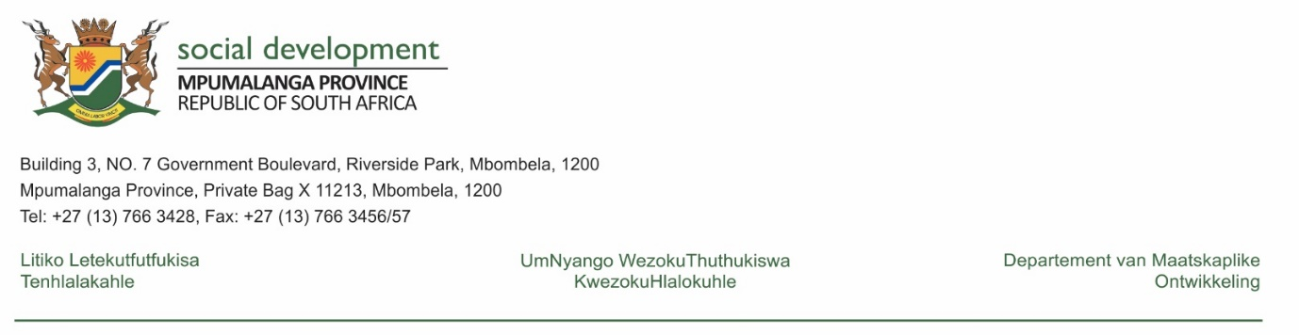

NATIONAL ASSEMBLY QUESTION FOR WRITTEN REPLY

QUESTION NUMBER: 1794
DATE OF PUBLICATION IN INTERNAL QUESTION PAPER: 06 MAY 2022
INTERNAL QUESTION PAPER NUMBER: 16 - 2022

1794. Ms L L van der Merwe (IFP) to ask the Minister of Social Development:

(1) (a) What total number of non-profit organisations (NPOs) in each province did her department provide funding to in the 2021-22 financial year and (b) will she provide Ms L L van der Merwe with (i) a list of all NPOs funded and (ii) the total amount of funding allocated to each NPO;

REPLY:
- The Mpumalanga Department of Social Development funded a total of 1741 NPO’s broken down as follows:

PROGRAMME: WELFARE | NO OF NPO’S FUNDED
Older Persons | 118
Persons with disabilities | 140
HIV and AIDS | 5
Drop in Centres | 95
Families | 12
Child and Youth Care Centres | 25
Child Protection Organisations | 40
Early Childhood Development | 798
Early Childhood Development (Conditional grant) | 301
Aftercare | 3
Non Centre Based Care | 19
RESIHA | 53
VEP | 23
Substance Abuse | 8
Social Crime | 9
PROGRAMME: COMMUNITY DEVELOPMENT | NO OF NPO’S FUNDED
Youth Development | 89
Women Development | 03
TOTAL | 1741

- See attached list of organisations funded (Welfare and Community Development)
- See database of organisations funded (Annexure A)
- See database of organisations funded and amount allocated per organisation (Annexure B)
- See attached database of funded for Community Development (Annexure C)

(2) what (a) total number of NPOs had their budgets cut in the 2021-22 financial year in each province, (b) are the names of the NPOs that had their budgets cut and (c) did the cuts amount to in total? NW2123E
REPLY:

(2) (a) WELFARE
Only one NPO’s budget was reduced during 2021/22 financial year,

- Emmanuel Family Home CYCC

- Budget cut amounted to R48,000

COMMUNITY DEVELOPMENT
- The department did not have any cuts in the budget for the NPOs in the 2021-22 financial year in the province. There are no NPOs affected by budgets cuts
- Only one organization, namely Honey Dew Youth Development Centre was terminated / discontinued due to poor management of funds.
- An amount of R242, 014 was suspended, following the identification of a replacement NPO. The allocated budget was spent in line with the planned outputs for 2021/2022.

__________________ _____________________
MR SM MTSWENI MS LL NTSHALINTSHALI
HEAD: SOCIAL DEVELOPMENT MEC: SOCIAL DEVELOPMENT
DATE _____________ DATE: _______________

