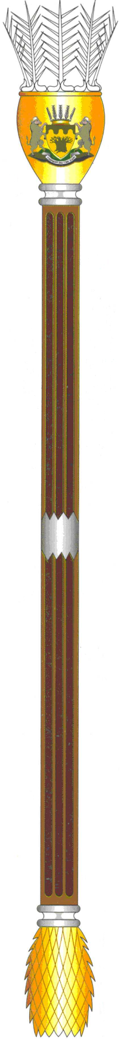
To : The Chairperson: Select Committee on
Appropriations

Name of Bill : Division of Revenue Bill

Number of the Bill : [B03-2020]

Date of Deliberation : 08 May 2020

Vote of the Legislature : Provincial NCOP Permanent Delegates
to negotiate in favour of the Bill.

HON. K.A PHALA DATE: 18 MAY 2020
COMMITTEE CHAIRPERSON
(Consider it signed if submitted electronically)

Tel: (015) 633 5071 – Fax: (015) 633 8185/ 633 8119

