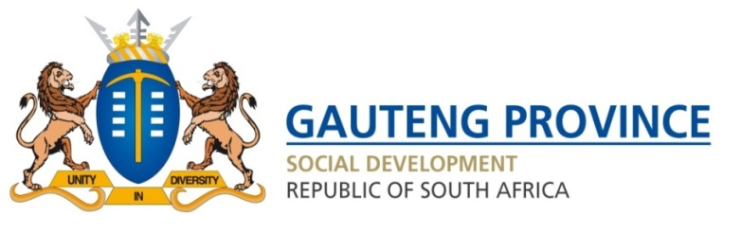

RESPONSE TO PARLIMENTARY QUESTION 1794 OF 2022

1794. Ms L L van der Merwe (IFP) to ask the Minister of Social Development:

(1) (a) What total number of non-profit organisations (NPOs) in each province did her department provide funding to in the 2021-22 financial year and (b) will she provide Ms L L van der Merwe with (i) a list of all NPOs funded and (ii) the total amount of funding allocated to each NPO;
(2) what (a) total number of NPOs had their budgets cut in the 2021-22 financial year in each province, (b) are the names of the NPOs that had their budgets cut and (c) did the cuts amount to in total?
NW2123E
Response
- (a) 2856 NPOs were funded to render a variety of social welfare and development services.
(b)(i) Please refer to the attached Annexure A, of all the programmes funded by the Department. Noting the Department may fund one NPO for multiple programmes.
(ii) The total amount is R 2 670 309 028. Please refer to attached Annexure A.

- (a) The Department has maintained the level of funding to NPOs and are not aware of any budget cuts, unless if more information can be provided.
(b) Not applicable, as there were no budget cuts.
(c) Not applicable, as there were no budget cuts.

Regards,

________________
Ms M Mosupyoe
Member of Executive Council
Department of Social Development
Date:

