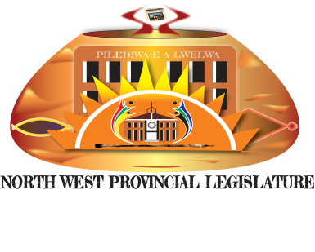
COMMITTEES’ MEETINGS - SCHEDULES FOR OVERSIGHT WEEK (NGAKA MODIRI MOLEMA)
11 – 14 FEBRUARY 2020
Item | Portfolio/ Standing Committees | Day | Date | Time | Venue | Responsible Administrator
1 | Public Works and Roads, Community and Transport Management | Tuesday | 11/02/2020 | 08:00 -11:00  13:00 – 15:00 | Makgobistad Police Station  Tshidilamolomo Police Station | Masego Mjemla  072 760 6314
2.  3. | Economic Development, Environment and Tourism, Agriculture and Rural Development | Tuesday | 11/02/2020  11/02/2020 | 08:00 – 10:00  11:00- 13:00 | Cookes Lake  Mahikeng (Meeting with NW Gambling Board  Meeting with the Department of Agriculture | Matshediso  060 991 7782  Aobakwe  082 822 1244
4. | Public Works and Roads, Community and Transport Management | Wednesday | 12/02/2020 | 08:00 – 10:00  10:00 – 12:00 | Ottostadal Police Station  Discussion on the road from Ottostadal to Haartebesfontein  Tswaing Local Municipality Board Room (Ottosdal) | Masego Mjemla  072 760 6314  Elizabeth Wessels  072 631 0816
5. | Economic Development, Environment and Tourism, Agriculture and Rural Development | Tuesday | 13/02/2020 | 08:00 – 11:30 | Cookes Lake  Mahikeng (Meeting with Barolong Boo Tau Boo Mariba on Buffalo Donation and Intensive Breeding Project | Matshediso  060 991 7782
6. | Public Works and Roads, Community and Transport Management | Thursday | 13/02/2020 | 09:00 – 11:00 | Discussion on Lichtenburg, Itsoseng, Goedgevonden, Springbok Pan, Dudgield to Sephaku Mines  Ditsobotla Local Municipality | Elizabeth Wessels  072 631 0816
7. | Economic Development, Environment and Tourism, Agriculture and Rural Development | Friday | 14/02/2020 | 08:00 – 10:00  10:00 – 12:00 | Kgora Institute  Ramatlabama  Cookes Lake (Meeting with the department and Tourism Board on Manyane 3 & 4. | Aobakwe

