BLIND SA
ANNUAL REPORT & AUDITED
FINANCIAL STATEMENTS
2017/2018

1. ORGANISATIONAL PROFILE

Head Office: 102 – 104 8th Avenue, Mayfair, Johannesburg.
Postal Address: Private Bag X9005, Crown Mines, 2025, RSA
Contact Person: Jace Nair (CEO)
Tel: 011 839 1793
Fax: 011 839 1217
Email: ceo@blindsa.org.za
Website: www.blindsa.org.za
Facebook: https://facebook.com/Blind-SA-1777715589132307/
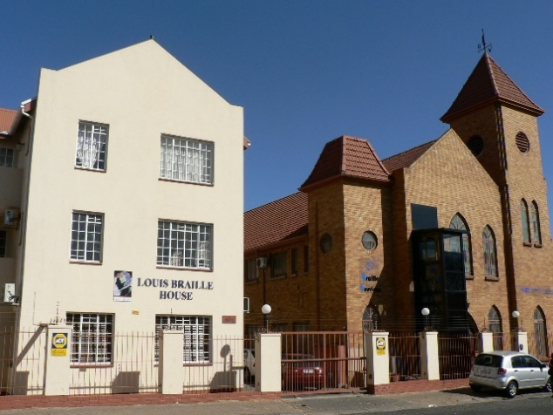

1.2 STATUTORY MANDATE
Blind SA is a national Disable People’s Organisation (DPO) of the blind and for the blind. Established in 1946 as the South African Blind Workers Organisation (SABWO) and became Blind SA in 2004.
Not-for-profit organisation registration number:
000-606 NPO
Public benefit organisation registration number:
PBO 130003512
Central Suppliers Database registration:
MAAA0497449

1.3 VISION STATEMENT
The vision of Blind SA is to do whatever is necessary or conducive to empower visually impaired people to become economically self-supporting and to live a full and meaningful life as citizens of South Africa.
1.4 MISSION STATEMENT
The mission of Blind SA is to promote the interests of all visually impaired people through the provision of appropriate services -
To create an informed blind society,
To enable them to gain meaningful employment,
To enhance their quality of life, and
To incorporate them into everyday life.

1.5 SERVICES
Blind SA provides services that empower blind and partially sighted people directly and by training trainers that empower our beneficiaries. The main services are listed below:
Advocacy, lobbying and self-representation.
Awareness raising, information dissemination and distribution of information through various publications: Blind SA News, Braillorama, Braillorette, Braille Trumpet, Young Stoners and Parents Network.
Assistive devices: white canes, talking and braille watches, liquid level indicators, Mali-Bhala, braille paper, Tatrapoint Brailler and the Braille Me.
Assistance for learners in special and mainstream schools and student’s registration with tertiary institutions.
Braille production of literature in UBC (unified braille code) in all 11 official languages.
Provision of study bursaries and loan facilities for the purchase of work and study related items.
Training in accredited braille and orientation and mobility services and placement in skills training and placement in employment.

Presidential Report

Another year has passed, and it gives me great pleasure in presenting this Annual Report for the period 1 April 2017 until 31 March 2018. The review period had a number of significant highlights and milestones for our organisation.
The appointment of the CEO, now two years with the organisation, has assisted the organisation to focus on strengthening member organisations, improved financial sustainability and emphasis on quality and accredited empowerment programmes for blind and partially sighted persons.
Blind SA has 30 member organisations and acts as the voice of its members and to a large extent as the voice of other visually impaired South Africans as well. The fact that its member organisations are autonomous and separately registered in terms of the NPO Act, make it essential that the member organisation leadership should also be fully informed of the needs, aspirations and abilities of their members. The member organisations should be strengthened, as this is the only growth point for the organisation as a whole.
At the 71st General Assembly we had a capacity building workshop, which was well received and will be an ongoing initiative for all member organisations of Blind SA.
Capacity building and strengthening of our member organisations received our specific attention during this year. An organisational capacity assessment audit was instituted and an action plan for building sustainability within our organisation has been implemented.
During the course of the year, emphasis was given to the development of a five-year strategic plan with an implementation matrix. This plan clearly identified three broad goals:
Maintaining a sound, ethical, transparent and accountable governance and administration;
Programmatic objectives of empowering blind and partially sighted people; and
Creating a more visible sustainable organisation.
The effects of these goals will receive greater clarity in the Operational Report that follows in the Annual Report.
May I acknowledge our gratitude to all our members and member organisations for the work you have undertaken in this past year. We are aware of the economic constraints that affected your organisations and despite these barriers you forged ahead.
Members of the General Assembly and the Executive Committee, Advocacy and Information Committee, Braille Committee, Education and ECD Committee, Employment Committee, Finance and Human Resource Committee, Legal and Constitutions Committee and Policy Committee – thank you for the sterling work you performed!
Our sincere appreciation also to our many volunteers and staff for tasks you undertook to ensure that Blind SA fulfils its mandate of empowering blind and partially sighted people.
Our special thanks to our many donors and funders, especially the Department of Arts and Culture for the generous ad hoc grand, other State Departments, corporates, SMME’s bequests, individuals and the media for your kind counsel, technical assistance and funding.
The pages that follows will provide a record of the highlights achieved during this review.
Thank you
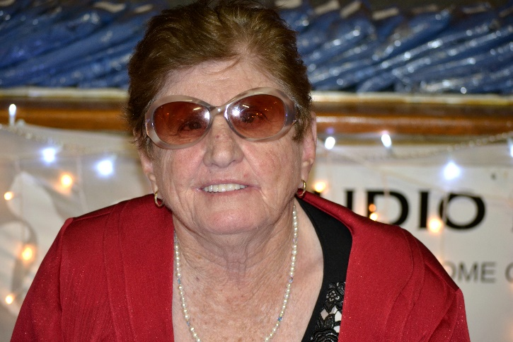
Cathy Donaldson
President
2. GOAL 1: SOUND, ETHICAL, TRANSPARENT AND ACCOUNTABLE GOVERNANCE AND ADMINISTRATION
2.1 STRATEGIC OVERVIEW
Target period
The strategic plan and implementation matrix was adopted on 4 August 2016 and makes provision for a short-term twelve-month, medium-term three-year and long-term five-year framework.
Goals
The plan has three goals with specific objectives for each of the goals.
Goal 1: Sound, ethical, transparent and accountable governance and administration;
Goal 2: Programmatic objectives to empower blind and partially sighted people in South Africa to become economically self-supporting and live a full and meaningful life as citizens.
Goal 3: To increase visibility, public relations and develop sustainability for the organisation.
Sustainability
An outcome of the plan is to ensure sustainability of the organisation by achieving a zero deficit budget within the short-term and funding for at least a year to sustain the programmatic objectives by the long-term framework of the strategic plan.
Quality Services
The other pillar of the strategic plan is to ensure quality services is offered to blind and partially sighted beneficiaries by implementing monitoring and evaluation mechanisms. The focus will be to provide specifically identified services to targeted blind and partially sighted beneficiaries.
Operational Management
The implementation of the goals and objectives are to be achieved by staff, volunteers and members through the three divisions set up, viz.
Braille Services Division;
Skills Development and Training Division; and
Administration, Human Resources and Fundraising Division.
Monitoring and Evaluation
Monitoring and evaluation tools were formulated and monthly, quarterly and annual reviews held.
2.2 GOVERNANCE
All the committees of Blind SA meet regularly in accordance with the set down calendar. These meetings have taken place via telephone conferences, skype conferences and physical meetings. Attendance at these meetings are excellent. The minutes of all meetings are compiled and stored on site and electronically off site. All electronic round robin decisions are formally recorded at the subsequent physical meetings. The Annual Reports of the committees is summarised and included in the paragraphs that follow in this section.
2.2.1 Executive Committee
Office Bearers
Miss Catherine Jane Donaldson: President
Mr Ntshavheni Simon Netshituni: Vice-President
Mr Frederik (Derick) Albertus Greeff: Treasurer

Members
Mr André Vosloo: Advocacy & Information Committee
Mr Thomas Mollard Lehmkühl: Employment Committee
Mr Christoffel Johannes de Klerk: Braille Committee
Mrs Susanna Magdalena Bam: Education and Early Childhood Development Committee

Meetings
The Executive Committee held meetings on:
11 April 2017, 8 May 2017, 16 May 2017, 29 July 2017, 5 September 2017, 8 September 2017, 4 October 2017, 6 December 2017, 17 January 2018, 21 February 2018 and 15 March 2018.
Committee Activities
Approved the budget 2018-2019 on 15 March 2018.
Approved the Annual Report 2016-2017 on 29 July 2017.
Approved the Audited Financial Statement 31 March 2017 on 29 July 2017.
Hosted the General Assembly meeting on 27-28 October 2017 with twelve member organisations participating and one Member Organisation as an observer.
Approved the reports from the Advocacy and Information Committee; Braille Committee; Education and ECD Committee; Employment Committee; Finance and Human Resource Committee; Legal and Constitutions Committee; Ad Hoc Committee and Screening Committee.
Received reports from staff and monitored the operations of Blind SA projects and activities.
2.2.2 Advocacy and Information Committee
Members
Mr André Vosloo; Chairperson
Mr Christoffel Johannes de Klerk
Mr Dibatsela Johannes Maabane
Mr Ntshavheni Simon Netshituni
Miss Susan Webber
Miss Catherine Jane Donaldson

Meetings
The committee met on 24 June 2017 and on 26 October 2017.
Committee Activities
Reviewing policy documents and legislation that impacts upon the lives of blind and partially sighted people;
Completing questionnaires’ received from WBU, AFUB and other sources;
Publishing media releases and other information regarding Blind SA on traditional media and social media platforms;
Responding to documentation received from SADA concerning disability matters relevant to blind and partially sighted people;
Responding to queries received from member organisations regarding consumer issues affecting blind and partially sighted people;
Compiled a new strategy for the Advocacy and Information Committee which has been implemented since April 2018. The strategy provides for the committee to widen the net and drawing more members of Blind SA into its operations. The scope of work needs to be widened so that the needs of all blind and partially sighted people are catered for. Member Organisations need to be empowered so that they can advocate in their respective areas. If they cannot resolve a matter it then needs to be escalated to the committee for further handling.
A program broadcast on ETV regarding the challenges at Rivhoni School was brought to the attention of the committee. The matter was referred to Exco and a task team was appointed consisting of Ntshavheni Netshituni, Susan Bam, Andre Vosloo and the CEO. A very fruitful and informative meeting was held with the Principal of Rivhoni School and it was decided to make the following recommendations to Exco:
- That the matter be referred to the Office of the Presidency;
- That the Adopt-a-school foundation be approached to see where they can assist; and
- That Exco considers a special fundraising drive to assist with the problems regarding security fencing at the school.
The committee recommended that the matter of accessible banking services be referred to the SAHRC. Christo De Klerk is in charge of this process and meetings with the SAHRC were held. The SAHRC is very interested in this matter and it is hoped that this will lead to better access to all aspects of banking services by blind and partially sighted people.
The committee participated in the following meetings and workshops:
Banking Association of SA
Gauteng Policy Transformation Workshop: Development of a Theory of change and transformation policy framework
Gauteng Provincial Health Consultation Forum
Gauteng Office of the Premier: Girl Child Dialogue
Gauteng Disability Forum
ICT Disability Chamber: USO ICT School Workshop on DBE ICT procurement; ICT E-Commerce Working Group; ICT Gautrain Work Group; ICT Education Subcommittee: ICT Short term insurance Work Group.
Johannesburg Disability Forum
Men’s dialogue against intimate femicide
NACOSS Workshop
National Health Insurance Workshop
SA Consumer Council
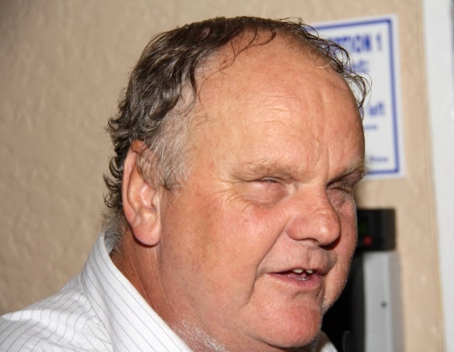
Andre Vosloo
Chairperson
2.2.3 Braille Committee
At the first meeting of the new committee the following office bearers were elected: Eric Gama – vice-chairperson; Heaven Botma – secretary. The other members of the committee are Derick Greeff, Ntshavheni Netshituni and Cathy Donaldson together with the manager: Braille Services, the Braille Instructor, manager: Skills Development and Training and the CEO in attendance.

Members
Mr Christoffel Johannes de Klerk; Chairperson
Mr Othusitse Eric Gama
Heaven Botma
Miss Catherine Jane Donaldson
Mr Ntshavheni Simon Netshituni
Mr Frederik (Derick) Albertus Greeff

Meetings
The committee had one physical meeting on 24 May 2017 in Worcester and on 19 March 2018 via Skype.
Committee Activities
Activities:
The presentation at Edu Week in July 2017 on the various formats in which blind persons read with the emphasis on Daisy. The second event was at the PASA AGM in Durban in August 2017. There was much interest in the presentation at the PASA AGM.
The third matter to report on, is the second Braille Cup Contest which took place in October 2017 at Prinshof School with the prize-giving dinner hosted by the SANCB. Only about 5 of the 22 schools for the blind participated. It was encouraging, though, that this time winner was spread across schools and one school did not walk away with almost all trophies as happened at the previous contest.
Another activity is the advocacy on the amendments to the Copyright Bill and ratification of the Marrakesh Treaty. Presentations and submissions were made at numerous meetings including the Portfolio Committee at Parliament, PASA Copyright Workshops and at DTI.
Blind SA partnered with Nal’ibali on 1 February 2018 in the World Read Aloud Day to promote a culture of reading at schools for the blind. Exco members and members of the Education and Early Childhood Development Committee and the Braille Committee participated in the project. Details on the event appears in the Education and ECD Report that follows. This will become an annual event.
Committee members participated in other activities which are included in the Advocacy and Information Committee report.
SABA:
All committee members attended the SABA General Assembly which took place in Worcester on 25-26 May 2017.
The Blind SA SABA Partnership MoU which provides quality braille training by the Skills Development and Training Division of Blind SA was under review during the year and the amended MoU will be signed at the next SABA General Assembly. Details on the quality braille training programme appears in the Skills Development and Training Report elsewhere in this report.
DBE:
During our stay in Worcester we also attended a meeting of Blind SA, Pioneer Printers and Mr Alan Subban of the DBE about the provision of LTSM in braille. At that meeting a number of agreements were reached: Blind SA and Pioneers would agree on which producer would do which books from the catalogue and Mr Subban would clear such procurement with Treasury. Mr Subban would engage with publishers to get them to bear the cost of the production of master copies. These matters were further dealt with at a meeting of Blind SA, Pioneer Printers, Publishing bodies, Daisy SA and the DBE. Publishing bodies seemed to be open to the suggestion that publishers should bear the cost of master copies (stencils as they are called in the industry).
On the same day we also attended a meeting of the DBE’s Advisory Committee which dealt with procurement. A query from Treasury was tabled about the inclusion of other braille producers, but the meeting felt that only the two producers present could guarantee quality. It was suggested that SABA should provide the necessary quality assurance and also that training should be provided to publishers in making their publications as accessible as possible to speed up braille production and cut down on production costs.
We attended a further meeting with the DBE and Pioneer Printers during November 2017 to discuss braille production of textbooks in terms of a MoU regulated by a deviation certificate from National Treasury.
DAISY Project:
The expansion of Braille Services into the production of material in Daisy format as well as producing math books, is progressing. One math book was produced and there is a request for another. Five magazines are produced with TTS voice for English and human narration for other languages. Two included audio annexures in human narration in African languages.
Braille Services staff tested the CSIR Human Languages Project; Setswana, Sesotho and Afrikaans TTS voices for use in those languages in Daisy production, but found them unsuitable. This means that we will have to look at human narration instead until there are suitable TTS in local languages.
Marketing:
The creation and uploading of the YouTube video was completed and is live on YouTube How braille is made – watch the YouTube video! https://youtu.be/wYtoMa3IH-4
The Ri Wana Ndivho (Sponsor a Book) project is ongoing and has provided an income of some R120000 with 18 book titles produced for the financial year with an undertaking from the major sponsor, Concor, to sponsor more books in the new financial year.
Tatrapoint Mechanical Braillers and Braille-Me Electronic Note-taker:
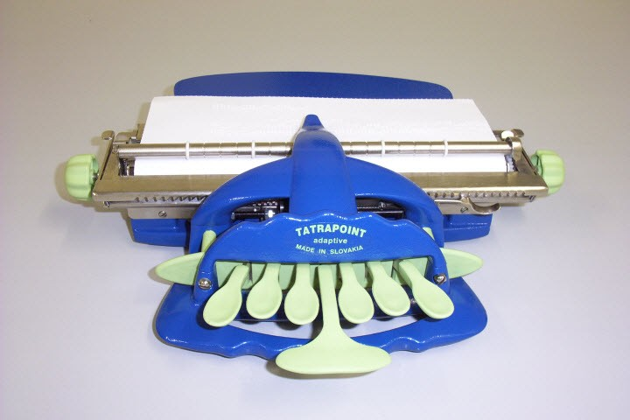
The Tatrapoint Mechanical Brailler is a more cost effective affordable braille writing machine manufactured in Slovakia. Blind SA imported one unit and after testing found it to be very suitable. Subsequently two orders of 30 and 45 units were imported. These devices were purchased by a number of Schools for the Blind. A technical repair and maintenance workshop was held on 24-25 January 2018 at Prinshof School with fourteen persons from the schools and organisations trained.
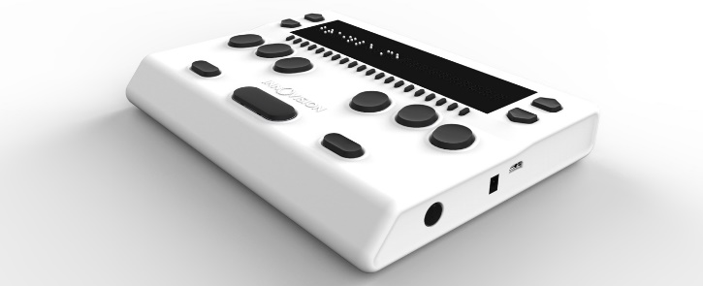
Braille-Me is an electronic braille note-taker and display produced in India. Blind SA entered into an exclusive distributor agreement after having tested the device. Our team assisted Innovision to identify challenges with the device and these have been resolved. Blind SA will import the first batch of 30 devices.
Constitutional changes:
As the committee no longer deals with braille matters only, but now also is responsible for the Daisy format which in turn could be used to produce documents in other formats as well, it is recommended that the Blind SA Constitution be amended so that the name of the committee can be changed to be more descriptive of its ambit, for example, it could be called the Accessible Formats Committee. The Terms of Reference would have to be amended accordingly.
Conclusion
In conclusion I wish to thank the members of this committee and the staff of Braille Service as well as those in Skills Development involved in braille training, for the great work you have all done during the past term of office, sometimes under difficult conditions. Your efforts are truly appreciated.
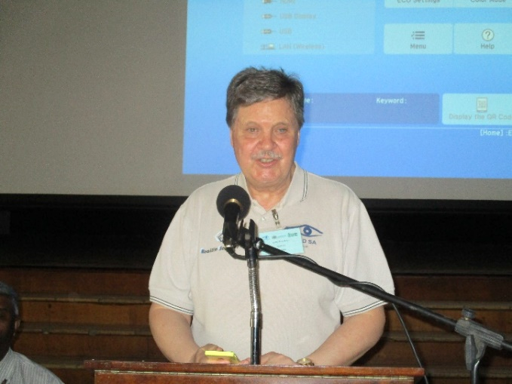
Christo de Klerk
Chairperson
2.2.4 Education and Early Childhood Development (ECD) Committee
Members:
Susan Bam (chairperson)
Eric Gama
Thinus van Sitter
Ntshavheni Netshituni
Tommie Lehmkuhl
Jan Bam
Cathy Donaldson

Meetings:
One telephone conference on the 6th of June 2017 and regular email contacts.

Committee Activities:
Infrastructure for special schools by DBE. The purpose was to look at ICT specifications for special schools to be included in the ICT network.
The SABA Annual General Meeting was held on 25-26 May 2017 in Worcester.
The GDE Education Lekgotla was held from 1 to 3 June 2017. The theme: Enhancing the quality of education provision in Gauteng.
Rivhoni School for the Blind
The Rivhoni School Task Team consisting of -
Chairperson of the Advocacy and Information Committee: Andre Vosloo, the Chairperson of the Education and ECD Committee: Susan Bam, the Vice President: Ntshavheni Netshituni and the CEO: Jace Nair, was set up to discuss the challenges at Rivhoni School for the Blind.
Rivhoni School remains a problem at this stage. A few programs were shown on TV about Rivhoni School and from the programs it was clear that the school buildings are in a terrible state and the learners do not even always have food to eat.
They are currently sharing the infrastructure with the Rivhoni Society for the Blind and that cause many problems. The assistive devices used by the school are faulty. The school receives a subsidy of R22.00 per day per learner, but does not receive additional money for text books and devices. It was decided to refer the matter to the Office of the Presidency
And that the Adopt-a-school foundation will be approached to see where they can assist. Blind SA will undertake a special fundraising for the school and also initiate advocacy with DBE and Limpopo Department of Education.
Tshimologo AET Centre
The Tshimologo AET Centre Task Team of the Chairperson of the Education Committee: Susan Bam, Eric Gama, Jan Bam and the CEO: Jace Nair was set up to assist the Centre with accessing textbooks and other resources for the AET programmes. The Task Team worked closely with the Bartimea School for the Deaf and Blind and the Tshimologo AET Centre in Thaba Nchu.
The Head of the Centre, Julian Setotlela reported that at the centre there was no electricity, there are no Grade 12 teachers and no braille or large print textbooks.
Three meetings were held on 29 November 2017, 23rd February and 23 March 2018 at Bartimea School for the Deaf and Blind at Thaba Nchu. The delegations included the management from Bartimea School, Sello Morang representing DHET, management of Tshimologo AET Centre and Blind SA was represented by Susan Bam, Eric Gama, Jan Bam and Jace Nair.
Mr Moreng reported: “The reason why this centre does not get enough money is because they are not regarded or looked at as a special needs centre; they receive the same amount of money as all the other mainstream centres. It was confirmed that all staff members are appointed on annual contracts.”
The staff of Bartimea School felt that it would not be advisable to have the adult learners in the same classrooms as the learners.
Bartimea School can help with the brailling of learning and exam material. Lecturers of Tshimologo Centre get students to take notes because of the shortage of learning material.
A problem is that most blind learners cannot do proper note taking since they cannot write braille well and do not have assistive devices. Tshimologo AET Centre should liaise with the DHET so that they can be included in future planning and resourcing of more staff.
World Read Aloud Day
The World Read Aloud Day is to promote the right to read and promote the importance of braille and was held on the 1st of February 2018. Schools for the blind (Primary sections) were invited to participate by reading the story, “The final minute” by Zukiswa Wanner in the learner’s mother tongue. Comprehension questions were asked to the learners and there was even a braille treasure hunt. In the end we had 11 schools taking part and we had 850 learners participating in 6 different languages. Pioneer School for the Blind received the Tatrapoint Braille Writer as the first prize for participating in this competition, arranged by Blind SA and Nali’bali.
Learner Assistance
We gave advice or helped to place the following learners in appropriate schools:
Lilhe Magida – Multi disabled little boy of 7. Cannot see, walk or talk. Staying in East London. The mom is looking for stimulation centre. We referred the mom to a rehabilitation centre, where the little boy was assessed.
Maria Mmpalane – Girl of 15. She became blind at the age of 13 in G8. She will have to receive mobility training and braille lessons.
Amoherang Mollo: Eight years, Grade 2. Stays in Thembisa. Could not cope in a normal school. Was placed in Sibonile.
Ntomikayise Nguni: seven years, multi disabled. Stays in Duduza near Nigel. Will most probably be placed in Kangaroo home in Klip River.
Ofentse Molefe: Was taken out of school. Had to convince mom that it is important for child to go to school. Arlene van Huysteen was asked to assess the learner and the Education Committee paid for the consultation. We are waiting for a psychologist of the department to assess Ofentse and then he will be placed in a school for the blind.
Leeah Marthinus: Twelve years. She stays in Primrose. Learner is not blind, but cognitively impaired. Mother wants child in a school for the blind.
Ofense Sipheri: Twelve years old, Grade 6. Stays in Soweto. Was placed in Prinshof.
Mpilo Mdabe: Four years old. Gave advice on facilitators and main stream schools. The parents decided in the end that little boy will attend a school for the blind.
Noah Gaika: eight years old. Staying in Fourways. Applied for a place in Prinshof. Will be assessed.
Imad Baba: Six years old. Staying in Lenasia. Attending Prinshof School as a day scholar.
Financial Assistance:
In this financial year we have helped 6 learners of Prinshof with transport to school. They are: Katleho Selwana, Katleho Diutwileng, Lesedi Chisale, Unithi Madhela, Palesa Maome and Unathi Maphela.
We helped Andrea Padaychee with her transport to Open Air School.
From February we had paid R1 000 monthly into Sandile Rapopo’s bank account. He had to use it for his accommodation and groceries at the Tshimologo AET Centre.
Adult learners
Topollo Mofilikoane - He did not write exams in June-July. He got infection from an eye operation in his eyes and lost so much time from recovery that he did not sit the exams.
Nicolette Mendu - She had permission to use a scribe for her exams in June-July, but became sick and did not write the exams.
Michael Ndlovu – he wrote his exams this year.
Bronwyn Yorke - She stays in Sasolburg. We helped her with some of her learning material. Her results were good.
Three adult learners were helped with learning material. Pulane Moshai received material in braille and on cd. Wendy Hild received material on cd. Jongikhaya received material on a flash drive.
We helped Wendy Hild with her registration at Higher Education and applied for permission to make use of scribes for Wendy. We also arranged that a group of teachers read her guidelines of Economics on cd.
Rudi Holtzhausen studying at UNISA was assisted with advocacy and interventions so that he may complete his studying at UNISA.
A meeting was held at UNISA on 22 March 2018. The exam centre would be changed and adaptation of learning and exam material was discussed. The DRSU and other university representatives agreed to engage more regularly with students to avoid similar issues as was raised by Rudi Holtzhausen.
General:
We require screening toolkits when undertaking assessments and screening of potential adult learners and to develop an agreement drawn up to be signed by the learners before assisting them.
Adult learners should be referred to AET (Adult Education and Training) Centres.
We must rather help adult centres with learning material, if they have teachers, because the one cannot work without the other. Individuals do not cope on their own.
More pressure should be put on disability units of universities and colleges when they do not help the students.
We must rather help adult centres with learning material, if they have teachers, because the one cannot work without the other. Individuals do not cope on their own.
Retha Stassen still compiles and edits a Parents Network Letter every 3 months on behalf of this committee and the standard of this letter is excellent.
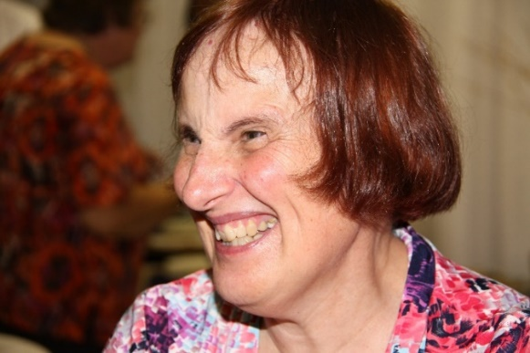
Susan Bam
Chairperson
2.2.5 Employment Committee
Members:
The members of the employment committee during this period were:
Tommie Lehmkuhl (Chairperson)
Abraham Allies
Ntshaveni Netshituni
Cathy Donaldson
Sello Mabusela
Hanif Kruger

Meetings:
Two telephone meetings were held on 20 September 2017 and 27 March 2018.
Committee Activities:
Database of job seekers
After eliminating job seekers above the age of 50 the database stands at 419 job seekers. The employment officer will be tasked to clean up and expand the database on a continuous basis.
Placements
The full time placement officer has been working for a year and three months. Awareness raising presentations were presented to six companies. Many positions were identified and CV’s submitted with five permanent placement done and two candidates enrolled in an internship programme. The Placement Officer held two Job Readiness training sessions.
Agreement with K&A
An agreement was entered into with this company with the following objectives:
Assistance with further study to obtain matric or equivalent qualification;
Assistance with placing of persons in internships; and
Assistance with the placement of persons in full time employment.
Committee members attended several workshops and conferences during the course of the year - listed below are some activities:
SEDA stakeholder feedback session held by the Small Enterprise Development Agency - Department of Small Business Development
Employment Equity in the Public Service held by the Public Service Commission - Department of Public Service and Administration
Disability awareness with the UIF - Department of Labour and Transnet
General
Annually there are several offers of internships from a range of employers. If we could have information about visually impaired learners finishing their degrees we should be in a much better position to find internships for them. Internships often serve as a precursor to employment and are therefore very important.
Blind SA endorses the Minimum Wage Act with regard to workers in sheltered/protected workshops.
The problems experienced by visually impaired people regarding public transport will be escalated to SA Disability Alliance and the Department of Transport.
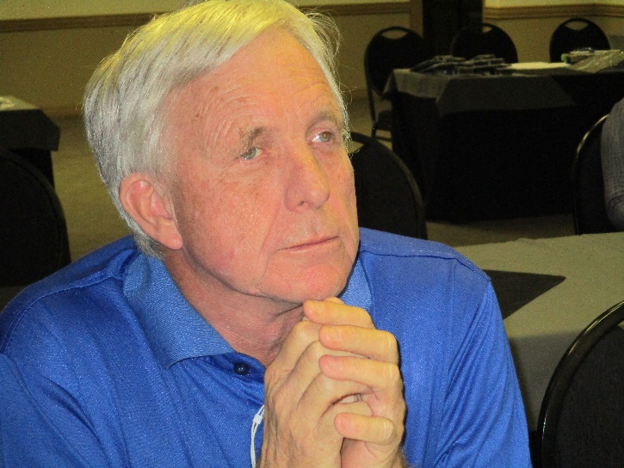
Tommie Lehmkuhl
Chairperson

2.2.6 Finance and Human Resource Committee
Members:
The FHR Committee was elected by the Executive Committee in 2016. Members are: Mr D Greeff (Chairperson), Ms C Donaldson, Mr N Netshituni, Mr C de Klerk and Mr J Nair and Ms R Vermaak as CEO and CFO respectively.
Meetings:
5 May 2017, 28 July 2017, 17 November 2017, 20 February 2018 and 12 March 2018.
Important decisions/resolutions taken
The main task of the members was to monitor the finances of the organisation. Each member attended to a section of the work. These included monitoring of the monthly financial statements, preparing reports and monitoring the debtors list and age analysis. With these monthly reports, it was hoped that members could gain an overview of the financial status of the organisation for that period.
Salary streamlining and grading:
This has been discussed and it was agreed that professional help was required to attend to this situation in the near future. It has become very urgent that salaries be put in its proper categories. Blind SA's next challenge will be to streamline the salary levels particularly for staff performing the same duties. An entry level (minimum salary level) at R7000 per month was established. The concept of equal pay for the same job is a complex issue. Blind SA will tackle this issue at a later stage.
Budget 2017/2018:
The budget for the financial year ending 31 March 2018 was approved on 6 March 2017. The budget was reviewed during the six months’ review in November 2017 for the remainder of the financial year. The meeting also agreed that a surplus is possible for the period ended 31 March 2018 but that this will in part depend on the level of bonuses agreed upon.
The meeting agreed that, working towards a zero based budget also means compromises. Small expenditures for committees can possibly be absorbed but larger items just cannot be accommodated until a proposed strategy plan has been submitted.
Members noted the different approach of allocating funds to the Advocacy and Information Committee. It was planned that all committees' budgets will be designed in this way in the future.
The budget for the year ending 31 March 2019 was also approved on 12 March 2018.
Subsidy from St. Dunstans Association – John and Esther Ellerman Memorial Trust:
The organisation indicated that they will not at this stage renew a subsidy for an O&M practitioner that has been cancelled. After successful negotiations, the Trust agreed to continue with the subsidy of three O&M Practitioners.
Policies of Blind SA:
The FHR Committee also agreed that the policies of the Organisation need to be reviewed regularly as to keep abreast with the latest developments in management.
It was recommended that a committee be set up to monitor and deal with this aspect of the work. Mr N Netshituni (convener), Mr C de Klerk, Ms S Bam and Ms C Donaldson will form the committee.
The Policy Committee reviewed and recommended twelve policies for adoption.
Communication/Marketing Officer:
There is a need for a part-time or fulltime person with a communication, public relations/marketing qualification to support Blind SA's communication and marketing strategy. The organisation may in the short term consider outsourcing this function, if it is unable to recruit a part-time candidate.
This matter was briefly discussed and it was agreed that, at some stage, a communications/Marketing officer should be appointed to further market the services of Blind SA.
Report on Analysis of Braille Services for the past six years:
An analysis of income and expenditure as well as a breakdown of braille produced was prepared with figures from 2013 to date. It was noted that the figures for braille production was high in 2013 and then gradually decreased over the period. This could be seen in the sales and turnover of production in the various years. One of the reasons for the sudden turn down in 2014 was the loss of the contract for the production of the braille edition of the Vuk'uzenzele. This had a major influence on the number of master pages and duplications. In discussing the matter, various other braille printing works were used to benchmark Braille Services, but this does not rectify or explain the increasing deficit experienced.
There was a real need to assess Braille Services in terms of its cost effectiveness and all efforts should be towards breaking even and if possible even showing a surplus.
One of the actions to take is to engage a cost accountant to assess the cost effectiveness of Braille Services to thereby identify the areas where adjustments could be made. The proposed 80/20% split has not been possible in the longer term.
Members were not convinced that this alone would provide the answer as it was clear that there was not enough work coming in and it was this situation that had to be addressed.
Report on Annual Financial Statements for the year ending 31 March 2018
The Statement of Financial Position, Statement of Surplus or Deficit and Other Comprehensive Income, Statement of Changes in Equity, Cash Flow Statement and the various pages with notes expanding the statements, form the bulk of the audited financial statements. It is on some of these that I shall expand to give you a broad outline of our financial status as at the end of the financial year.
Starting with the income statement, which is now called “Statement of Surplus or Deficit and other Comprehensive Income”, we see that it is divided into four sections. These deal with revenue income, then the cost incurred to achieve this revenue (cost of sales) with a gross profit or (loss) on this activity.
Other income and the operating expenses with the operating surplus/ (deficit) then follow. All of these headings refer to more detailed notes in the section on “Notes to the financial statements”.
The revenue for the year was R7,986,287 compared to R7,912,028 for 2017.
This is a decrease of income of 1% compared to the previous year.
The cost of sales (production costs) was (R11,396,841) compared to (R11,211,814) for 2017. This means an increase of 1.65% compared to the previous year.
The gross deficit was therefore (R3,410,554) compared to (R3,299,786) for 2017 with the deficit 3.35% increased.
Other income was R12,498,331 compared to R10,433,662 for 2017.
This was a 19.78% increase for the year.
Operating expenses were (R8,856,997) compared to (R8,721,710) for 2017 or 1.55% increased.
The operating profit/deficit for the year is therefore R230,780 compared to (R1,587,834) for 2017.
Add to this investment revenue of R11,649 compared to R39,005 for 2017 and the total profit is R242,429 compared to a deficit of (R1,548,629) for 2017.
As an overall picture, we see that total income was at R20,496,267 compared to R18,345,690 or 11.72% increased.
Expenditure for the same period was R19,933,524 or 1.60% increase.
More details of the different segments are:
REVENUE
(What is revenue? When the outcome of a transaction involving the rendering of services can be estimated reliably. In our case this includes braille services income and donation income from Embrio programme.)
Braille Services - Sales decreased to R2,890,958 compared to R3,006,291 for 2017 or 3.86% decreased compared to the previous year.
Donations received from the direct mail programme increased with 3.86% to R5,095,329 compared to R4,905,737 for 2017.
COST OF SALES
(What is cost of sales? It includes purchases of for example employee costs, consumables, repairs and maintenance, transport and freight etc.)
Purchases - Embrio increased to (R3,209,518) compared to (R3,038,035) or 5.64% compared to 2017.
Cost of manufacturing goods - these are inventories and employment costs increased to (R8,187,323) compared to (R8,173,779) or 0.16% compared to 2017.
Gross profit/Loss (that is deducting cost of sales from the revenue) was (R3,410,554) compared to (R3,299,786) for 2017.
Other income which does not have an associated cost and which include debts recovered, other donations received, the grant received, internal fundraising etc.
The grant received from the Department of Arts and Culture increased to R7,859,000 compared to R7,485,000 or 4.99% increased.
General donations received increased to R2,115,363 compared to R1,175,116 or 80.01% for 2017.
OTHER EXPENSES
(advertising, accredited braille training, auditors, bad debts, bursaries, motor vehicles, postage etc.)
Auditor's remuneration increased to (R115,820) from (R109,800) for 2017.
Bad debts decreased to R96,225 compared to R205,779 for 2017.
Bursaries decreased to R475,963 compared to R518,201 for 2017.
Salaries, wages and employment expenses increased to (R12,871,985) to (R11,720,129) for 2017 or 9.82% increased.
The Annual Financial Statements also contains the budgets for the various items. Ideally the income and expenditure should be within 10% of the budget to be acceptable.
Turning to the balance sheet or Statement of Financial Position as it is currently called, we see that the non-current assets, that is property, plant, motor vehicles, furniture and fittings, office and computer equipment, has decreased to R8,541,817 compared to R8,731,651 for 2017.
The Current Assets, that is inventories, loans receivable or special loans, staff loans, trade and other receivables or VAT and trade debtors and bank balances has decreased to R1,926,359 from R1,966,592 for 2017.
Total assets have decreased to R10,653,312 to R10,928,044 for 2017.
Under liabilities one item needs noting. This is the outstanding loan from the SABWO Trust of R1,745,000 from R2,195,000 for 2017
In total, looking at the balance sheet, things look healthy with the total equities and liabilities being lower than for the same period of 2018 at R10,653,312 compared to R10,928,044 for 2017.
The cash flow statement tells us the differences between the states of activities of the end of last year against that of the end of this year.
It deals with cash flow from operating and investing activities. This difference between the beginning and the end of the year brings about the total cash movement for the period.
In my view, the audited annual financial statements represent a fair overview of the financial activities of Blind SA. According to information included in these statements, Blind SA is in a healthy financial situation at present, and there is no reason to doubt that this situation will continue in the future with the present management team in place.
Further detailed information can be found in the notes to the audited financial statements at the end of this Annual Report.
I trust you will find the above information informative and that it will provide you with a broad outline of the financial status of Blind SA.
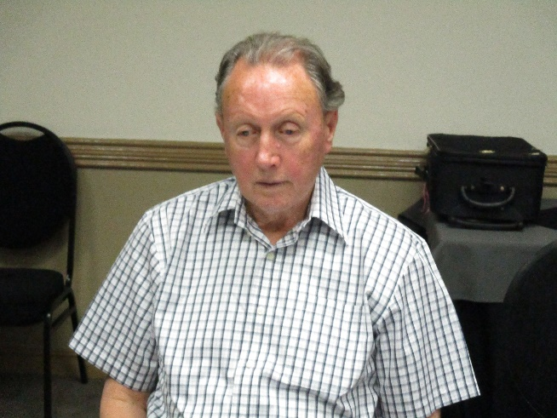
Derick Greeff
Treasurer
2.2.7 Policy Committee
The Policy Committee reviewed eight existing policies and developed four new policies as listed below.
- ADM01 Policy on ICT
- HR01 Conditions of Employment
- HR02 Policy on Leave
- HR03 Policy on Smoking
- HR04 Policy on Overtime
- HR06 Policy on Confidentiality
- HR07 Policy on Travel
- HR08 Policy on Housing Allowance
- HR09 Policy on Sexual Harassment
- HR10 Policy on Fraud Theft and Dishonesty
- HR12 Policy on Performance Management
- HR13 Policy on Staff falling Ill while away from Office
- HR14 Policy - Staff Family Funerals

2.2.8 General Assembly
In the past year the General Assembly arranged leadership training and capacity building workshop for the member organisations at the General Assembly.
This will be an ongoing process as new member organisations join Blind SA.
The following delegates from member organisations very successfully attended our General Assembly meeting on 27-28 October 2017:
Blind SA Peninsula (Cape Town, Western Cape): Mr L. van der Sandt
Breede Valley (Worcester, Western Cape): Mr C. Vorster
BWO Orion (Pretoria, Gauteng): Ms S. Webber
Egoli Blind (Johannesburg, Gauteng): Mr H. Kruger
Khutala Association for the Blind (Embalenhle, Mpumalanga): Mr B. Mthimunye
Inkwekwezi Blind Society (Peddie, Eastern Cape): Ms K. Magilindane
Itereleng Association for People with Disabilities (Warrenton, Northern Cape): Mr T. Mangalenyana
Mbombela Blind Association (Mbombela, Mpumalanga): Mr D. Nkosi
Now is the Time Blind SA (Bela-Bela, Limpopo): Mr S. Mabusela
Progressive Centre for the Blind (Bloemfontein, Free State): Mr L. Likhoka
Siyazingca Social Group (Port Elizabeth, Eastern Cape): Mr E. Faltein
Vukani Ma-Afrika (Soweto, Gauteng): Mr M. Motlhamme

OBSERVERS:
House of Hope (Kagiso, Gauteng): Ms M. Letlhage
Their contributions were invaluable at this important gathering and we are indeed looking forward to their active participation in future.
2.3 ADMINISTRATION AND MANAGEMENT
2.3.1 Organogram
The organogram of the organisation appears on the back inside cover of this Annual Report. The operations of the organisation are headed by the CEO, Jace Nair and three Divisional Managers;
Braille Services Manager: Philip Jordaan
Skills Development and Training Manager: Susan van Wyk and
Administration, Human Resources and Fundraising Manager (CFO): Ria Vermaak with Cindy Zulu (Human Resource Manager).
The Staff Management Team consists of the managers and heads of departments and meets monthly and has met on 19 April 2017, 16 May 2017, 19 June 2017, 27 July 2017, 16 August 2017, 26 September 2017, 24 October 2017, 22 November 2017, 31 January 2018, 28 February 2018 and 28 March 2018.
The Staff Finance Team meets on a monthly basis to review and monitor the budget and the expenditure.
2.3.2 Human Resources
Staff Movements
Appointments: 5
Temporary Appointments: 3
Resignations: 2
Contract ended: 3
Promotions: 2

Employment Statistics

Number of staff employed: 45
Number of Black Staff: 23
Number of Women Staff: 28
Number of Staff with disability: 10
Number of staff who fall within the youth group (between the ages of 18 to 35 years: 9

Staff Development and Training

Number of staff trained: 5
Black staff trained: 3
Women staff trained: 2
Disabled staff trained: 1

3. GOAL 2: PROGRAMMATIC OBJECTIVES TO EMPOWER BLIND AND PARTIALLY SIGHTED PEOPLE IN SOUTH AFRICA TO BECOME ECONOMICALLY SELF-SUPPORTING AND LIVE A FULL AND MEANINGFUL LIFE AS CITIZENS
3.1 BRAILLE SERVICES
3.1.1 Braille Production
Master Page Production
During the past year we produced 63 644 new master pages - a decrease of 37% on the previous year.
This is made up by the following main categories:
Braille Magazines: 2 312 p. 6% increase
Students & Individuals: 22 977p. 20% decrease
School & TVET College Text Books: 11 102 p. 3% decrease
Commercial Printing: 15 423 p. 250% increase
Blind SA Administration: 9 507 p. 380% decrease
Other work: 2 324 p.

Duplication Page Production
Duplication pages showed a 4% increase to 1 685 867 braille pages.
Paper Sales
Paper sale figures are constant. With the difficulty to source local stock, we decided to replace flat-sheet Camelot 135gsm with Sun Offset 140gsm, a Chinese paper. We also changed the paper grade on our Interpoint high-speed reel embossers from Camelot to Bristol Vellum 147gsm, sourced from Indonesia and the USA.
Paper sales were as follow:
Paper Grade Sales
Sun Offset (kg) 7 851
Computer (boxes) 343
Camelot (reels) 0

Braille Magazines
We produced five magazines for Blind SA (Braillorama, Blind SA News, Braille Trumpet and Young Stoners – monthly & Braillorette – bi-monthly).
Magazine Subscribers Master Duplication
Pages Pages
Braillorama 234 862 210 690
Blind SA News 272 220 67 812
Braillorette 327 310 100 842
Braille Trumpet 330 720 240 954
Young Stoners 402 200 82 652
Total 1 565 2 312 685 680

All these magazines are supplied to readers free of charge. The number of subscribers and page-output was constant.
Individuals and Students
Subsidized braille printing for individuals and students is our core business and this year we produced 61 752 (16% down on the previous year).
Department of Basic Education (DBE), Schools and Institutions
Braille Services assisted DBE with the Grade 12 examination papers, as well as debrailling of the learner answer sheets. A total of 73 443 pages were produced, of which 29 664 were examination papers. The Sponsor-a-book campaign raised enough funds to produce 18 new school titles in braille.

Other Work
Braille business cards are still very popular and this year we produced cards for 255 persons (down by 40%), 85 830 cards (down by 3%).
The 2018 braille calendar was again produced with 850 pocket and 750 standard-size copies being distributed to schools, organisations and individuals. We are currently the only producer of braille calendars in South Africa.
Philip Jordaan
Manager Braille Services
3.2 SKILLS DEVELOPMENT AND TRAINING
The Skills division of Blind SA consist of 3 departments, namely:

1 Braille training
2. Orientation and Mobility training and
3. Placement

Each department has its own speciality, but is also linked to each other.
To ensure that a person can function independently he/she needs to know how to get from one place to another on his own. Therefore, the assistance from the Mobility department is very important. Once such a person can function independently, he/she needs to be able to take notes/ or read information for himself. For this function the skill to be able to read and write braille is very important. Once he/she has the skill to be able to work through information, the person needs to play his/her part in the economy of our country. For this, he/she needs to be placed in a working environment
The assistance of this division vary according to the needs of the client. In some cases, it is only necessary to assist in one of the three areas.
In a nutshell, this division assists in preparing a client to provide himself and his family with a dignified and responsible life.
Susan van Wyk
Manager
3.2.1 Braille Training
During this period 73 clients were trained in grade 1 braille, whereas 74 clients were trained in grade 2 braille, while 37 clients were trained in Technical braille (Mathematics and Science) . The provinces served were Free State, Eastern Cape, North West, Mpumalanga and Northern Cape.
Induction
We conducted induction programmes on three groups that undertook training under ETDP SETA certified qualification. The following provinces were visited for such programmes:
Province | Number of people trained | Unit Standard
Eastern Cape | 15 | 264937 Communication methods for blind and partially sighted.
Eastern Cape | 49 | 117872 Read and write fully contracted braille in any one language.
Eastern Cape | 37 | Technical Braille (Mathematics and Science)
Free State | 9 | 117872 Read and write fully contracted braille in any one language.
Mpumalanga | 26 | 264937 Communication methods for blind and partially sighted.
North West | 21 | 264937 Communication methods for blind and partially sighted.
North West | 16 | 117872 Read and write fully contracted braille in any one language.
Northern Cape | 11 | 264937 Communication methods for blind and partially sighted.

We offer braille training under the following:
- Communication methods for blind and partially sighted Unit Standard 264937 (Grade 1)
- Read and write fully contracted braille in any one language Unit Standard 117872 (Grade 2)
- Technical Braille (Mathematics and Science); Tactile Graphics Production; Braille Production (Skills transferee programme)
During this year we managed to conduct training on grade 1, grade2 and technical braille only. This training was provided in 5 provinces. The following table illustrates the provinces, type of training and dates training conducted.
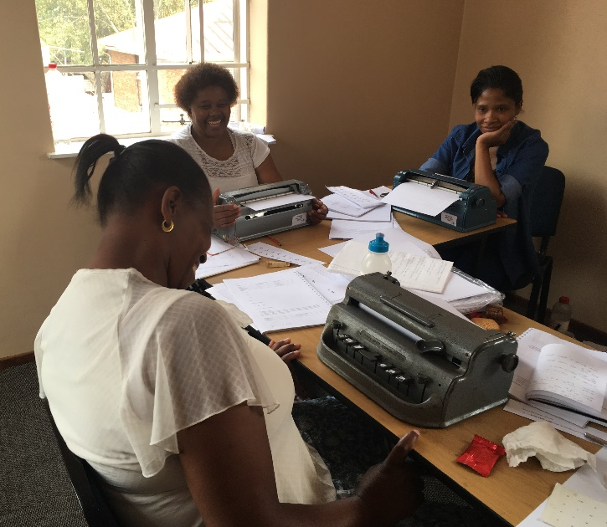
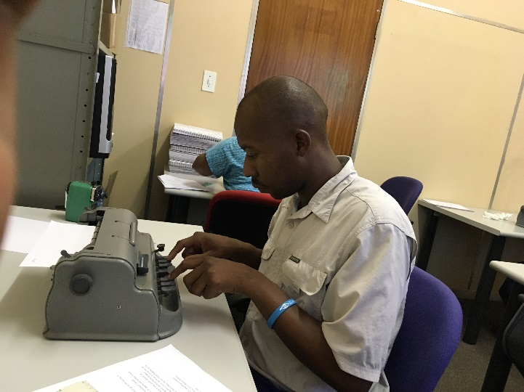
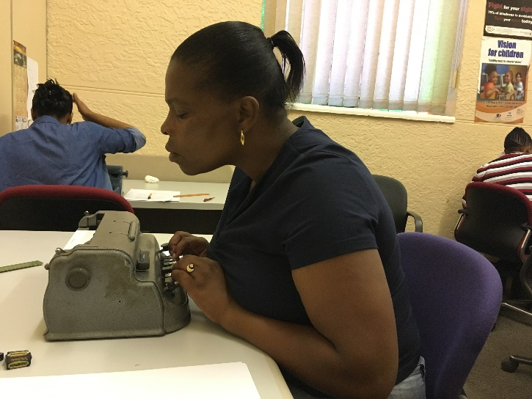

Province | Type of Training | No. of Candidates | Date Conducted
Eastern Cape | Grade 2 | 30 | 10 – 14 July 2017
Eastern Cape | Grade 1 | 15 | 31 July – 4 August 2017
Eastern Cape | Grade 2 | 19 | 31 July – 4 August 2017
Eastern Cape | Technical | 37 | 2 – 6 October 2017
North West | Grade 1 | 21 | 30 October – 3 November 2017
North West | Grade 2 | 16 | 27 November – 1 December 2017
Northern Cape | Grade 1 | 11 | 4 – 8 December 2017
Free State | Grade 2 | 9 | 15 – 19 January 2018
Mpumalanga | grade 1 | 26 | 19 – 23 March 2018

SAQA Competency Certificate
We issued a total number of 94 competency certificates endorsed by ETDP-Seta, SAQA and SACE
Ofentse Manyane
Braille Instructor
3.2.2 Orientation and Mobility Training
Introduction
This period under review has been a difficult one as donor base is becoming limited perhaps due to our weak economic factors. The O&M practitioners are continuing to provide the O&M training programme in Gauteng province, however we are working very hard to move and reach out to other provinces. We are optimistic that in the new financial year ETDP SETAs in other provinces would come on board in funding the O&M training programme, a lot of effort is being done to make sure that this dream becomes a reality.
Orientation and Mobility (O&M) is a profession specific to blindness and low vision that teaches safe, efficient, and effective travel skills to people of all ages:
- "Orientation" refers to the ability to know where you are and where you want to go, whether you're moving from one room to another or walking downtown for a shopping trip.
- "Mobility" refers to the ability to move safely, efficiently, and effectively from one place to another, such as being able to walk without tripping or falling, cross streets, and use public transportation.

Municipality Clients
Ekurhuleni Municipality: 8
Johannesburg: 6
Tshwane Municipality: 3
Chief Mogale City: 18
Sedibeng/Orange Farm: 5
Total: 40

Johnson Mdluli
Head-of-Department O&M
3.2.3 Placement in skills training and employment
Blind SA provides a professional placement service assisting employers or recruiters to select suitable blind or visually impaired candidates for designated positions within their business.
The Benefits of Employing People with Disabilities in South Africa
Business leaders need to gain a deeper understanding of how to create an inclusive organisation.
The South African Government is asking employers to strategically look at a diverse workforce and capacity planning to create an inclusive environment. This is done through their policies, practices, infrastructure, training and increased awareness that address the barriers of employing people with disabilities.
A major benefit is that the organisation will be supporting national legislation in terms of:
- Employment Equity (EE),
- Broad Based Black Economic Empowerment (BBBEE),
- Corporate Social Responsibility (CSR) and in turn addressing social injustices of the past.

Where the person with a disability has not worked for a long time or has not had the opportunity to study further, the placement of this person should always be coupled with an intensive training programme. By doing so, employers will benefit from gaining points on the BBBEE scorecard under Employment Equity as well as Skills Development.
In addition, when placing a person with a disability on a Learnerships programme, an organisation can claim up to R100 000 (one hundred thousand Rands) in tax rebates per learner.
Our Services
Screening: All candidates on our database have been interviewed and thoroughly screened. A comprehensive CV is prepared for employers and recruiters to peruse. Our Job Placement Officer monitors and updates candidate records on a continual basis so our data is always fresh and accurate.
Client Interview: Once the employer or recruiter has expressed an interest in a particular candidate we will prepare the candidate for an interview at the employer’s premises. This process includes providing the candidate with information as to the role and its responsibilities, details of the employer as a company as well as accompanying the candidate to the employer’s premises in order to sensitise the candidate as to transport and access.
Placement: Once a candidate has been successfully selected for a job our Job Placement Officer will assist the employer or recruiter in finalising contracts as well as assisting with the induction of the candidate into the workplace.
Follow-up: Our Job Placement Officer will conduct monthly follow-up consultations with both the candidate and the candidate’s employer or direct superior. During this process we will assist both the candidate and the employer in resolving any issues that may have arisen. This service is offered over a period of 3 months after the candidate has been placed.
Things to Consider
Accessibility: Employers need to ensure that their premises are easily accessible for the prospective employee with regard to public transport routes, clear signage, clearly demarcated entrance and exit points, braille on lifts and easy access to personal amenities and work stations.
Software: The installation of specialised software at the candidate’s workstation such as NVDA (Nonvisual Desktop Access) which is a free open-source software or Zoom text, as well as the possible requirement for specialised hardware, depending on the prospective employee, needs to be taken into account.
Sensitisation: Sensitisation workshops are highly effective in assisting sighted employees to feel comfortable to communicate, include and interact with blind and visually impaired people in the workplace.
What Roles Blind and Visually Impaired People Best Suited for?
The suitability of a candidate for a position depends on the individual’s education, motivation and mind-set rather than their disability.
Suitable positions for blind and visually impaired people include: -
Leadership:
- CEO
- Branch Manager, Regional Manager, Line Manager
- Lawyer or Attorney
- Facilitator
- Public Speaker

Office Support and Administration:
- Switchboard Operator
- Telephonist
- Secretary
- Administrator
- Call Centre Operator or Manager
- Data Capturer
- Researcher
- Software Developer or Programmer

Sales and Marketing:
- Sales Associate
- Telesales Agent
- Copywriter

General:
- Massage Therapist
- Event Co-ordinator
- Broadcaster
- Disc Jockey
- Musician

Database of unemployed blind and partially sighted: 419
Learnerships and internships: 2
Placed in employment: 4

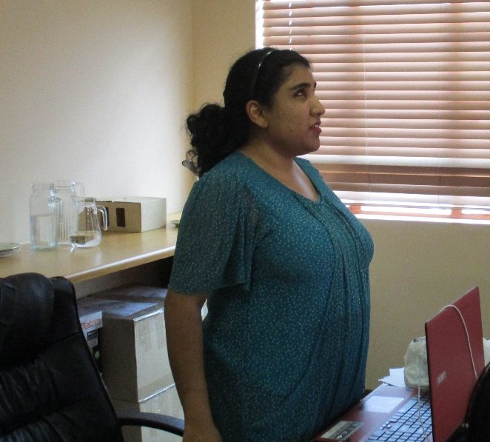

Parishna Ramluckan
Placement Officer

3.3 GENERAL ACTIVITIES
3.3.1 Special Loans
2 Special Loans were approved and paid out during this financial year.
3.3.2 Study Bursary
A total of 57 bursaries with the amount of R417 500 were allocated.
3.3.3 Assistive Devices
Value of assistive devices that was sold for this financial year was R30723.
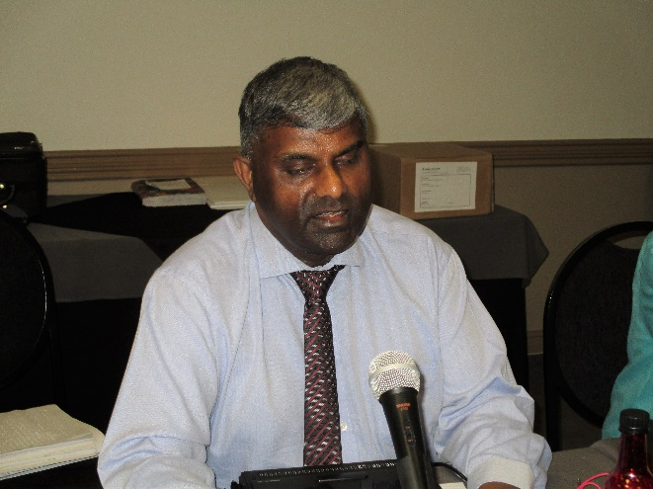
Jace Nair
CEO

4. Goal 3: Increased visibility, public relations and organisational sustainability
4.1 PUBLICATIONS
Blind SA Donor Newsletter
Approximately 21800 newsletters were distributed to donors during February 2018.
Blind SA Newsletters and Magazines
We produced five magazines: Braillorama, Blind SA News, Braille Trumpet and Young Stoners – monthly & Braillorette – bi-monthly.
The technical editorial team comprise of Philip Jordaan, Martie de Klerk, Lenah Ndlovu, Karin Gouws, and Jace Nair.
The Blind SA Newsletter has a new design and feel to it and a number of positive comments were received.
Magazines Subscribers Editors
Braillorama 234 Christo de Klerk
Blind SA News 272 André Vosloo
Braillorette 327 Christo de Klerk
Braille Trumpet 330 Johannes Dube
Young Stoners 402 Itumeleng Mohale
Parent Newsletter 187 Retha Stassen
Total 1752
Braille services edited and produced in print and in house a number of publications for Blind SA:
Blind SA Annual Report
Braille Services pamphlet
What is Orientation & Mobility?
Mobility Tips for the Blind
How to walk with a blind person
When you meet a blind person …
What to do when you meet a blind person
O & M Manual
Blind SA newsletter
Braillorette
Braille Training Material

4.2 MEDIA
During the course of the year, Blind SA circulated 13 media releases to over 292 media houses. Various representatives appeared on radio and television and contributed to external newsletters and newspapers.
Facebook
84% Response Rate
1091 Followers
1088 Likes
The Blind SA website was redesigned and made more accessible.
4.3 FUNDRAISING
“Our rewards in life will always be in direct ratio to our service” - Earl Nightingale
Through our lives, two of the elements that give real meaning are people and passion.
At Blind SA, through good times and not so good times, the one thing that is blatantly apparent is passionate people. We are all gifted with a unique set of skills and abilities, and we make extra-ordinary things happen.
Whether we are producing quality braille, teaching braille literacy, providing Orientation and Mobility to visually impaired people to ensure that they are ultimately able to be self-sufficient and so much more, the key is that we are passionate about providing these services and proud to be part of this organisation.
At the heart of all Blind SA’s accomplishments in the world of visually impaired people is a group of people who give financially and of themselves so generously. Our donors ensure that we are able to continue this very necessary work and they give fuel for our passion.
As we reach one milestone after another serving visually impaired people, we thank all our donors who year after year make this all possible.
Thank you for being the wind beneath our wings, and thank you for caring as much as we do.
Income to date – 1 April 2017 to 31 March 2018
Embrio R1631861
Assistive Devices R30723
Tin Collections R7318
Corporates, Trusts & Foundations R1357635
Individual Donations R100519
Bequest Programme R657342
Schools R1000
Given-Gain Website R170
Churches R3511
Total R3799979

Karin Gouws
HOD: PR, Fundraising and BB-BEE Compliance
5. GENERAL
5.1 Letters of Appreciation received:
Tassie Foundation
Sparrow Home
Mario and Amanda Nijenhuis
Shani Little (bursary recipient)
5.2 Accreditation
Blind SA is accredited with:
BBB-EE Level 1
Education and Training Development Practices Sector Education and Authority (ETDP SETA)
SA Council of Educators (SACE)

5.3 Affiliation
Blind SA is affiliated to:

SA Braille Authority
SA Disability Alliance
PASA
OMSA

6. CONCLUSION
The period under review was filled with the achievement of significant milestones. The four main outcomes in the five-year strategic plan were successfully implemented and the results appear in the Annual Report; viz. Strengthening Member Organisations, Financial sustainability, Provision of quality services to blind and partially sighted people and increasing the visibility of Blind SA.
The coming year promises to be even more significant with the implementation of the National Skills Fund Vocational and Social Rehabilitation Rural Project and the public relations and social media campaign to increase visibility and financial sustainability.
May I acknowledge the gratitude to all our donors, supporters, volunteers, well-wishers, staff and beneficiaries.
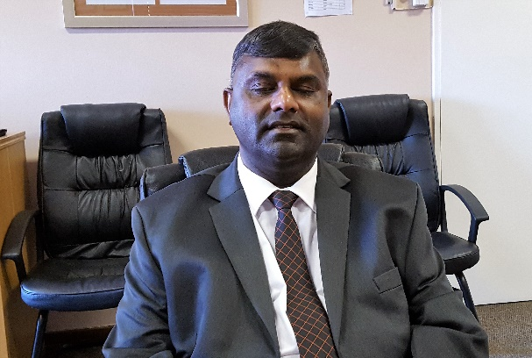
Jace Nair
CEO

